**Contributor name:** Benson E B

**Book Proposed:** Probability and Statistics

**Total Chapters:** 12

**Total Examples:** 686

**Codable Examples:** 349

**Chapter 1: Introduction to probability**

Example 1.4.1 – Codable

Example 1.4.2 – Codable

Example 1.4.3 – Codable

Example 1.4.4 – Non-Codable (Reason: Results are in variable expressions)

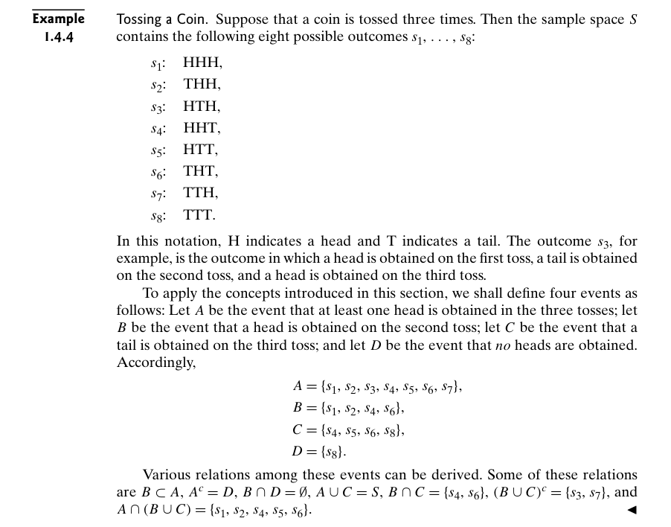

Example 1.4.5 – Non-Codable (Reason: Does not have any computational scope)

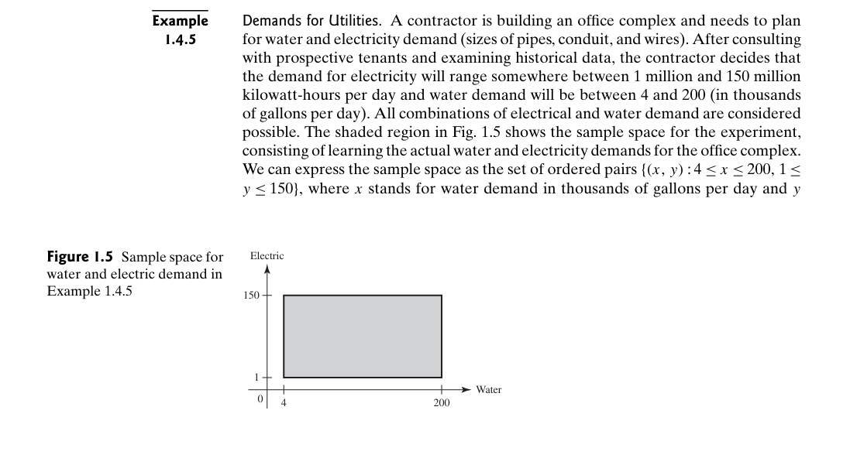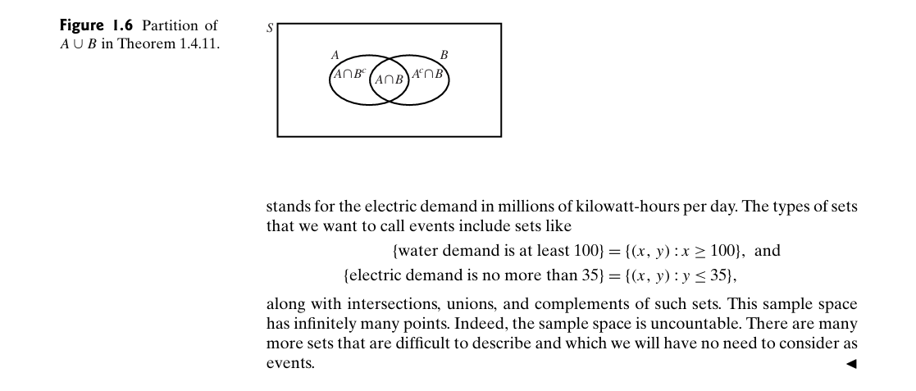

Example 1.5.1 – Non-Codable (Reason: Theoretical example with no problem solving)

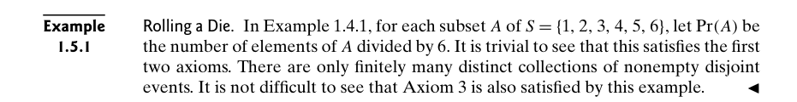

Example 1.5.2 – Codable

Example 1.5.3 – Codable

Example 1.5.4 – Codable

Example 1.6.1 – Non-Codable (Reason: Example with no computation, as an introduction)

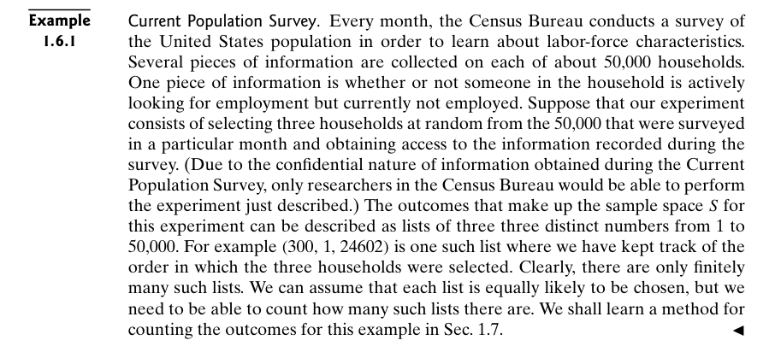

Example 1.6.2 – Codable

Example 1.6.3 – Codable

Example 1.6.4 – Codable

Example 1.6.5 – Codable

Example 1.7.1 – Codable

Example 1.7.2 – Non-Codable (Reason: Theoretical example with the purpose of proving a concept)

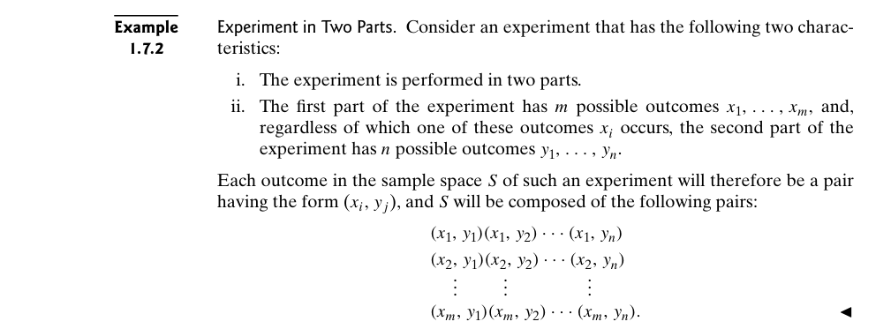

Example 1.7.3 – Codable

Example 1.7.4 – Codable

Example 1.7.5 – Codable

Example 1.7.6 – Non-Codable (Reason: Theoretical example with the purpose of proving a concept)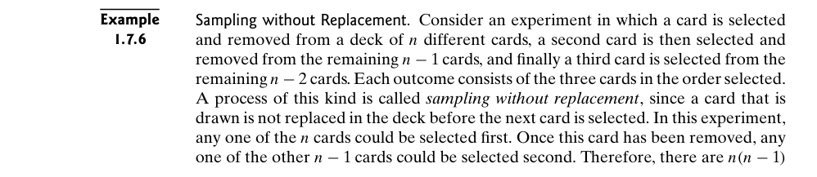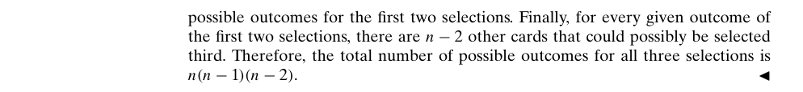

Example 1.7.7 – Codable

Example 1.7.8 – Codable

Example 1.7.9 – Codable

Example 1.7.10 – Non-Codable (Reason: Theoretical example with the purpose of proving a concept)

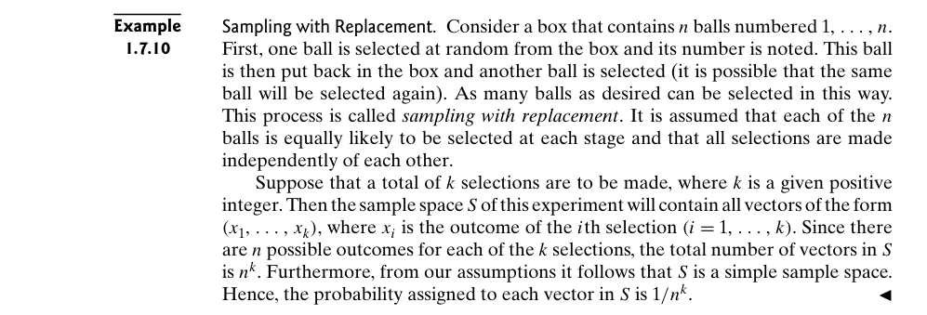

Example 1.7.11 – Non-Codable (Reason: Theoretical example with the purpose of proving a concept)

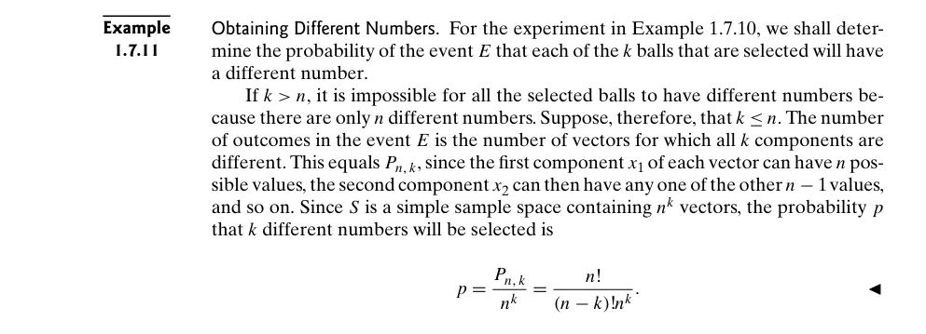

Example 1.7.12 – Codable

Example 1.8.1 – Non-Codable (Reason: Theoretical example with the purpose of proving a concept)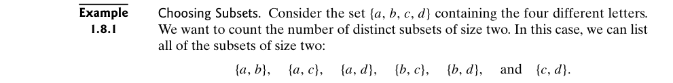

Example 1.8.2 – Codable

Example 1.8.3 – Codable

Example 1.8.4 – Codable

Example 1.8.5 – Codable

Example 1.8.6 – Codable

Example 1.8.7 – Codable

Example 1.8.8 – Codable

Example 1.8.9 – Codable

Example 1.8.10 – Codable

Example 1.8.11 – Codable

Example 1.8.12 – Non-Codable (Reason: Theoretical example with no scope of computation)

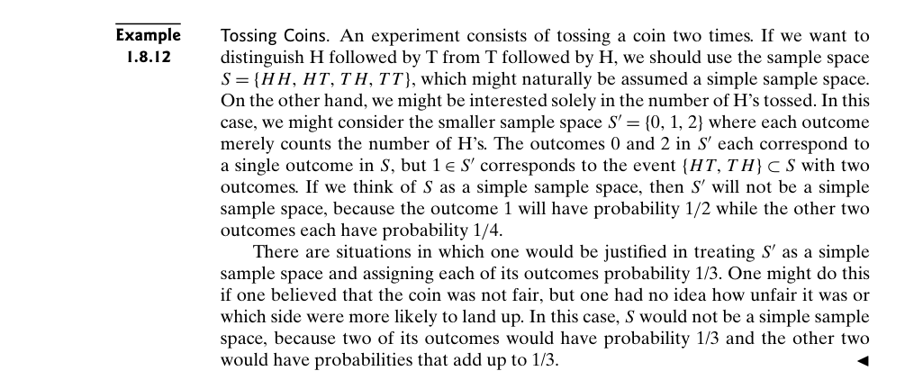

Example 1.9.1 – Codable

Example 1.9.2 – Codable

Example 1.9.3 – Codable

Example 1.9.4 – Codable

Example 1.10.1 – Codable

**Chapter 2: Conditional probability**

Example 2.1.1 – Non-Codable (Reason: Example with no computation, as an introduction)

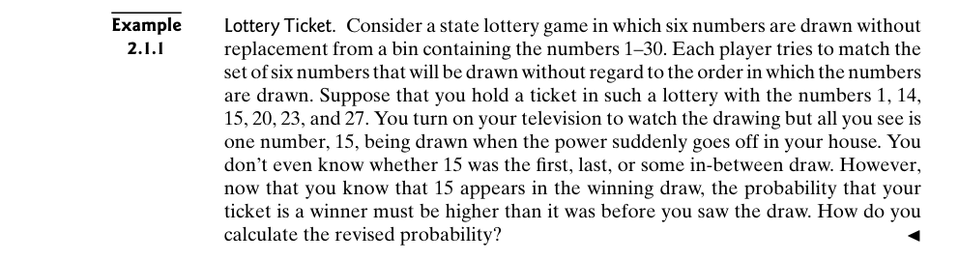

Example 2.1.2 – Codable

Example 2.1.3 – Codable

Example 2.1.4 – Codable

Example 2.1.5 – Codable

Example 2.1.6 – Non-Codable (Reason: Theoretical example with the purpose of proving a concept)

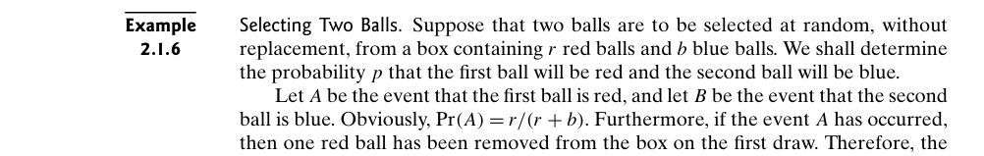

Example 2.1.7 – Non-Codable (Reason: Theoretical example with the purpose of proving a concept)

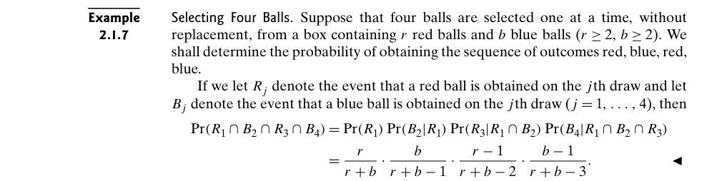

Example 2.1.8 – Non-Codable (Reason: Example with no computation, as an introduction)

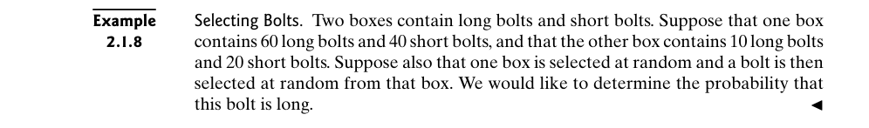

Example 2.1.9 – Codable

Example 2.1.10 – Codable

Example 2.1.11 – Non-Codable (Reason: Example with no computation, as an introduction)

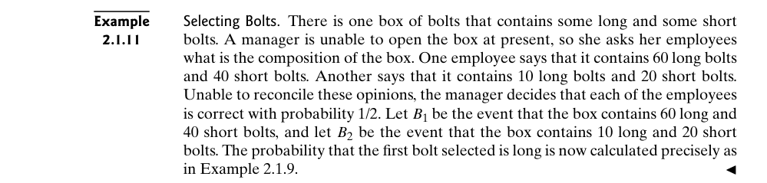

Example 2.1.12 – Codable

Example 2.1.13 – Non-Codable (Reason: Theoretical example with the purpose of proving a concept)

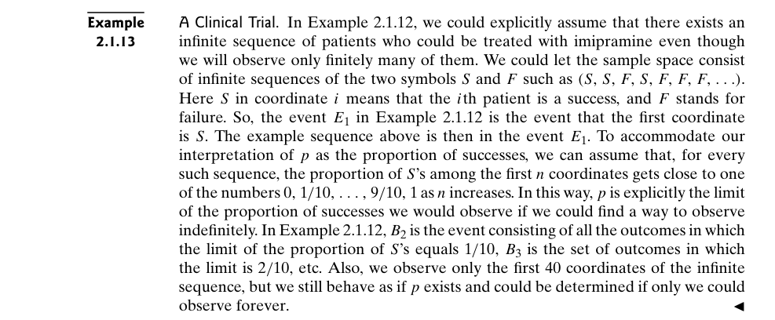

Example 2.2.1 – Codable

Example 2.2.2 – Codable

Example 2.2.3 – Codable

Example 2.2.4 – Codable

Example 2.2.5 – Non-Codable (Reason: Theoretical example with the purpose of proving a concept)

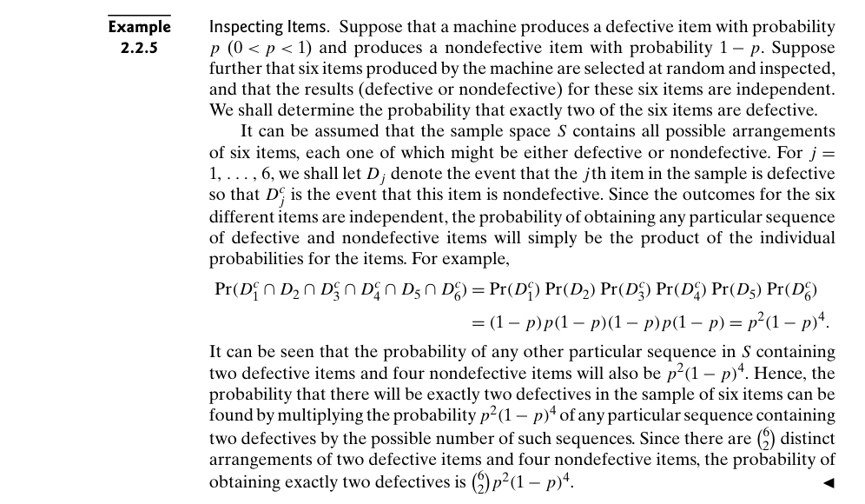

Example 2.2.6 – Non-Codable (Reason: Theoretical example with the purpose of proving a concept)

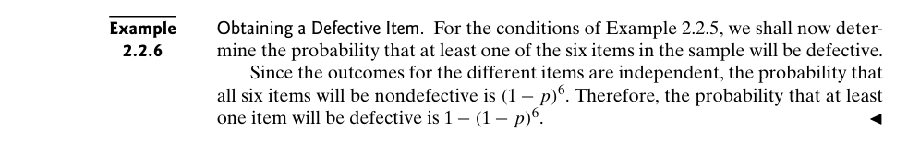

Example 2.2.7 – Codable

Example 2.2.8 – Non-Codable (Reason: Theoretical example with the purpose of proving a concept)

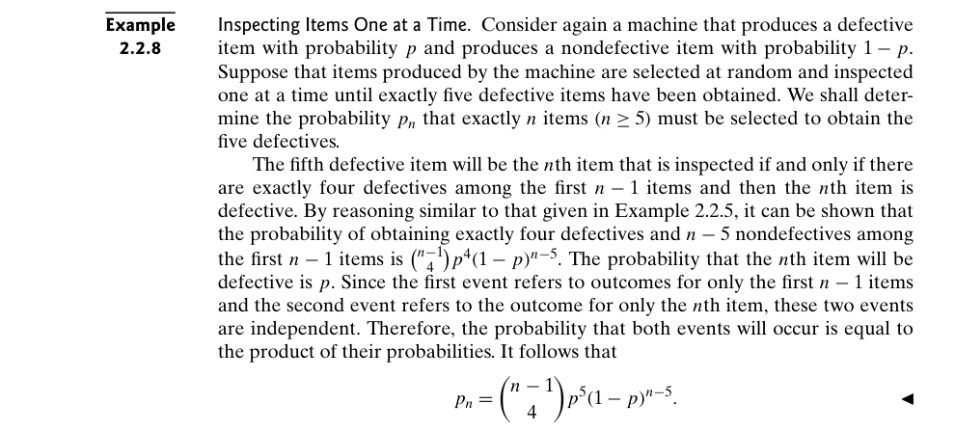

Example 2.2.9 – Codable

Example 2.2.10 – Codable

Example 2.3.1 – Non-Codable (Reason: Example with no computation, kept as an introduction)

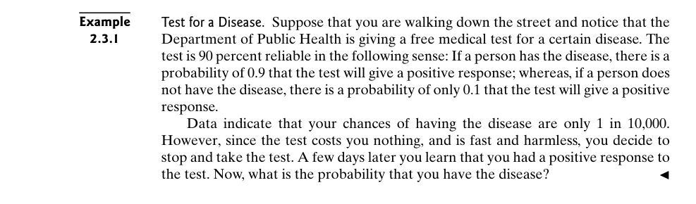

Example 2.3.2 – Codable

Example 2.3.3 – Codable

Example 2.3.4 – Codable

Example 2.3.5 – Codable

Example 2.3.6 – Codable

Example 2.3.7 – Codable

Example 2.3.8 – Non-Codable (Reason: Example with no computation, kept as an introduction)

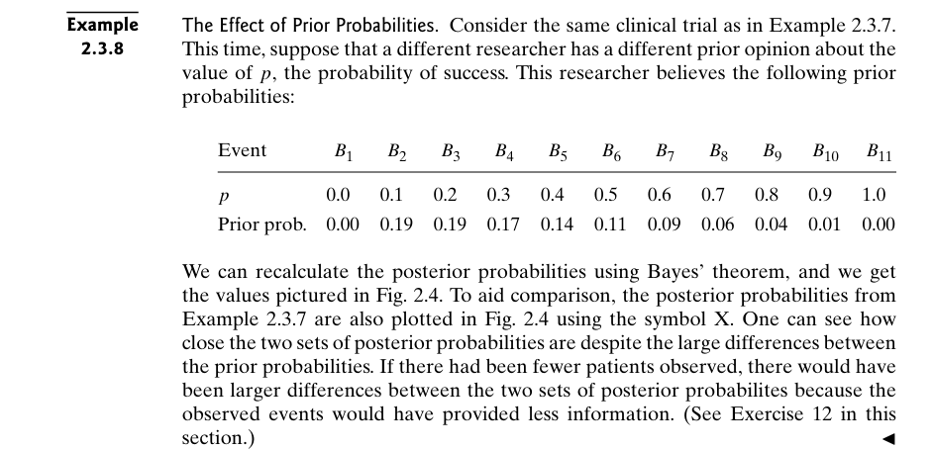

Example 2.4.1 – Codable

Example 2.4.2 – Codable

**Chapter 3: Random Variables and Distributions**

Example 3.1.1 – Non-Codable (Reason: Example with no computation)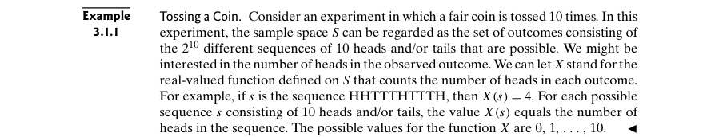

Example 3.1.2 – Non-Codable (Reason: Example with no computation)

Example 3.1.3 – Non-Codable (Reason: Example with no computation)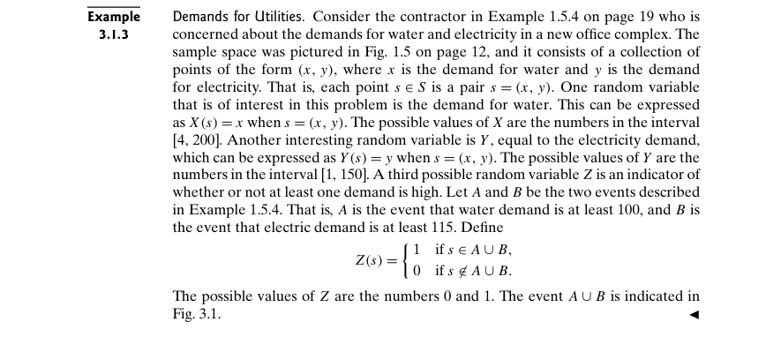

Example 3.1.4 – Non-Codable (Reason: Final answer is in variable)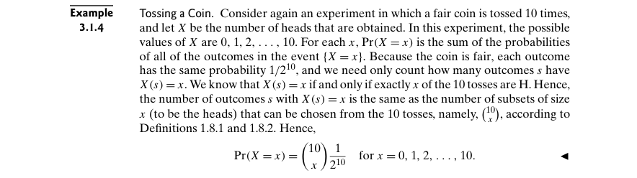

Example 3.1.5 – Codable

Example 3.1.6 – Non-Codable (Reason: Example with no computation)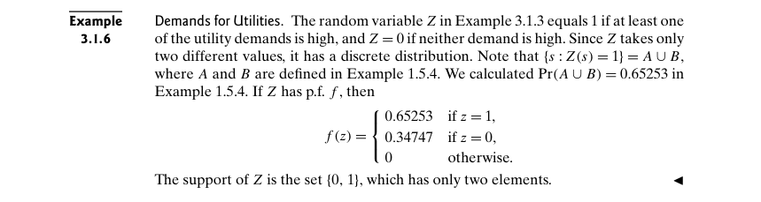

Example 3.1.7 – Non-Codable (Reason: Example with no computation)

Example 3.1.8 – Codable

Example 3.1.9 – Non-Codable (Reason: Example with no computation)

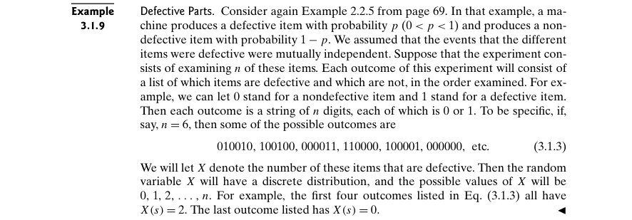

Example 3.2.1 – Non-Codable (Reason:The final answer is provided in infinity)

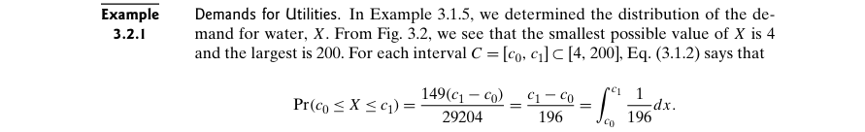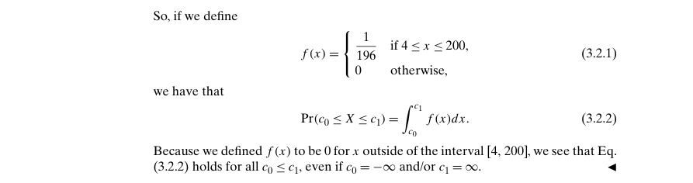

Example 3.2.2 – Non-Codable (Reason: Example with no computation)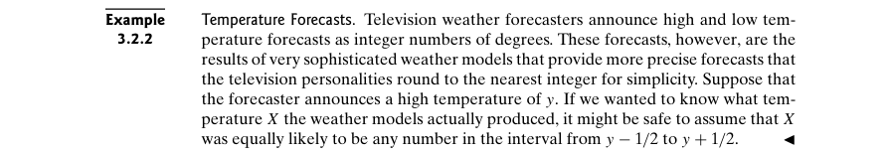

Example 3.2.3 – Codable

Example 3.2.4 – Codable

Example 3.2.5 – Codable

Example 3.2.6 – Non-Codable (Reason: Example with no computation)

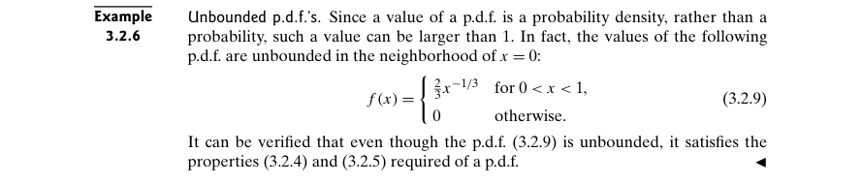

Example 3.2.7 – Codable

Example 3.3.1 – Codable

Example 3.3.2 – Non-Codable (Reason:Results are in variables)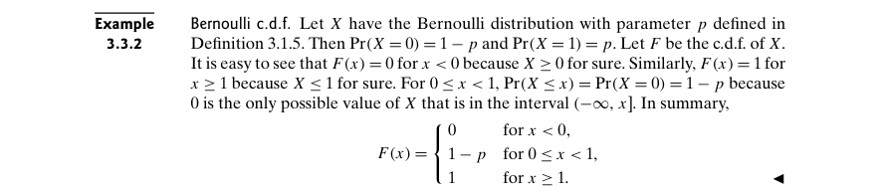

Example 3.3.3 – Codable

Example 3.3.4 – Non-Codable (Reason: Theoretical example with no computation)

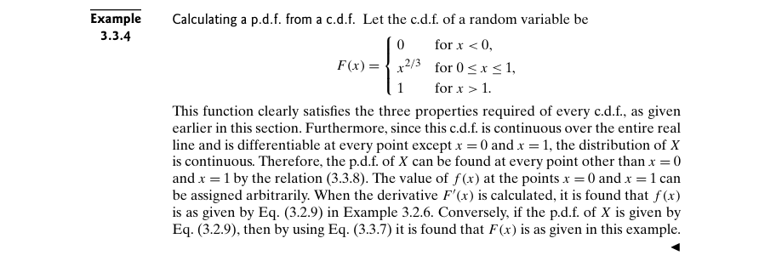

Example 3.3.5 – Non-Codable (Reason: Example with no computation)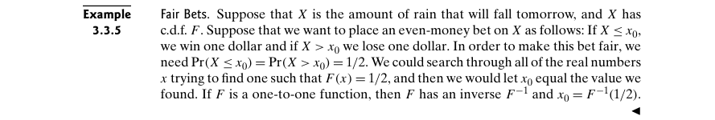

Example 3.3.6 – Non-Codable (Reason: Example with no computation)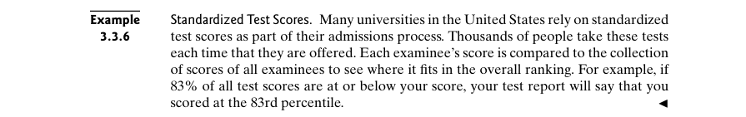

Example 3.3.7 – Non-Codable (Reason: Example unable to be computed from figure)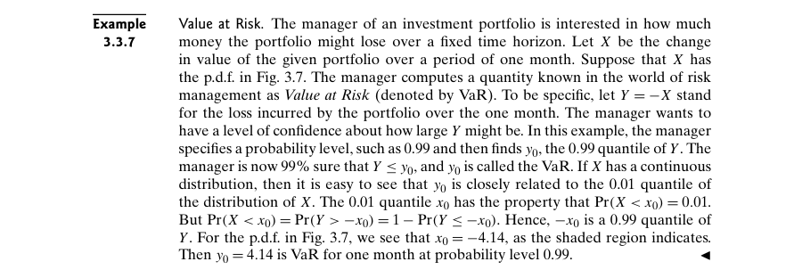

Example 3.3.8 – Non-Codable (Reason: Theoretical example)

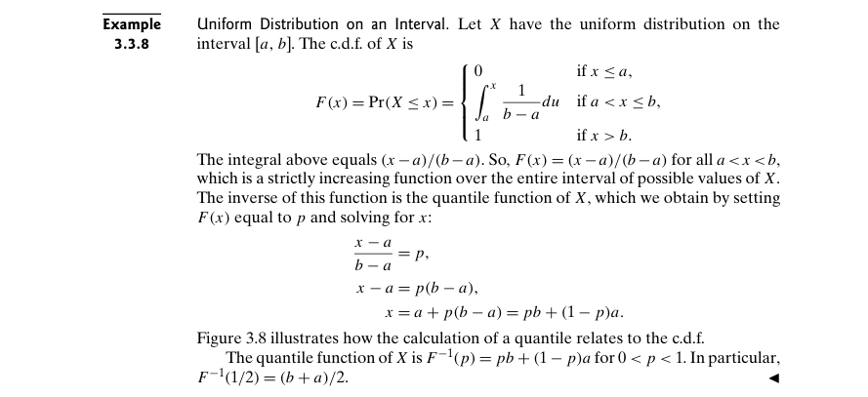

Example 3.3.9 – Codable

Example 3.3.10 – Codable

Example 3.4.1 – Non-Codable (Reason: Example with already computed results)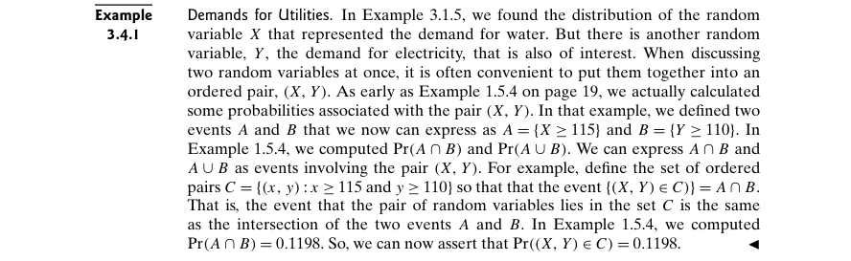

Example 3.4.2 – Non-Codable (Reason: Example with no computation)

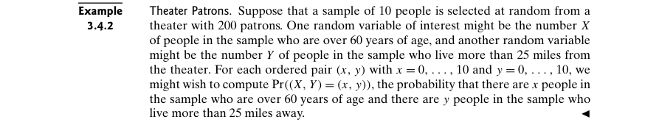

Example 3.4.3 – Codable

Example 3.4.4 – Non-Codable (Reason: Final result is in integration by a variable)

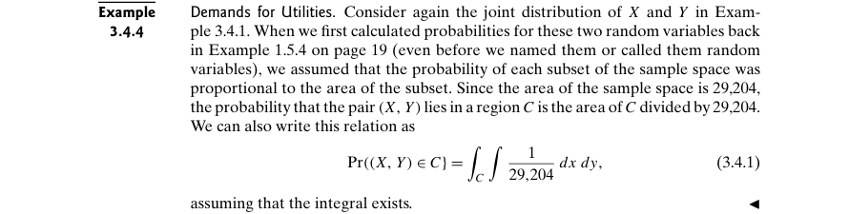

Example 3.4.5 – Non-Codable (Reason: Example with no computation)

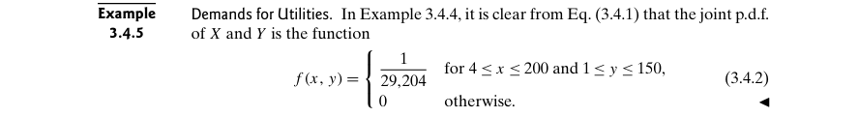

Example 3.4.6 – Non-Codable (Reason: Example with no computation)

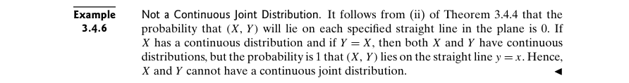

Example 3.4.7 – Codable

Example 3.4.8 – Codable

Example 3.4.9 – Codable

Example 3.4.10 – Non-Codable (Reason: Example with no computation)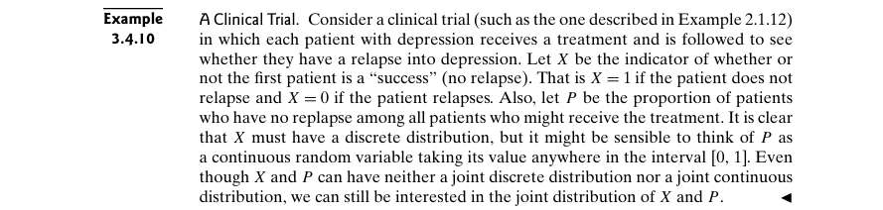

Example 3.4.11 – Codable

Example 3.4.12 – Codable

Example 3.4.13 – Non-Codable (Reason: Example with no computation)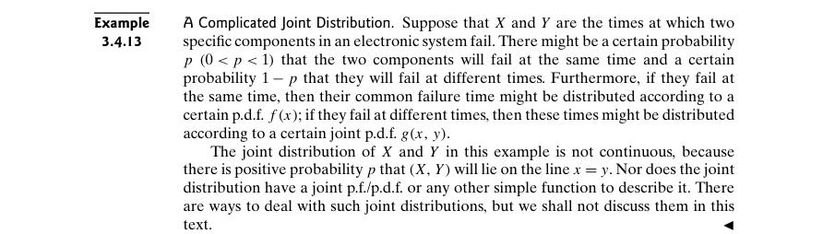

Example 3.4.14 – Non-Codable (Reason: Example with no scope of computation)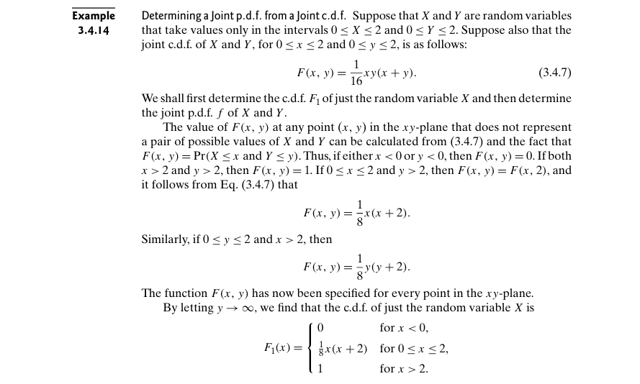

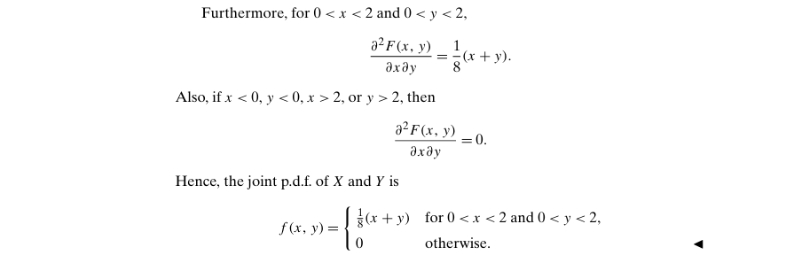

Example 3.4.15 – Non-Codable (Reason: Integrals are limited by variables)

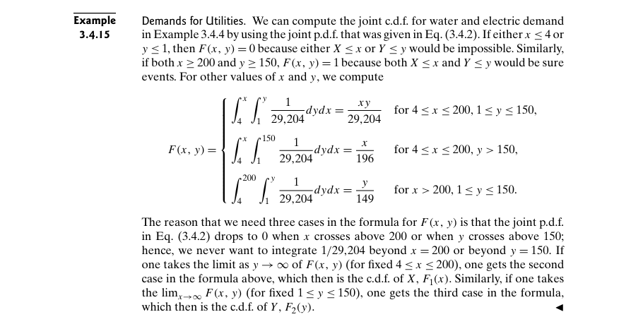

Example 3.5.1 – Non-Codable (Reason: Example with no scope of computation)

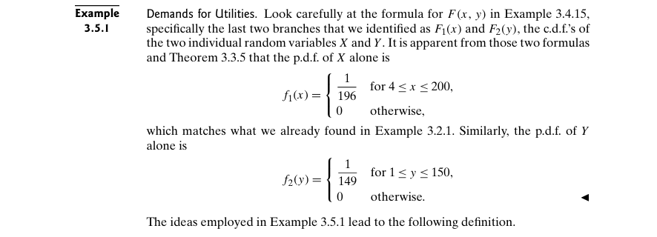

Example 3.5.2 – Codable

Example 3.5.3 – Non-Codable (Reason: Final answers are multiples of variables)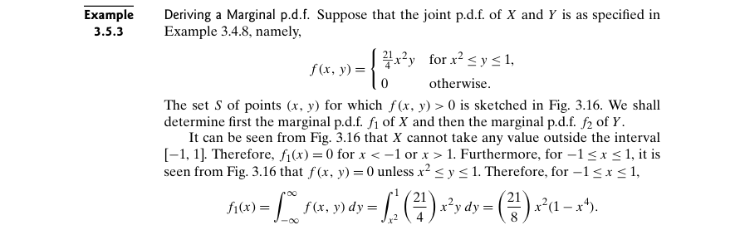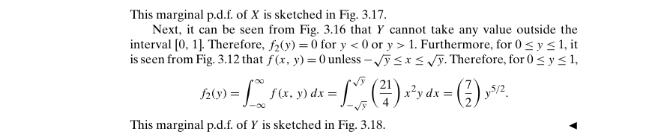

Example 3.5.4 – Codable

Example 3.5.5 – Non-Codable (Reason: Example with no computation)

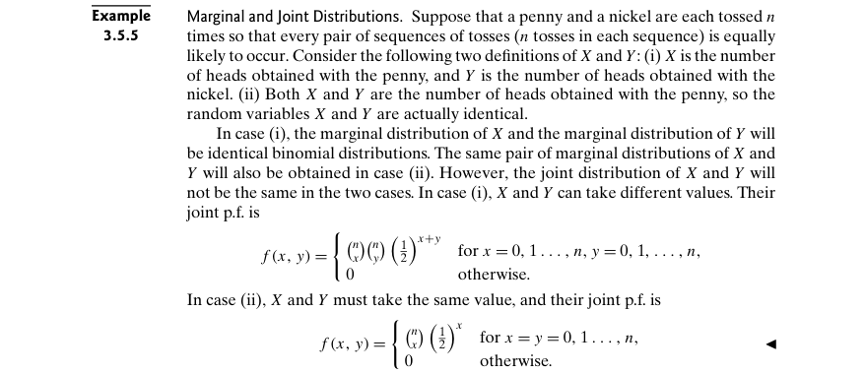

Example 3.5.6 – Non-Codable (Reason: Example with no computation)

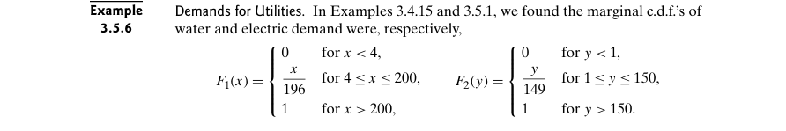

Example 3.5.7 – Codable

Example 3.5.8 – Codable

Example 3.5.9 – Codable

Example 3.5.10 – Non-Codable (Reason: Example with no computation)

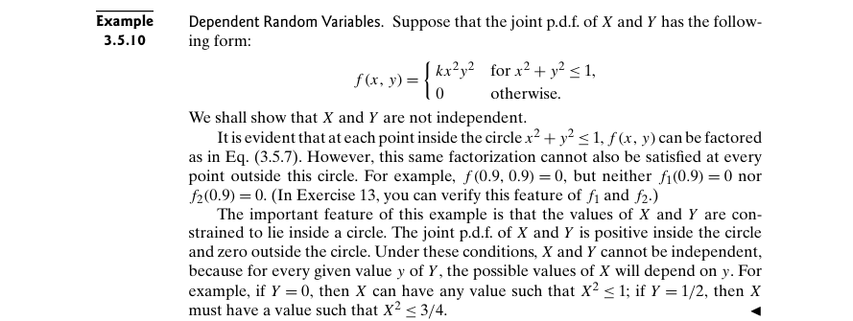

Example 3.5.11 – Codable

Example 3.6.1 – Codable

Example 3.6.2 – Codable

Example 3.6.3 – Non-Codable (Reason: No scope of computation)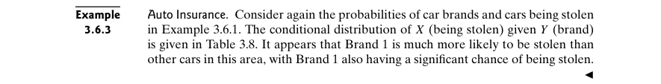

Example 3.6.4 – Non-Codable (Reason: Example with no computation)

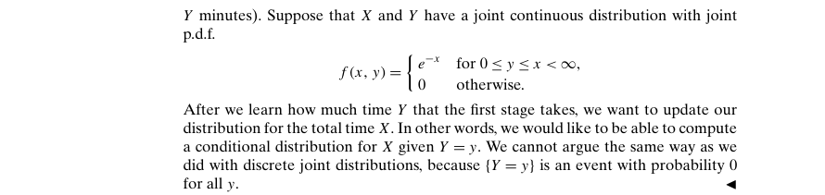

Example 3.6.5 – Codable

Example 3.6.6 – Codable

Example 3.6.7 – Non-Codable (Reason: Results are in variable format)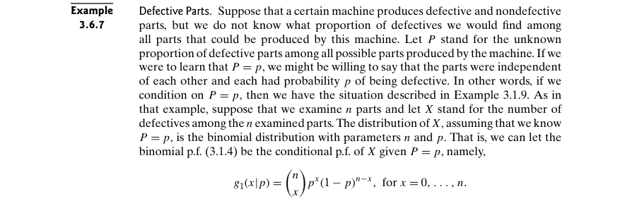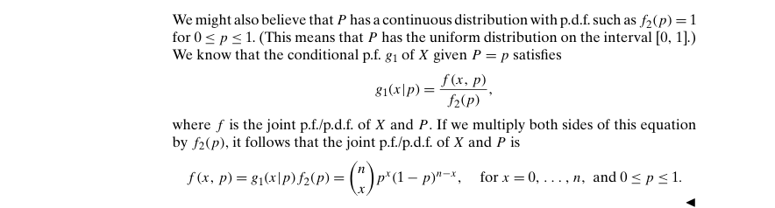

Example 3.6.8 – Non-Codable (Reason: Example with no computation)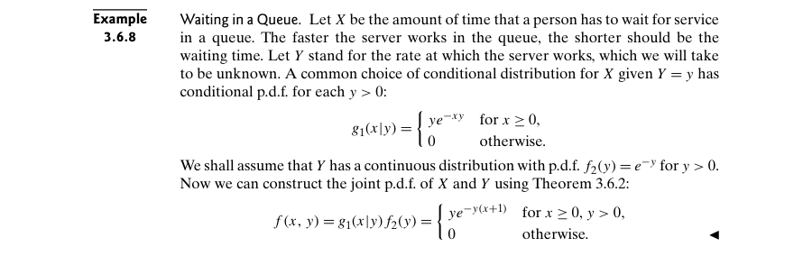

Example 3.6.9 – Codable

Example 3.6.10 – Codable

Example 3.7.1 – Non-Codable (Reason: Results are in variable form)

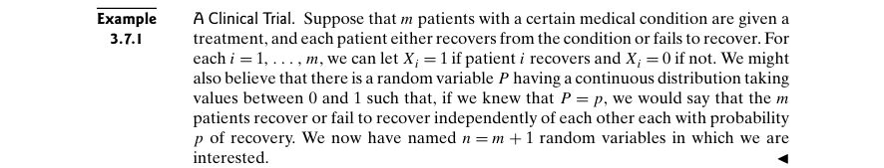

Example 3.7.2 – Non-Codable (Reason: Example with no computation)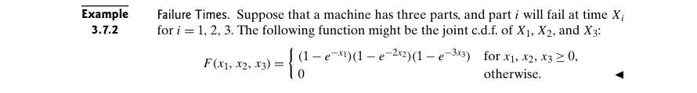

Example 3.7.3 – Non-Codable (Reason: Example with no computation)

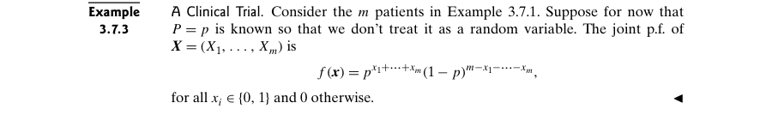

Example 3.7.4 – Non-Codable (Reason: Example with no computation)

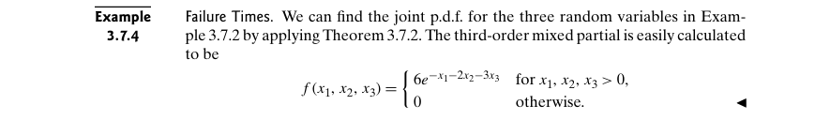

Example 3.7.5 – Non-Codable (Reason: The final result is variables)

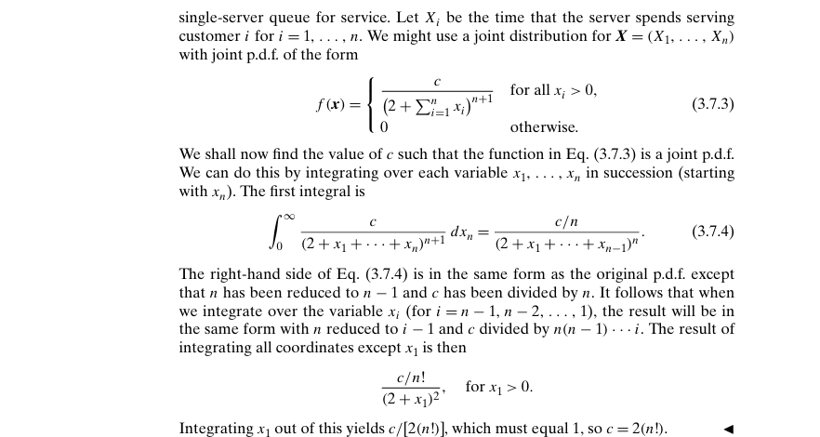

Example 3.7.6 – Non-Codable (Reason: Example with no computation)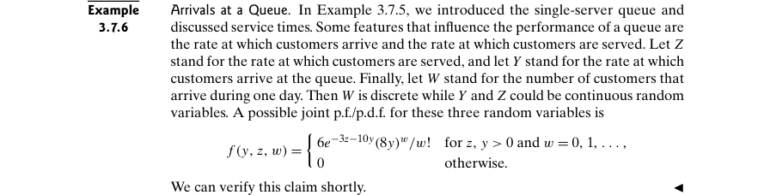

Example 3.7.7 – Codable

Example 3.7.8 – Codable

Example 3.7.9 – Codable

Example 3.7.10 – Non-Codable (Reason: Result is in variable expression)



Example 3.7.11 – Non-Codable (Reason: Result is in variable expression)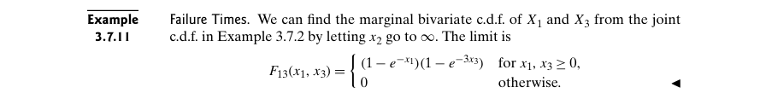

Example 3.7.12 – Non-Codable (Reason: Example with no computation)

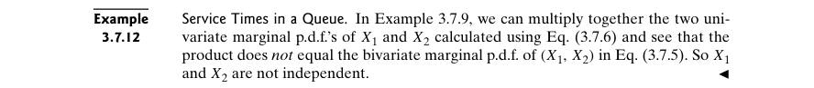

Example 3.7.13 – Non-Codable (Reason: Result is in variable format)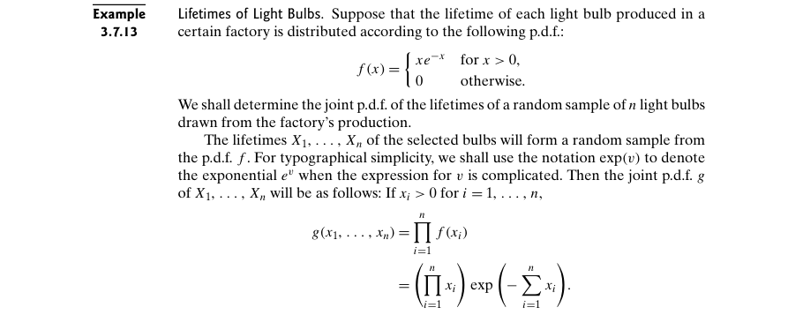

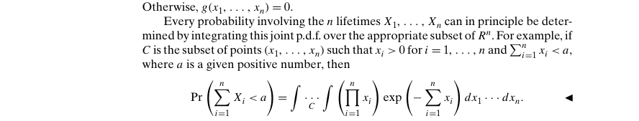

Example 3.7.14 – Codable

Example 3.7.15 – Codable

Example 3.7.16 – Codable

Example 3.7.17 – Non-Codable (Reason: Theoretical example for a definition)

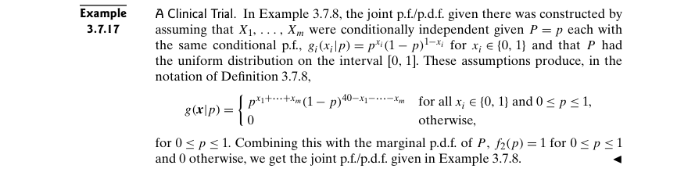

Example 3.7.18 – Non-Codable (Reason: No scope of computation)

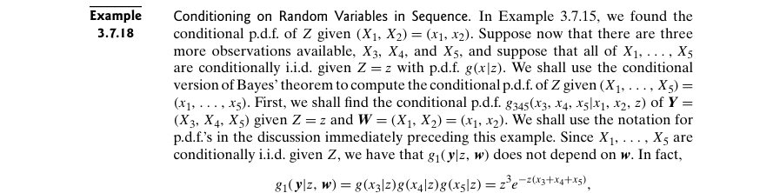

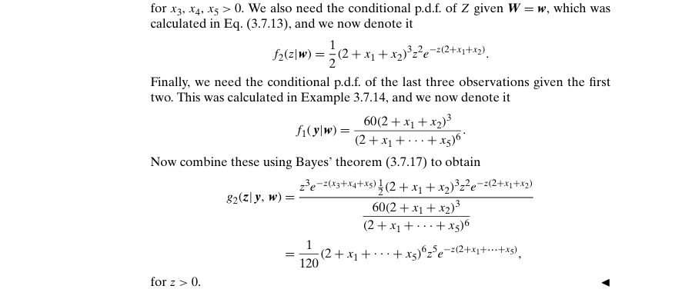

Example 3.7.19 – Codable

Example 3.7.20 – Codable

Example 3.8.1 – Codable

Example 3.8.2 – Codable

Example 3.8.3 – Non-Codable (Reason: Example with no computation)

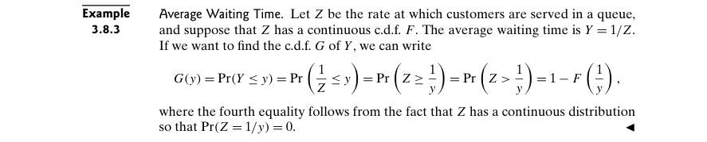

Example 3.8.4 – Codable

Example 3.8.5 – Non-Codable (Reason: Result is in variable expression)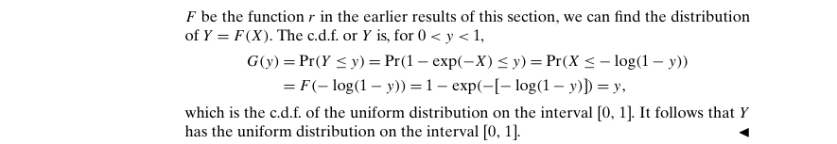

Example 3.8.6 – Codable

Example 3.8.7 – Non-Codable (Reason: Result is in variable expression)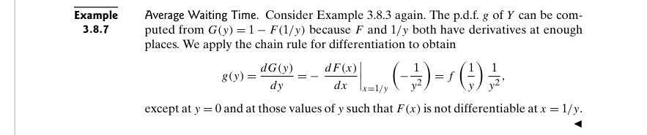

Example 3.8.8 – Non-Codable (Reason: No scope of computation)

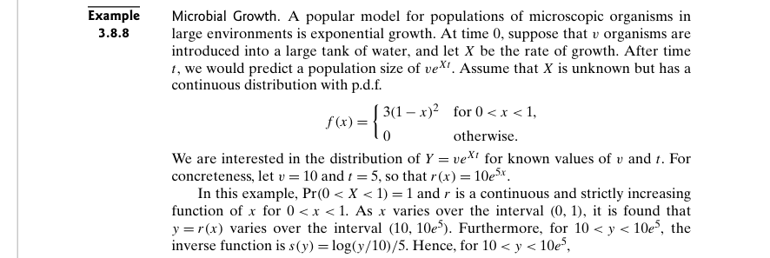



Example 3.9.1 – Non-Codable (Reason: No scope of computation)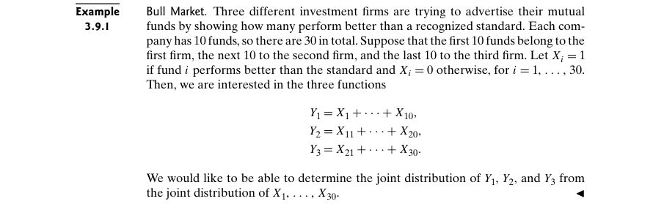

Example 3.9.2 – Codable

Example 3.9.3 – Non-Codable (Reason: Example with no computation)

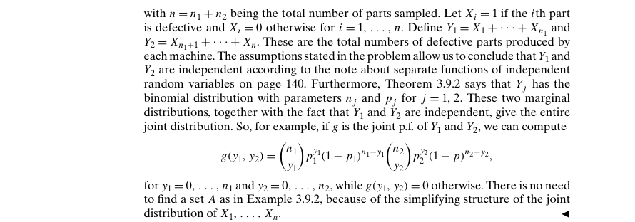

Example 3.9.4 – Non-Codable (Reason: Results are in variable expression)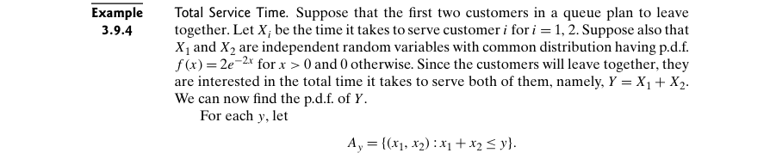

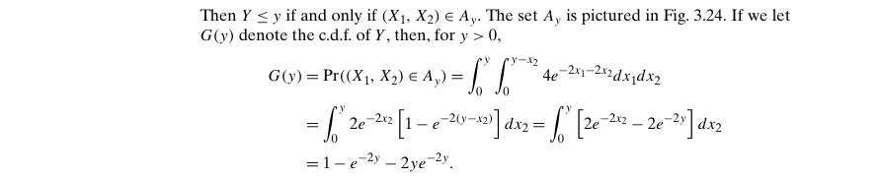



Example 3.9.5 – Codable

Example 3.9.6 – Codable

Example 3.9.7 – Non-Codable (Reason: Results are in variable format)

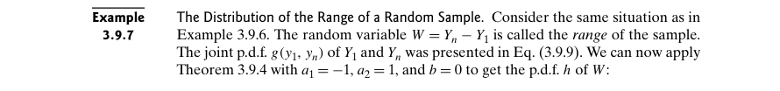

Example 3.9.8 – Non-Codable (Reason: Figure already computed in the previous example 3.9.6)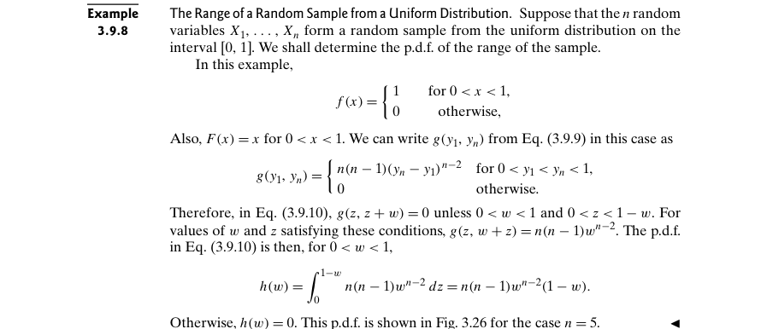

Example 3.9.9 – Non-Codable (Reason: No scope of computation)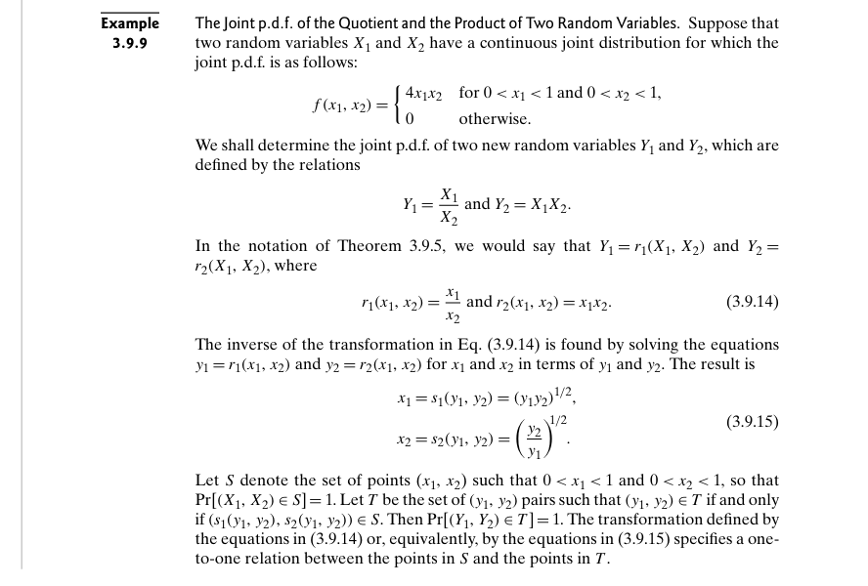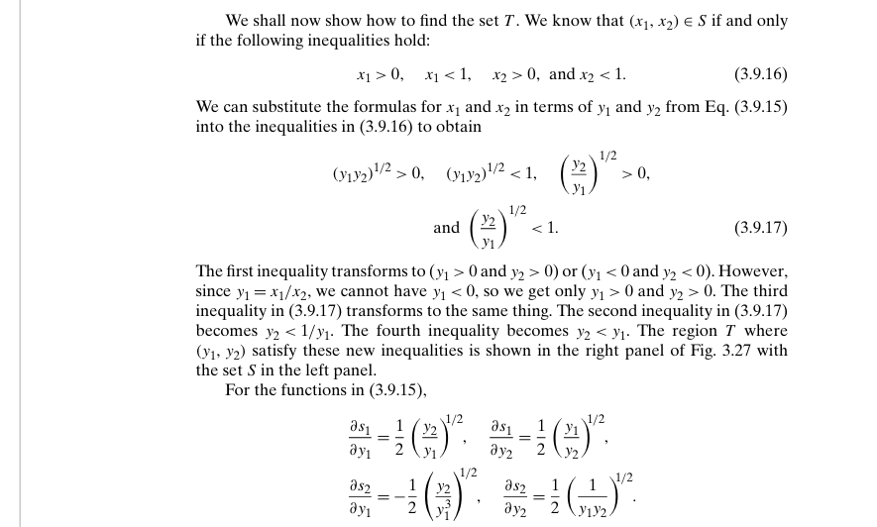

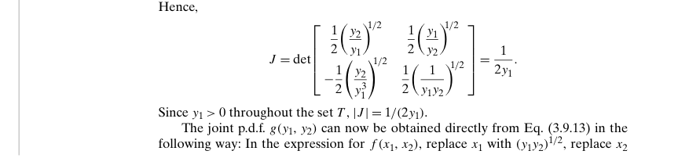

Example 3.9.10 – Non-Codable (Reason: No scope of computation)

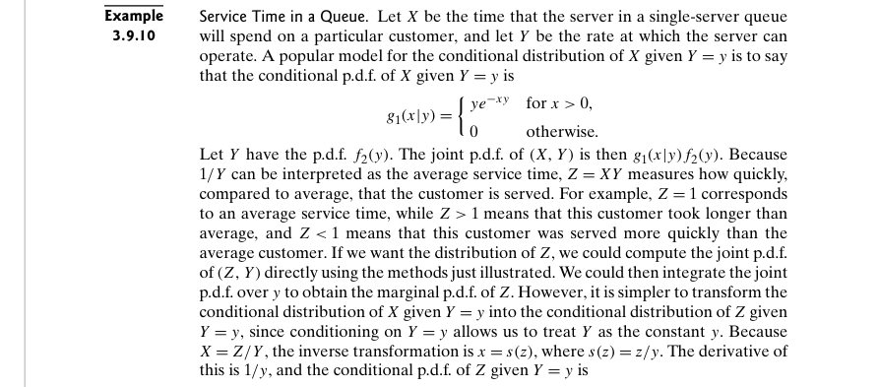

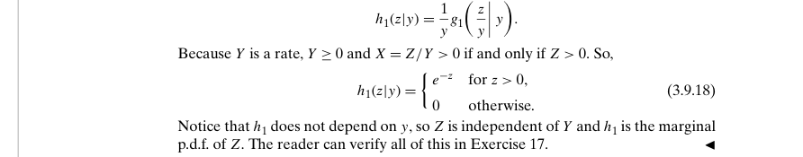

Example 3.9.11 – Non-Codable (Reason: No scope of computation)

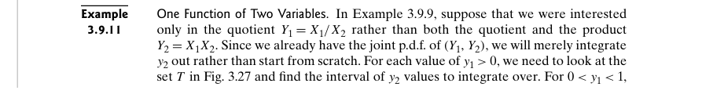

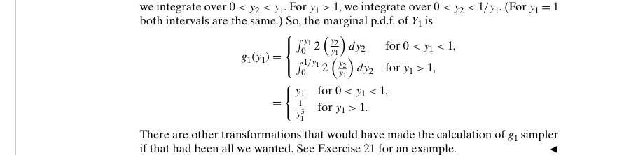

Example 3.10.1 – Non-Codable (Reason: Example with no computation)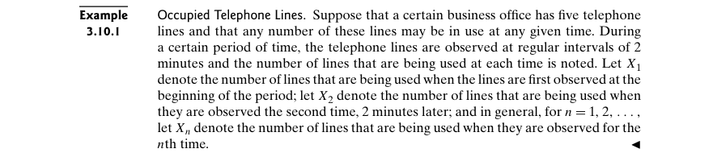

Example 3.10.2 – Codable

Example 3.10.3 – Non-Codable (Reason: Example with no computation)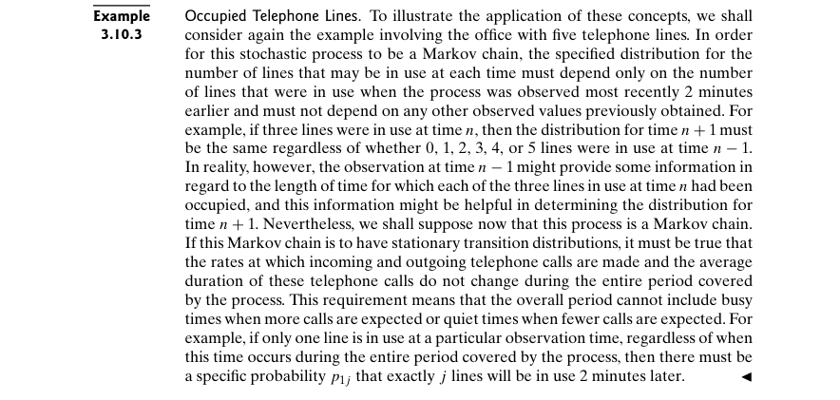

Example 3.10.4 – Codable

Example 3.10.5 – Codable

Example 3.10.6 – Codable

Example 3.10.7 – Codable

Example 3.10.8 – Codable

Example 3.10.9 – Codable

Example 3.10.10 – Codable

Example 3.10.11 – Codable

Example 3.10.12 – Codable

Example 3.10.13 – Non-Codable (Reason: No scope of computation)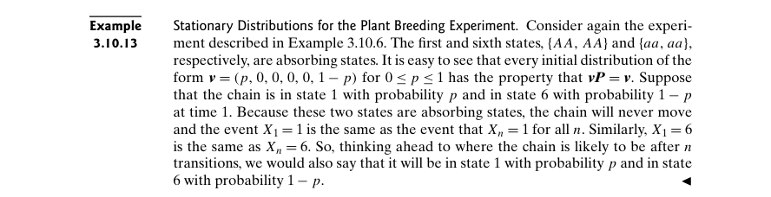

Example 3.10.14 – Codable

Example 3.10.15 – Codable

Example 3.10.16 – Non-Codable (Reason: Example with no scope of computation)

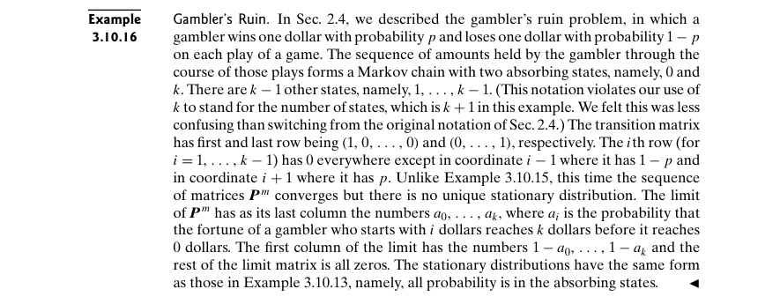

**Chapter 4: Expectation**

Example 4.1.1 – Non-Codable (Reason: Example with no scope of computation)

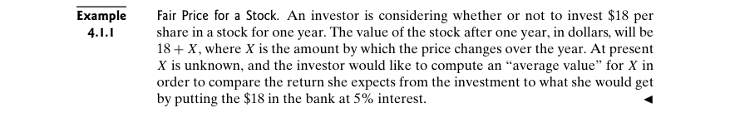

Example 4.1.2 – Codable

Example 4.1.3 – Non-Codable (Reason: Theoretical example for proving a concept)

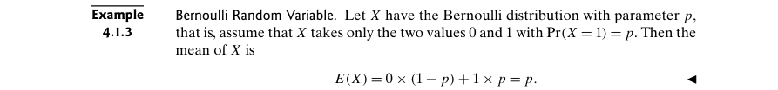

Example 4.1.4 – Non-Codable (Reason: The result is in infinity)

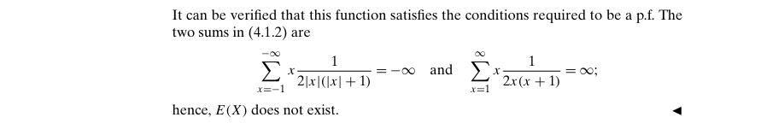

Example 4.1.5 – Non-Codable (Reason: Final result is in infinity)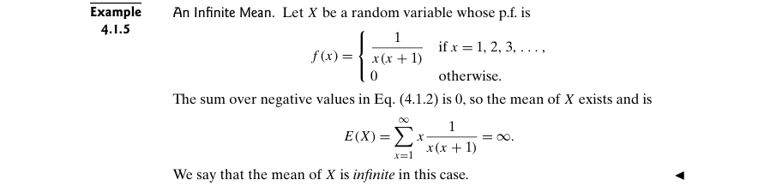

Example 4.1.6 – Codable

Example 4.1.7 – Codable

Example 4.1.8 – Non-Codable (Reason: Final results are in infinity)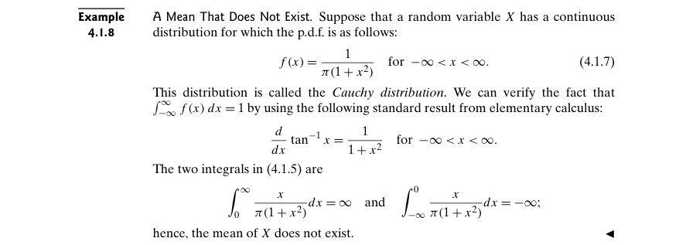

Example 4.1.9 – Codable

Example 4.1.10 – Non-Codable (Reason: Example with no computation)

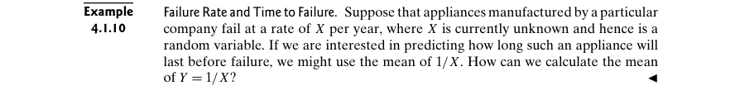

Example 4.1.11 – Codable

Example 4.1.12 – Codable

Example 4.1.13 – Codable

Example 4.1.14 – Codable

Example 4.1.15 – Non-Codable (Reason: Example with no scope of computation)



Example 4.1.16 – Codable

Example 4.2.1 – Codable

Example 4.2.2 – Codable

Example 4.2.3 – Codable

Example 4.2.4 – Non-Codable (Reason: Results are in variable expressions)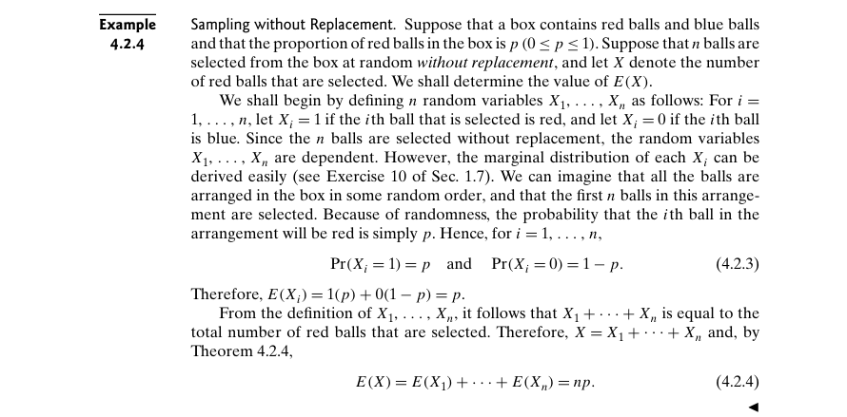

Example 4.2.5 – Non-Codable (Reason: Results are in variable expressions)

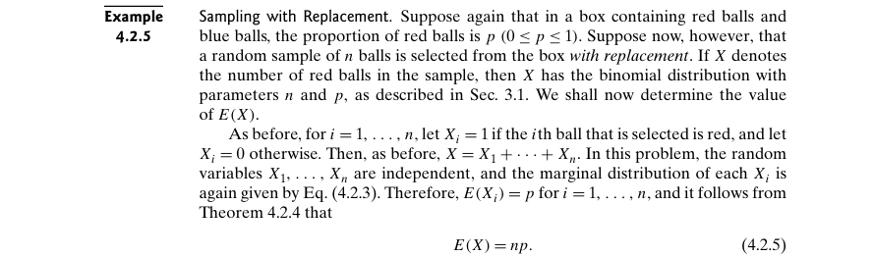

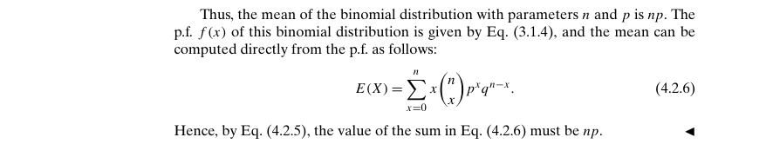

Example 4.2.6 – Codable

Example 4.2.7 – Codable

Example 4.2.8 – Codable

Example 4.2.9 – Non-Codable (Reason: Results are in the form of variables)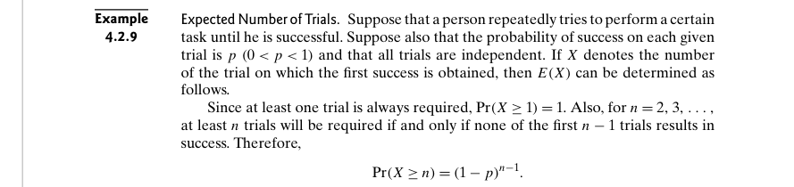



Example 4.2.10 – Codable

Example 4.3.1 – Codable

Example 4.3.2 – Codable

Example 4.3.3 – Codable

Example 4.3.4 – Codable

Example 4.3.5 – Codable

Example 4.3.6 – Codable

Example 4.3.7 – Codable

Example 4.3.8 – Non-Codable (Reason: Example with no computation)

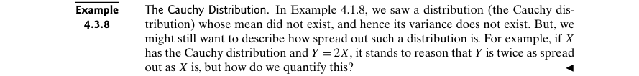

Example 4.3.9 – Codable

Example 4.4.1 – Non-Codable (Reason: Example with no scope of computation)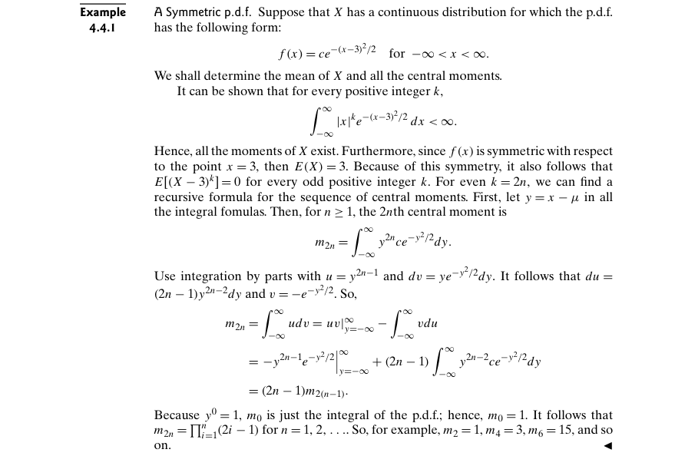

Example 4.4.2 – Codable

Example 4.4.3 – Codable

Example 4.4.4 – Non-Codable (Reason: Example with no scope of computation)

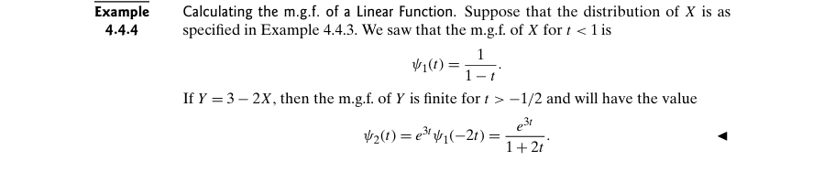

Example 4.5.1 – Codable

Example 4.5.2 – Codable

Example 4.5.3 – Codable

Example 4.5.4 – Non-Codable (Reason: Example with no scope of computation)

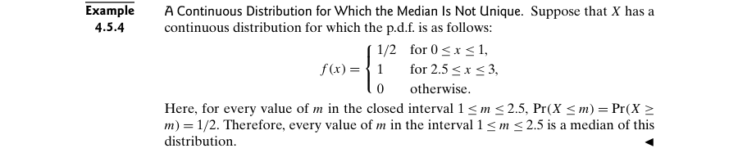

Example 4.5.5 – Non-Codable (Reason: Example with no scope of computation)

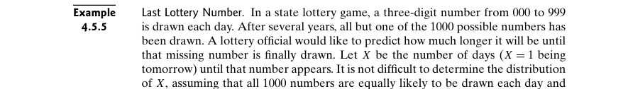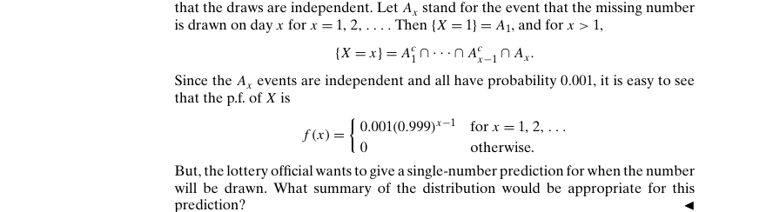

Example 4.5.6 – Non-Codable (Reason: Example with no scope of computation)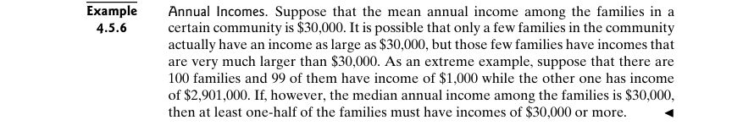

Example 4.5.7 – Codable

Example 4.5.8 – Codable

Example 4.5.9 – Codable

Example 4.6.1 – Non-Codable (Reason: Example with no computation)

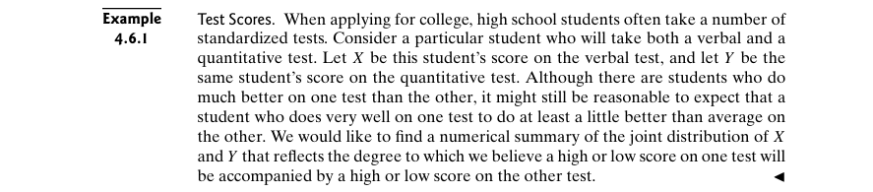

Example 4.6.2 – Codable

Example 4.6.3 – Codable

Example 4.6.4 – Codable

Example 4.6.5 – Codable

Example 4.6.6 – Non-Codable (Reason: Results are in terms of variables)

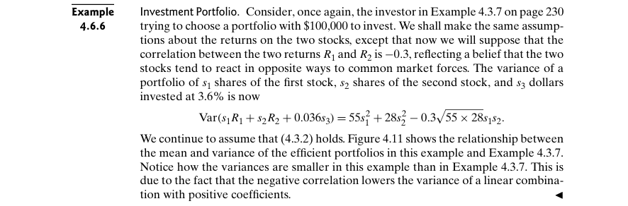

Example 4.7.1 – Non-Codable (Reason: Example with no computation)

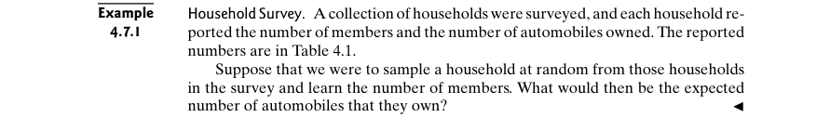

Example 4.7.2 – Codable

Example 4.7.3 – Non-Codable (Reason: No scope of computation)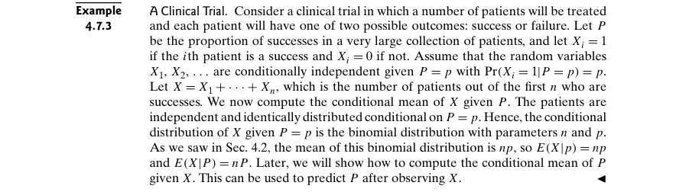

Example 4.7.4 – Codable

Example 4.7.5 – Non-Codable (Reason: Results are in terms of variables)

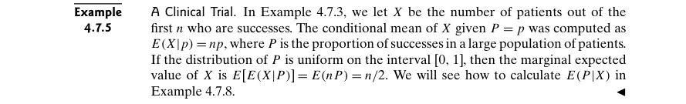

Example 4.7.6 – Codable

Example 4.7.7 – Non-Codable (Reason: No scope of computation)

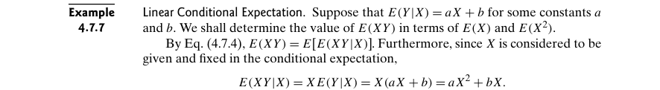

Example 4.7.8 – Codable

Example 4.8.1 – Codable

Example 4.8.2 – Codable

Example 4.8.3 – Codable

Example 4.8.4 – Codable

Example 4.8.5 – Codable

Example 4.8.6 – Codable

Example 4.8.7 – Codable

Example 4.8.8 – Non-Codable (Reason: No scope of computation)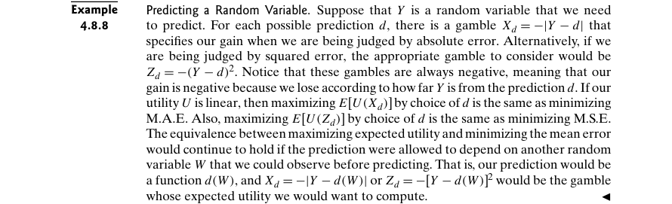

Example 4.8.9 – Codable

Example 4.8.10 – Codable

**Chapter 5: Special Distributions**

Example 5.2.1 – Non-Codable (Reason: No scope of computation)

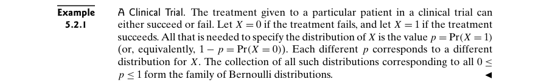

Example 5.2.2 – Non-Codable (Reason: Example with no scope of computation)



Example 5.2.3 – Non-Codable (Reason: No scope of computation)

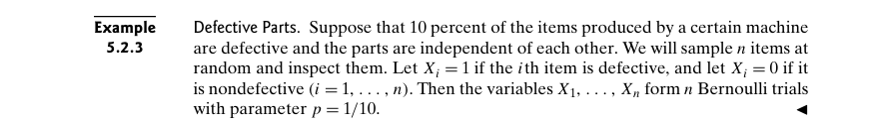

Example 5.2.4 – Non-Codable (Reason: Example with no scope of computation)

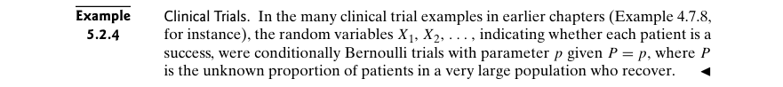

Example 5.2.5 – Non-Codable (Reason: No scope of computation)



Example 5.2.6 – Non-Codable (Reason: No scope of computation)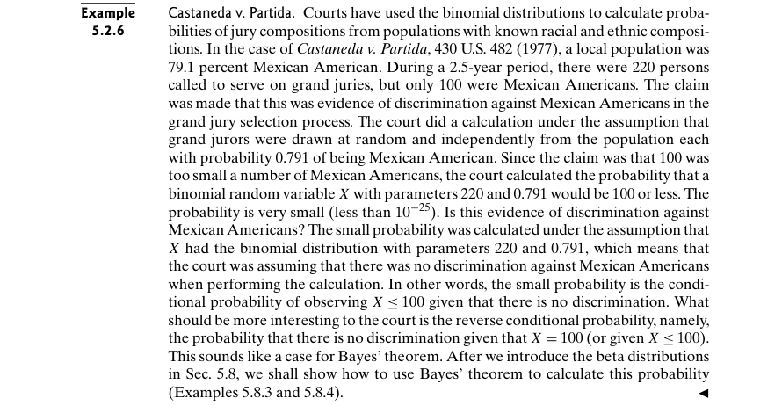

Example 5.2.7 – Codable

Example 5.3.1 – Non-Codable (Reason: Expressions are in variable format)

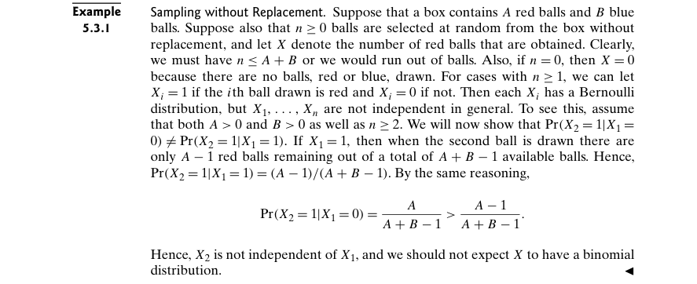

Example 5.3.2 – Non-Codable (Reason: Example with no computation)

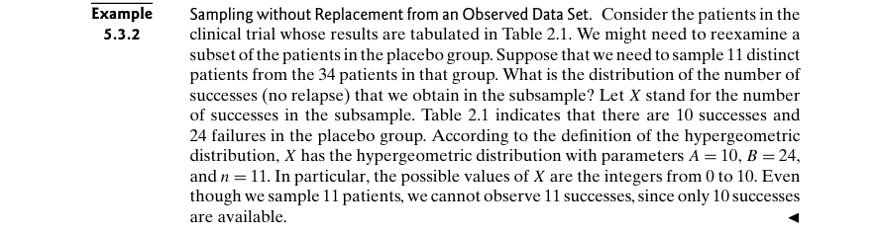

Example 5.3.3 – Non-Codable (Reason: No scope of computation)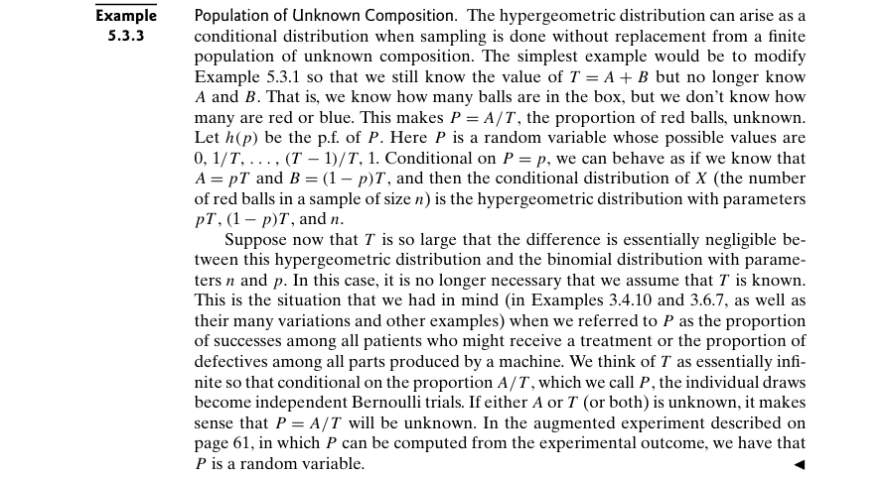

Example 5.4.1 – Non-Codable (Reason: The results are in terms of a variable)

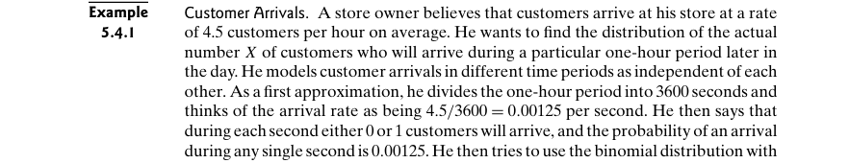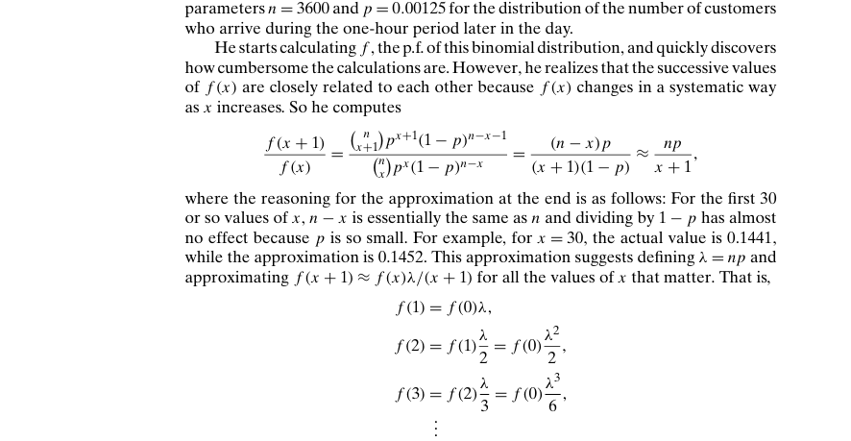

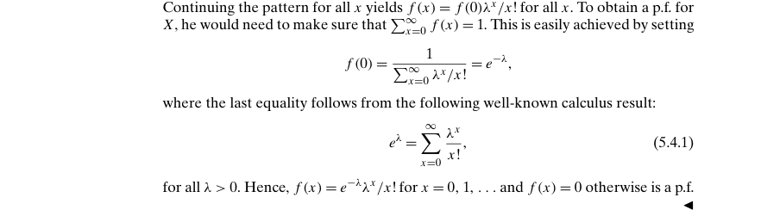

Example 5.4.2 – Codable

Example 5.4.3 – Codable

Example 5.4.4 – Codable

Example 5.4.5 – Non-Codable (Reason: Example with no computation)

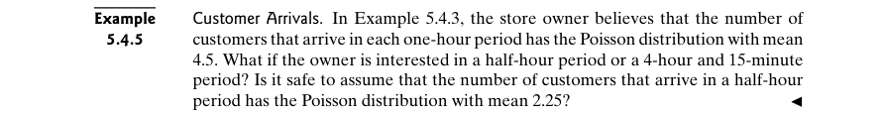

Example 5.4.6 – Codable

Example 5.4.7 – Codable

Example 5.5.1 – Non-Codable (Reason: Example with no computation)

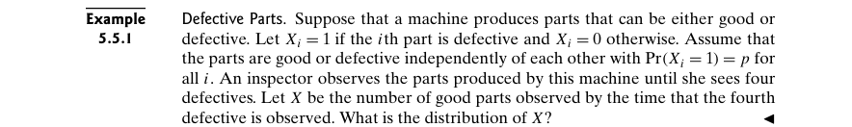

Example 5.5.2 – Non-Codable (Reason: Example with no computation)

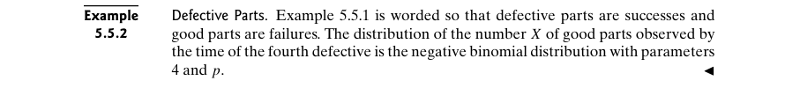

Example 5.5.3 – Codable

Example 5.5.4 – Codable

Example 5.5.5 – Non-Codable (Reason: Results are in variable format)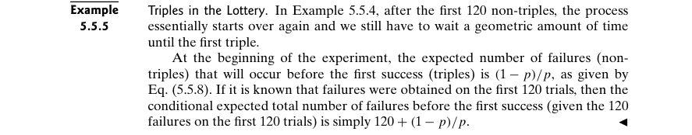

Example 5.6.1 – Non-Codable (Reason: Example unable to be computed from figure)

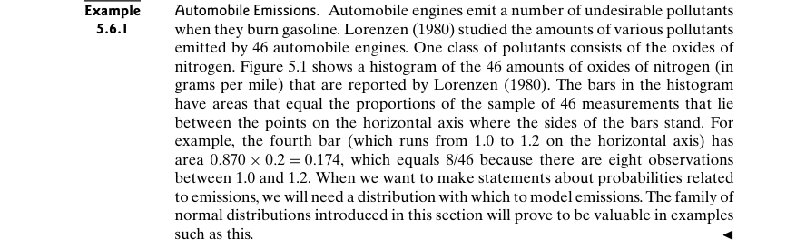

Example 5.6.2 – Non-Codable (Reason: Data not available)

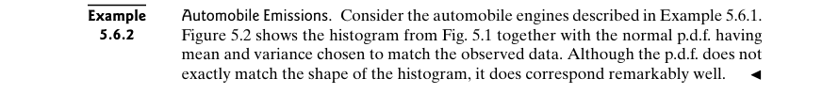

Example 5.6.3 – Non-Codable (Reason: Theoretical example to introduce a formula)

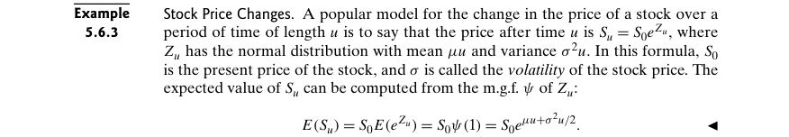

Example 5.6.4 – Codable

Example 5.6.5 – Codable

Example 5.6.6 – Codable

Example 5.6.7 – Codable

Example 5.6.8 – Codable

Example 5.6.9 – Codable

Example 5.6.10 – Codable

Example 5.7.1 – Non-Codable (Reason: Results are in variable format)

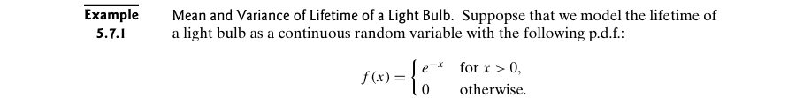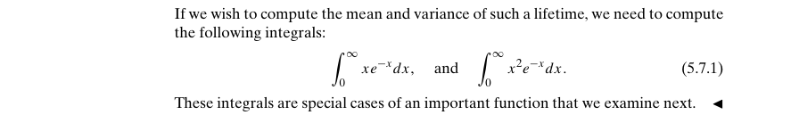

Example 5.7.2 – Codable

Example 5.7.3 – Non-Codable (Reason: Results are in variable format)



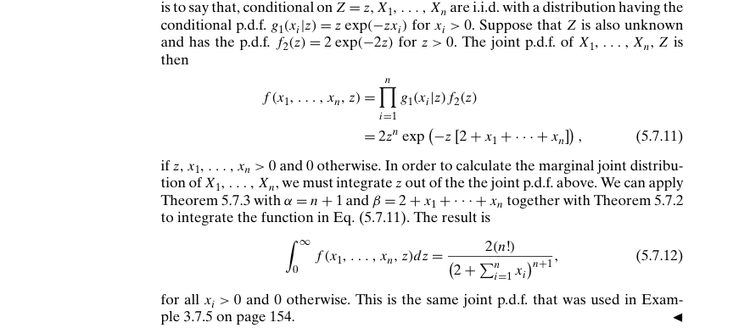

Example 5.7.4 – Non-Codable (Reason: Example with no computation)

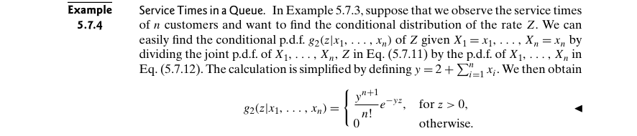

Example 5.7.5 – Non-Codable (Reason: Example with no computation)



Example 5.7.6 – Non-Codable (Reason: Example with no computation)

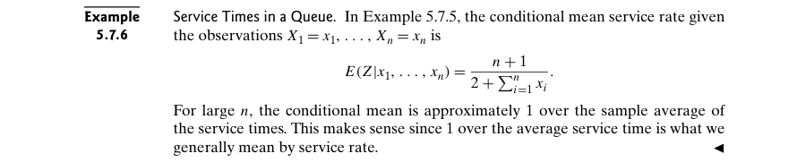

Example 5.7.7 – Non-Codable (Reason: Example with no computation)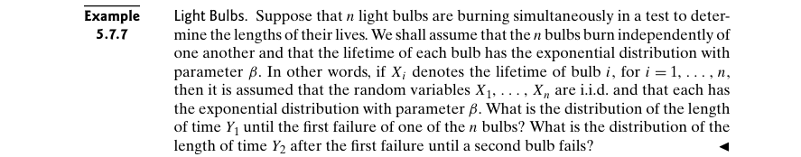

Example 5.7.8 – Non-Codable (Reason: Example with no computation)



Example 5.8.1 – Non-Codable (Reason: Example with no computation)

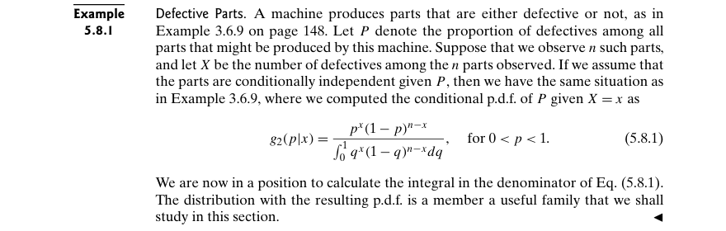

Example 5.8.2 – Non-Codable (Reason: Example with no scope of computation)

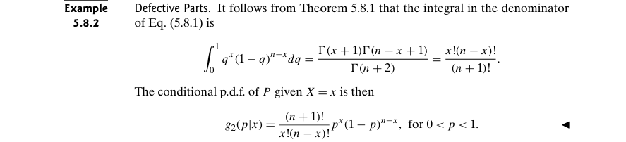

Example 5.8.3 – Non-Codable (Reason: Results are given as variable expressions)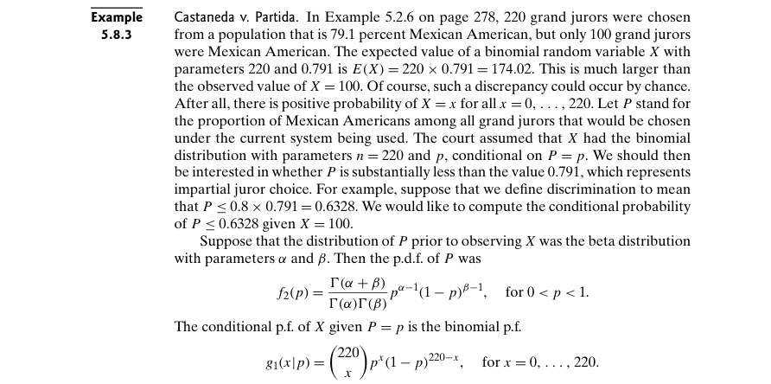

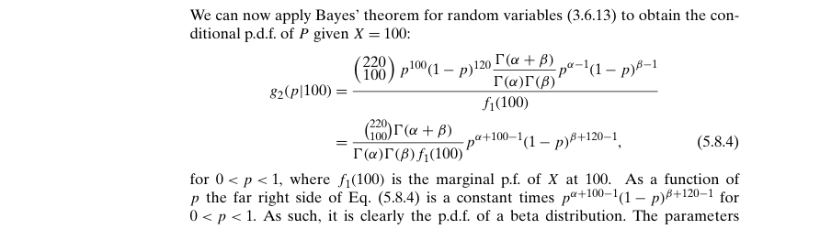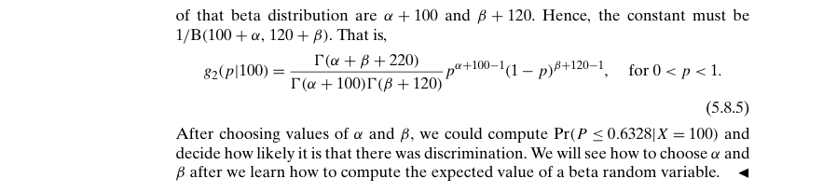

Example 5.8.4 – Codable

Example 5.8.5 – Codable

Example 5.9.1 – Non-Codable (Reason: Example with no computation)



Example 5.9.2 – Codable

Example 5.9.3 – Codable

Example 5.10.1 – Non-Codable (Reason: Example with no computation)

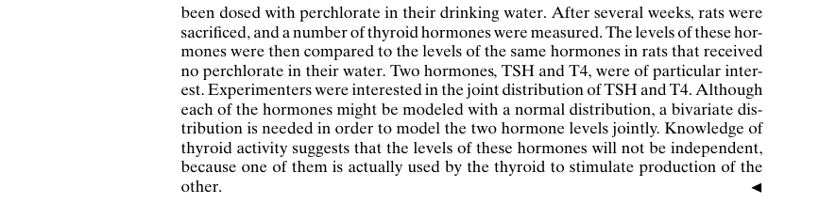

Example 5.10.2 – Non-Codable (Reason: Data used is unavailable)

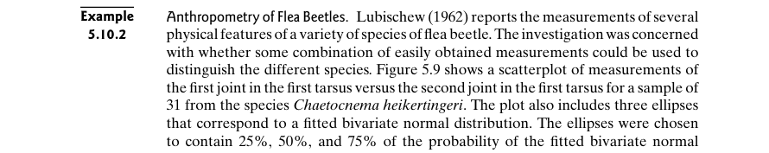

Example 5.10.3 – Non-Codable (Reason: Example with no computation)

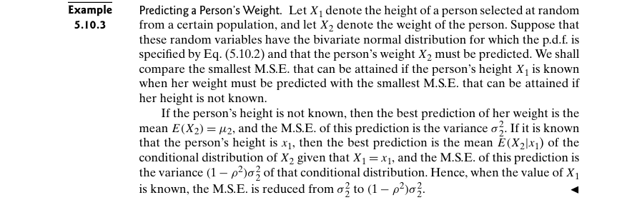

Example 5.10.4 – Non-Codable (Reason: Results are in terms of variables)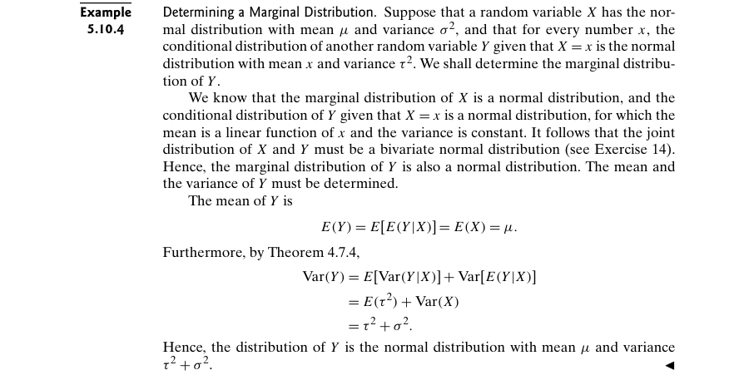

Example 5.10.5 – Non-Codable (Reason: Example with no computation)

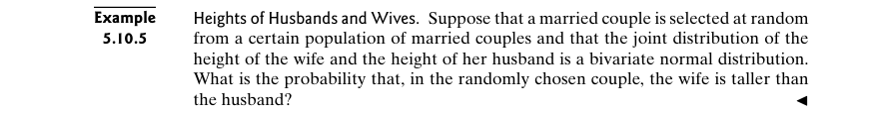

Example 5.10.6 – Codable

**Chapter 6: Large Random Samples**

Example 6.1.1 – Codable

Example 6.1.2 – Non-Codable (Reason: Example with no computation)

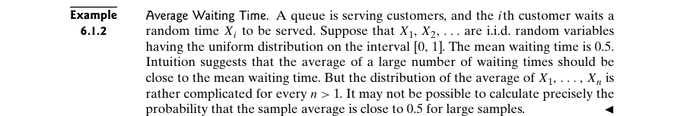

Example 6.2.1 – Codable

Example 6.2.2 – Codable

Example 6.2.3 – Codable

Example 6.2.4 – Codable

Example 6.2.5 – Codable

Example 6.2.6 – Codable

Example 6.2.7 – Non-Codable (Reason: The results are in the format of variable expressions)

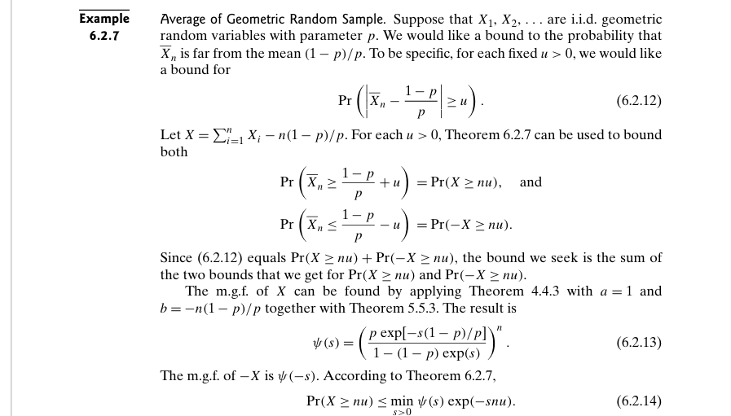

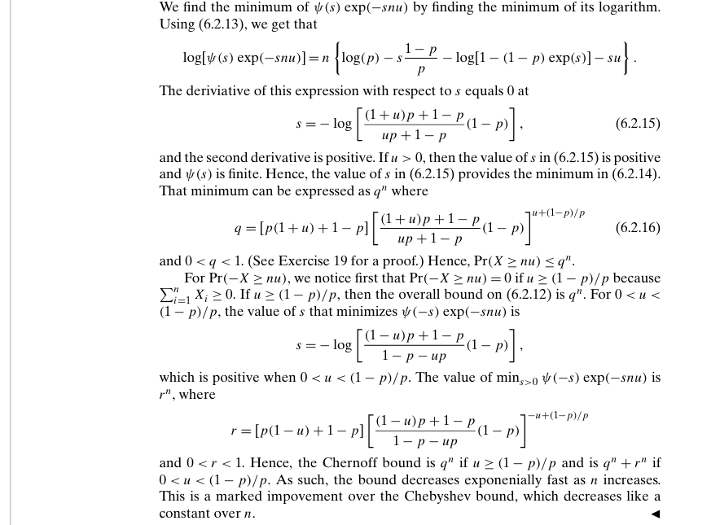

Example 6.3.1 – Codable

Example 6.3.2 – Codable

Example 6.3.3 – Codable

Example 6.3.4 – Non-Codable (Reason: Theoretical example to introduce a concept)

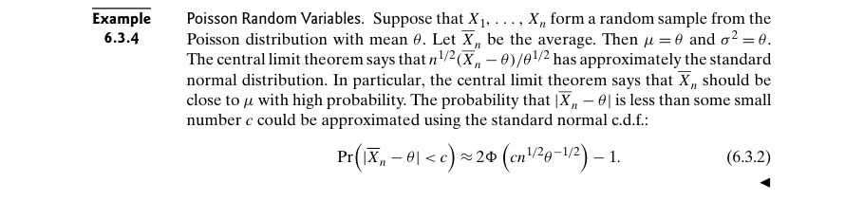

Example 6.3.5 – Codable

Example 6.3.6 – Non-Codable (Reason: Example without any computation)

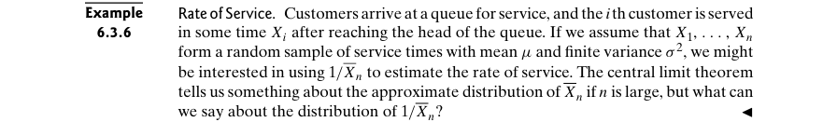

Example 6.3.7 – Non-Codable (Reason: Theoretical example to introduce a concept)

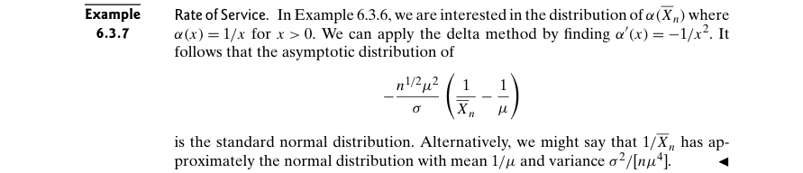

Example 6.3.8 – Non-Codable (Reason: The results are in the format of variable expressions)

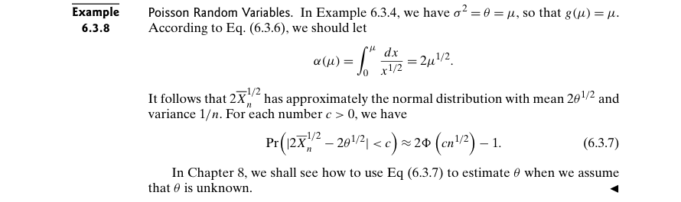

Example 6.3.9 – Codable

Example 6.4.1 – Codable

Example 6.4.2 – Codable

Example 6.4.3 – Codable

Example 6.4.4 – Codable

**Chapter 7: Estimation**

Example 7.1.1 – Non-Codable (Reason: Example to provide understanding of a theoretical concept without any computation)

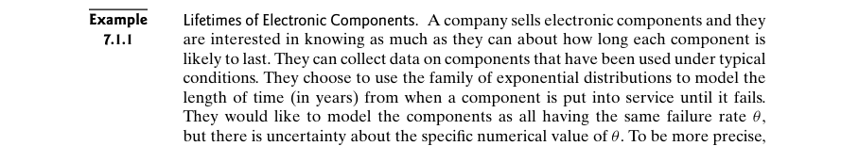

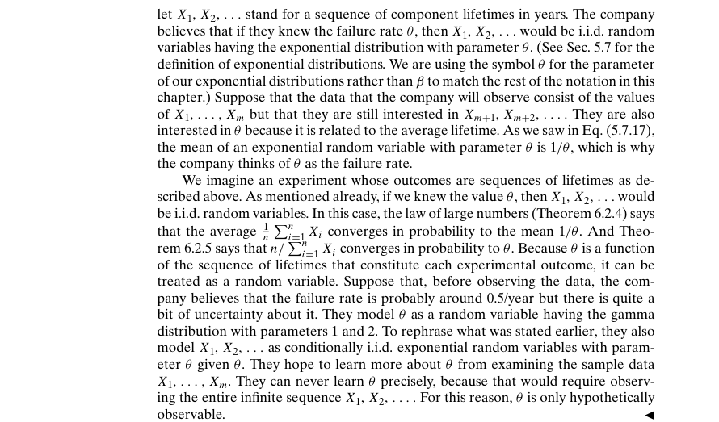

Example 7.1.2 – Non-Codable (Reason: Example without any computation)

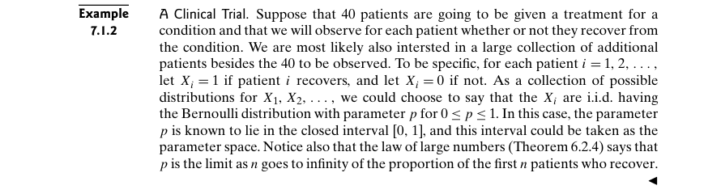

Example 7.1.3 – Non-Codable (Reason: Example without any computation)

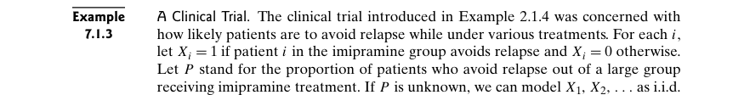

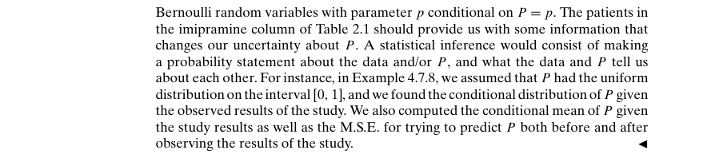

Example 7.1.4 – Non-Codable (Reason: Example without any computation)

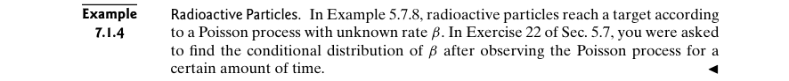

Example 7.1.5 – Non-Codable (Reason: Example to introduce a concept stating a previous example)

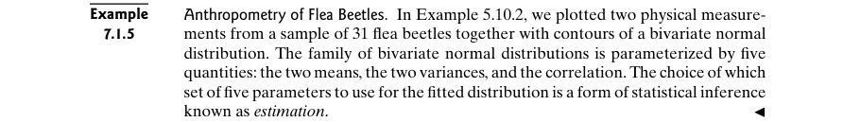

Example 7.1.6 – Non-Codable (Reason: Example coded in a previous example)

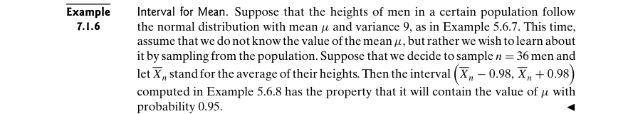

Example 7.1.7 – Non-Codable (Reason: Example without any computation)

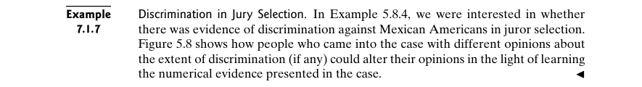

Example 7.1.8 – Non-Codable (Reason: Example without any computation)

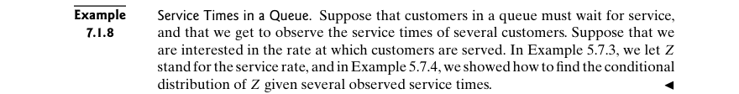

Example 7.1.9 – Non-Codable (Reason: Example without any computation)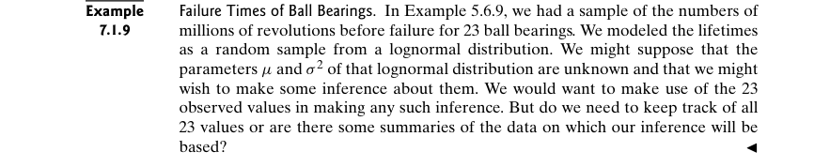

Example 7.1.10 – Non-Codable (Reason: Example to prove a statement. Actual data not available.)

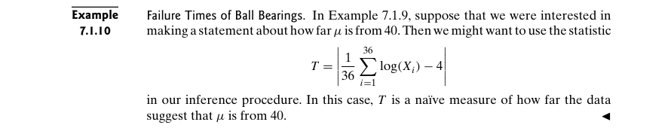

Example 7.1.11 – Non-Codable (Reason: Example without any computation)



Example 7.1.12 – Non-Codable (Reason: Theoretical example)

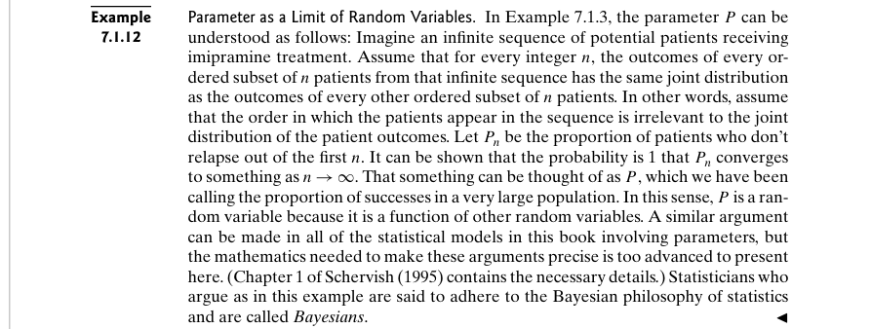

Example 7.2.1 – Non-Codable (Reason: Example without any computation)

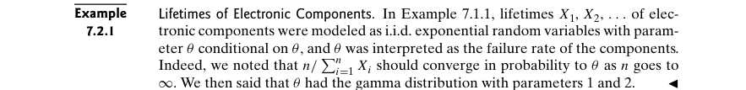

Example 7.2.2 – Non-Codable (Reason: Example without any computation)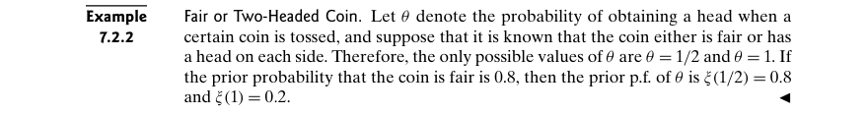

Example 7.2.3 – Non-Codable (Reason: Example without any computation)

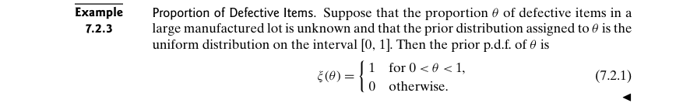

Example 7.2.4 – Non-Codable (Reason: Example without any computation)

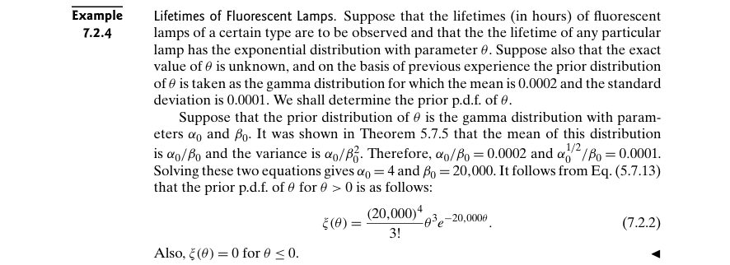

Example 7.2.5 – Non-Codable (Reason: Example without any computation)

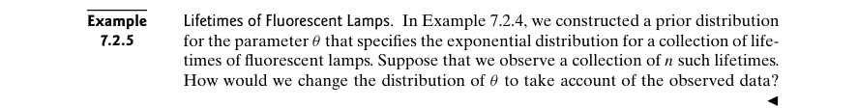

Example 7.2.6 – Codable

Example 7.2.7 – Non-Codable (Reason: Example with no scope of computation)

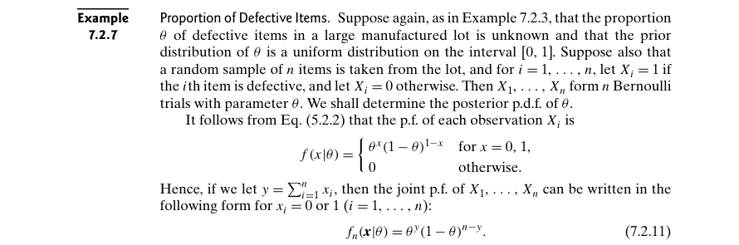

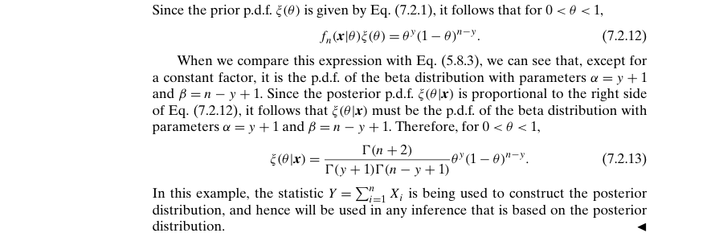

Example 7.2.8 – Codable

Example 7.3.1 – Non-Codable (Reason: Example with no computation)

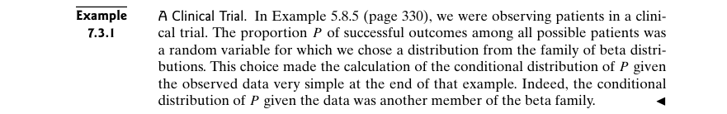

Example 7.3.2 – Non-Codable (Reason: Results are in terms of variables)

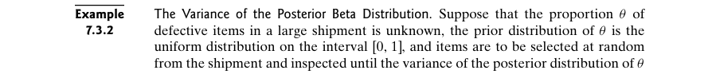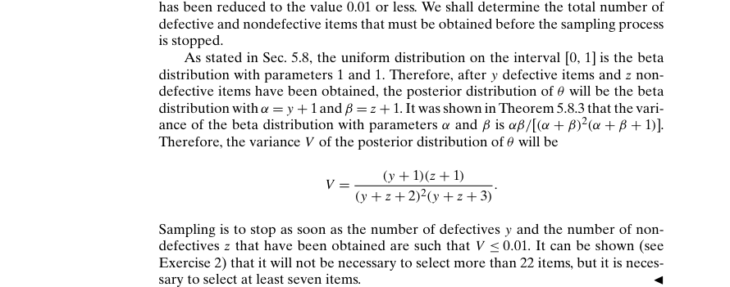

Example 7.3.3 – Codable

Example 7.3.4 – Non-Codable (Reason: Example with no computation)



Example 7.3.5 – Non-Codable (Reason: Example with no computation)

Example 7.3.6 – Non-Codable (Reason: Results are in variable expression)

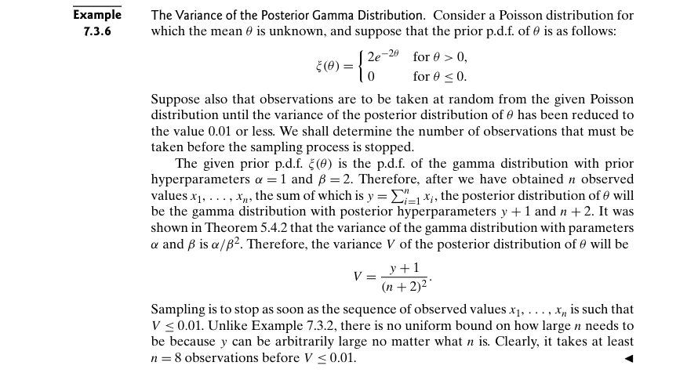

Example 7.3.7 – Non-Codable (Reason: Example with no scope of computation)

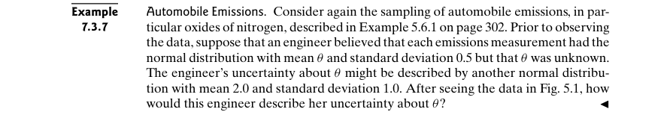

Example 7.3.8 – Codable

Example 7.3.9 – Non-Codable (Reason: Results are in variable expression)

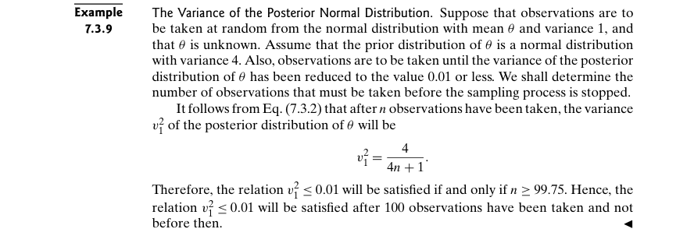

Example 7.3.10 – Codable

Example 7.3.11 – Non-Codable (Reason: Example with no scope of computation)

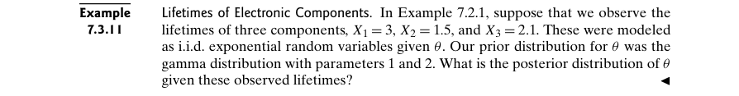

Example 7.3.12 – Codable

Example 7.3.13 – Non-Codable (Reason: Example with no scope of computation)

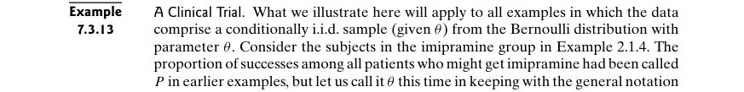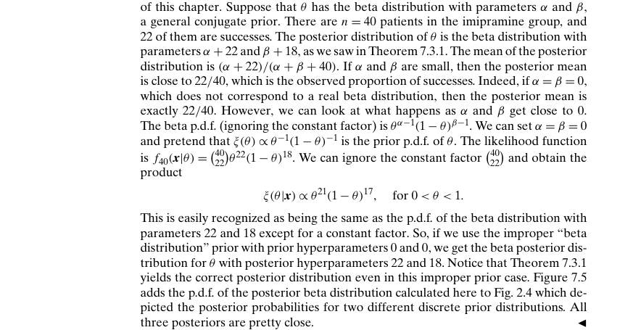

Example 7.3.14 – Non-Codable (Reason: Example with no scope of computation)

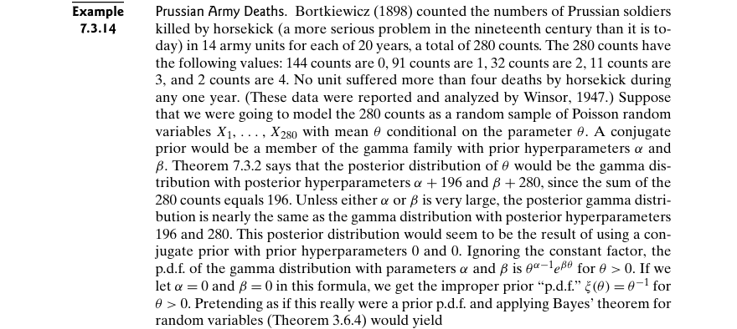

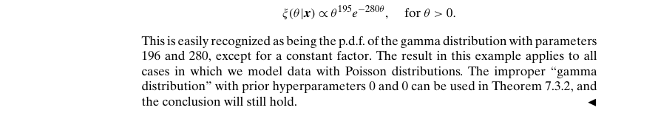

Example 7.3.15 – Non-Codable (Reason: Results are in variable expression)

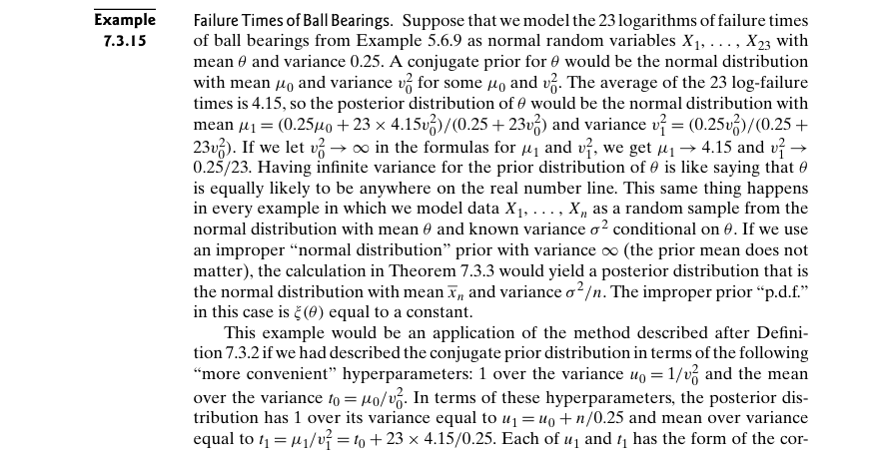

Example 7.3.16 – Non-Codable (Reason: Example with no computation)

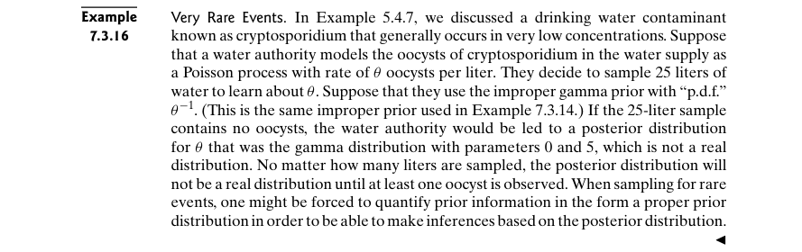

Example 7.4.1 – Non-Codable (Reason: Example with no computation)

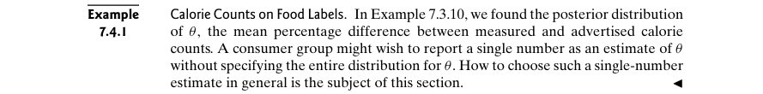

Example 7.4.2 – Non-Codable (Reason: Example with no computation)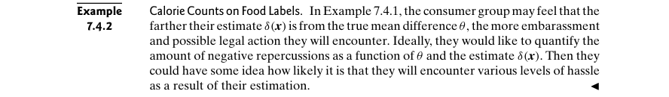

Example 7.4.3 – Non-Codable (Reason: Theoretical example with variable expressions)

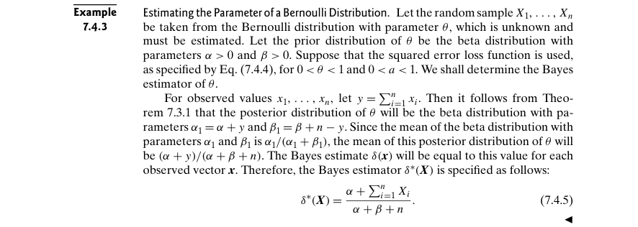

Example 7.4.4 – Non-Codable (Reason: Theoretical example with variable expressions)

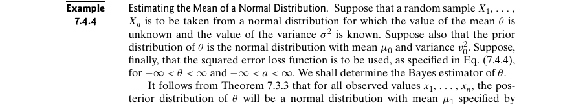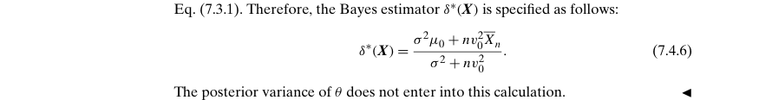

Example 7.4.5 – Codable

Example 7.4.6 – Non-Codable (Reason: Example with no computation)

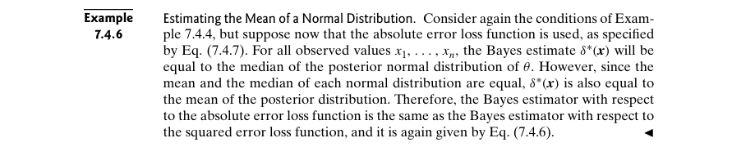

Example 7.4.7 – Non-Codable (Reason: Data not available)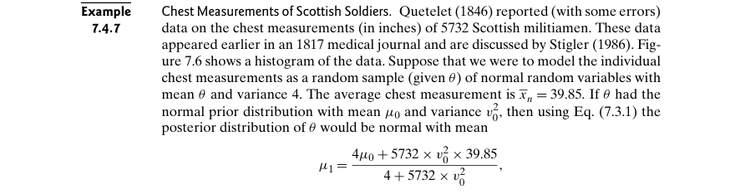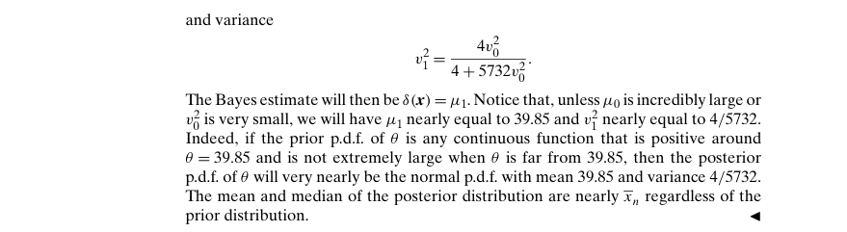

Example 7.4.8 – Codable

Example 7.5.1 – Non-Codable (Reason: Example with no computation)



Example 7.5.2 – Codable

Example 7.5.3 – Codable

Example 7.5.4 – Non-Codable (Reason: Results are in variable expressions)

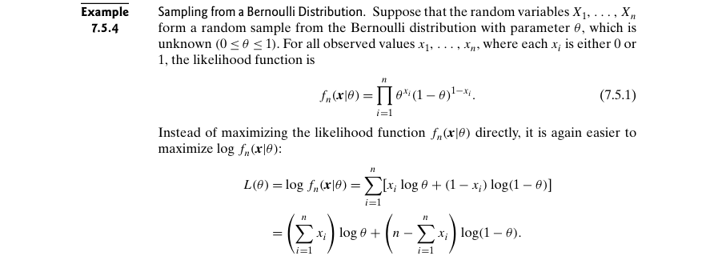

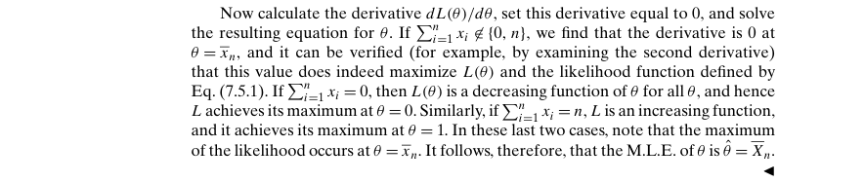

Example 7.5.5 – Non-Codable (Reason: Theoretical example in variable expressions)

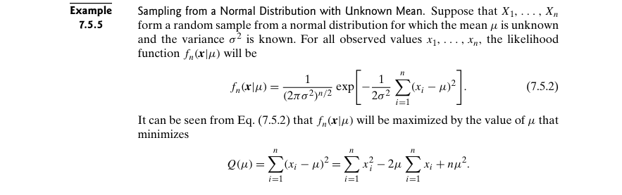

Example 7.5.6 – Non-Codable (Reason: Theoretical example to explain a concept)

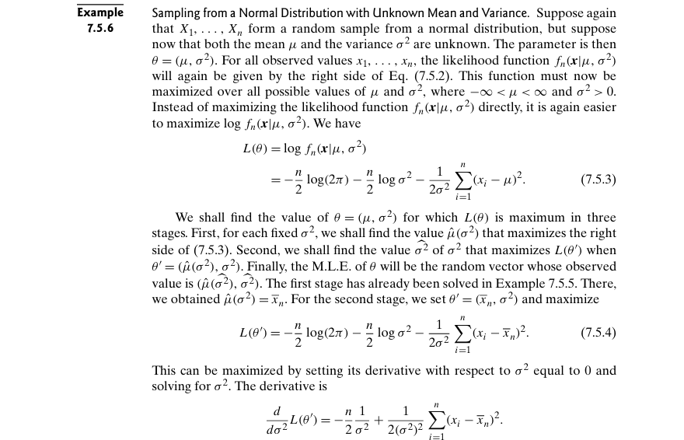

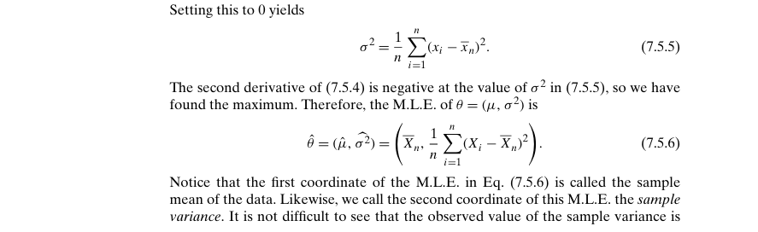

Example 7.5.7 – Non-Codable (Reason: Example with no computation)

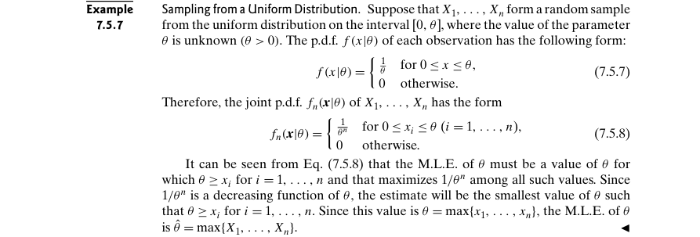

Example 7.5.8 – Non-Codable (Reason: Example with no computation)

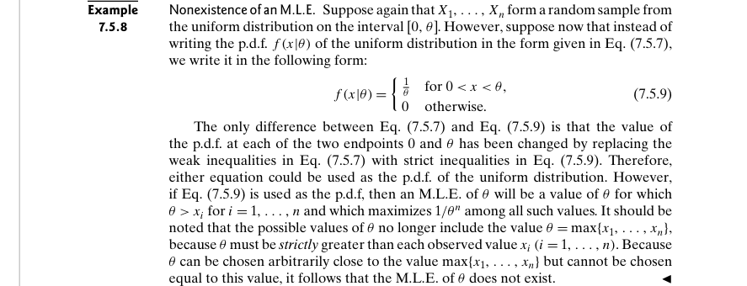

Example 7.5.9 – Non-Codable (Reason: Example with no computation)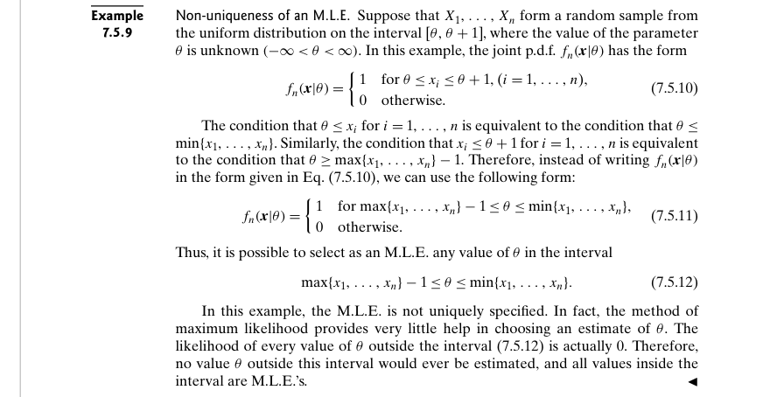

Example 7.5.10 – Non-Codable (Reason: Results are in variable format)

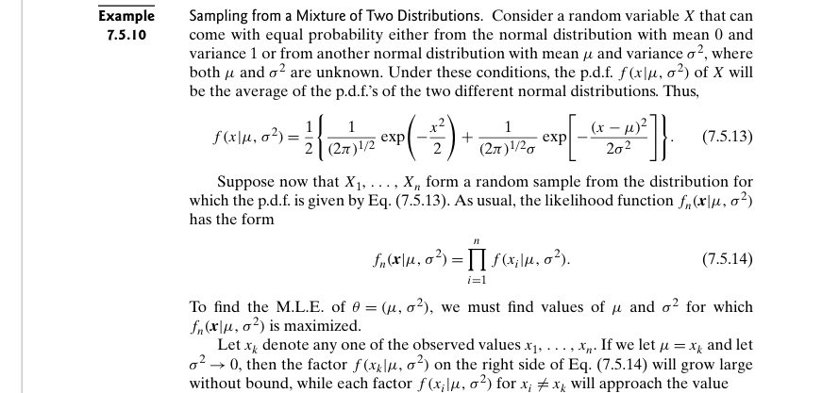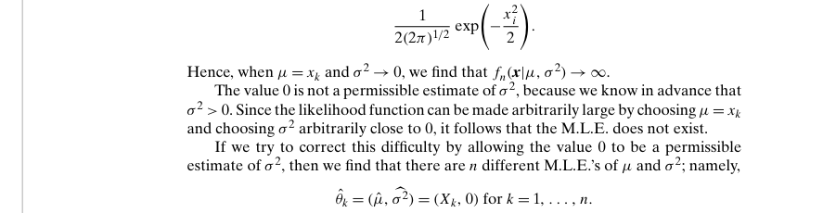

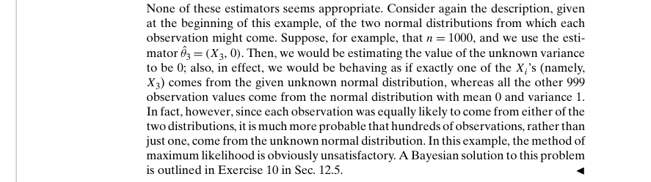

Example 7.6.1 – Non-Codable (Reason: Example with no scope of computation)



Example 7.6.2 – Codable

Example 7.6.3 – Non-Codable (Reason: Theoretical example)

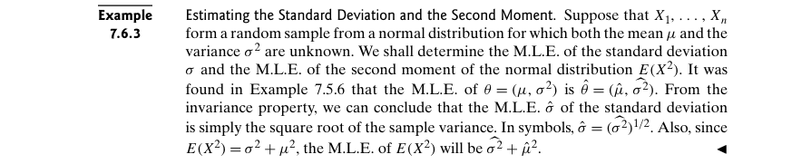

Example 7.6.4 – Non-Codable (Reason: Results are in variable format)

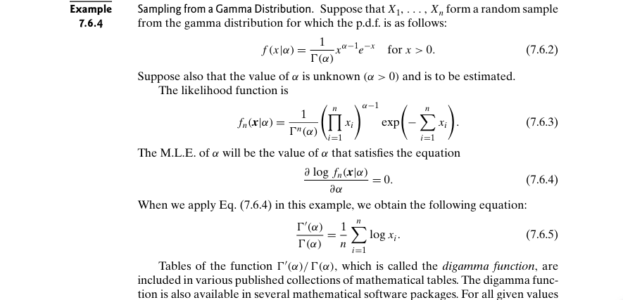

Example 7.6.5 – Non-Codable (Reason: Results are in variable format)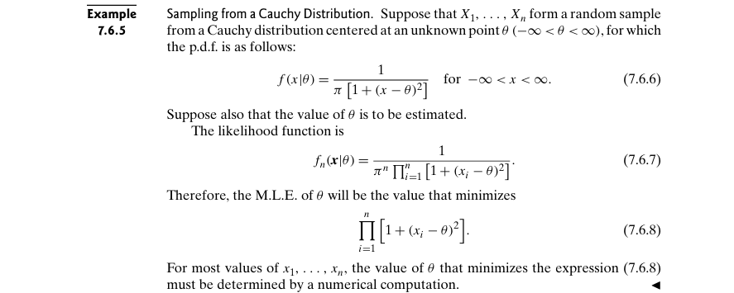

Example 7.6.6 – Codable

Example 7.6.7 – Non-Codable (Reason: Example with no computation)

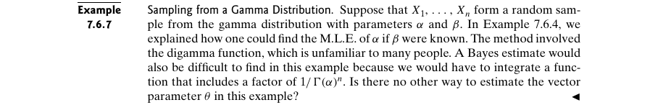

Example 7.6.8 – Non-Codable (Reason: Results are in terms of variable)



Example 7.6.9 – Non-Codable (Reason: Results are in variable format)

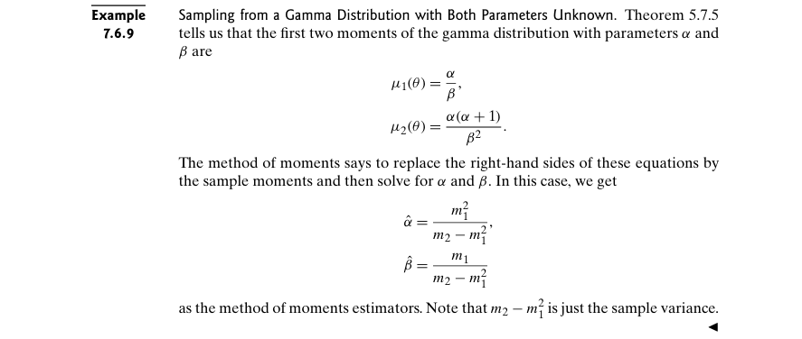

Example 7.6.10 – Codable

Example 7.6.11 – Non-Codable (Reason: Results are in variable format)

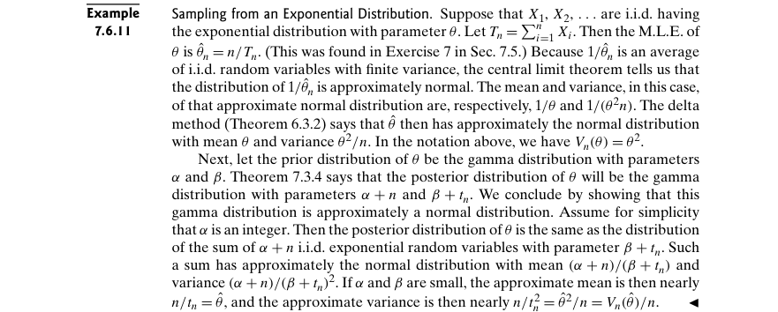

Example 7.6.12 – Codable

Example 7.6.13 – Codable

Example 7.6.14 – Non-Codable (Reason: Results are in variable format)

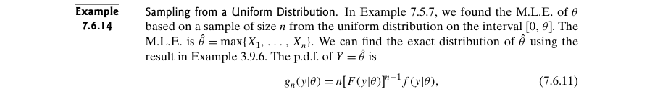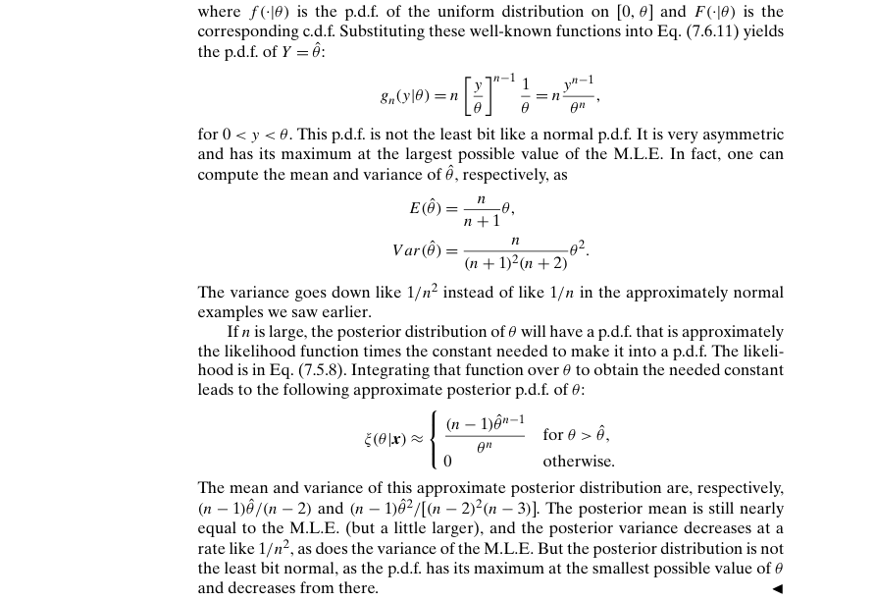

Example 7.6.15 – Codable

Example 7.6.16 – Codable

Example 7.7.1 – Non-Codable (Reason: Example with no scope of computation)

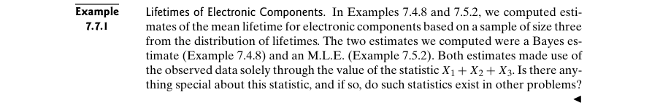

Example 7.7.2 – Non-Codable (Reason: Results are in variable format)

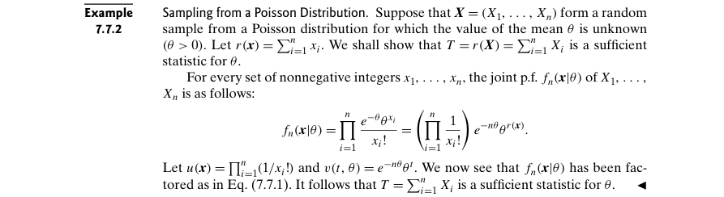

Example 7.7.3 – Non-Codable (Reason: Results are in variable format)

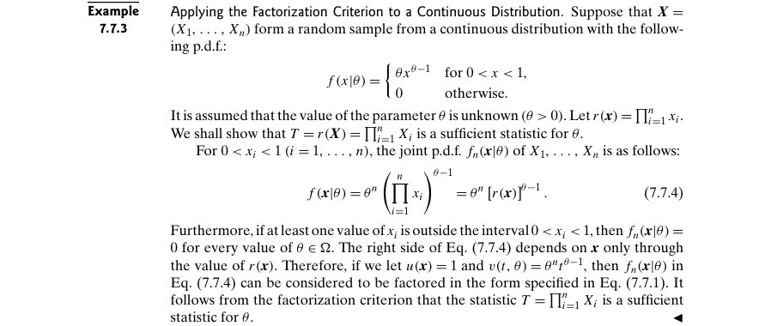

Example 7.7.4 – Non-Codable (Reason: Results are in variable format)



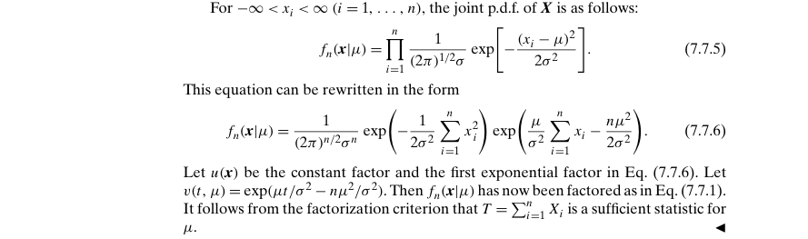

Example 7.7.5 – Non-Codable (Reason: Results are in variable format)

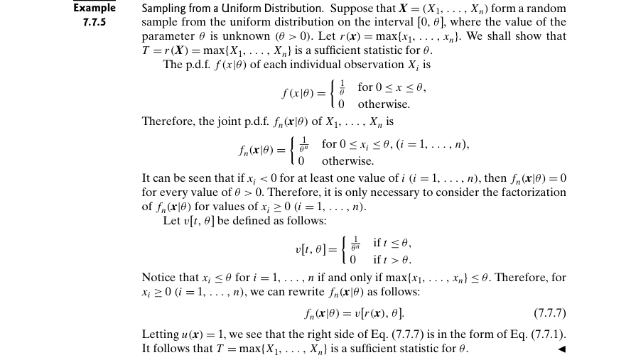

Example 7.8.1 – Non-Codable (Reason: Example with no scope of computation)

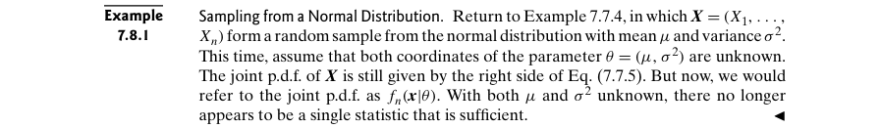

Example 7.8.2 – Non-Codable (Reason: Results are in variable format)

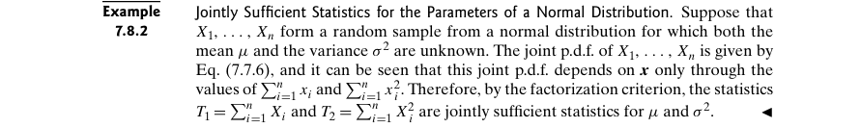

Example 7.8.3 – Non-Codable (Reason: Results are in variable format)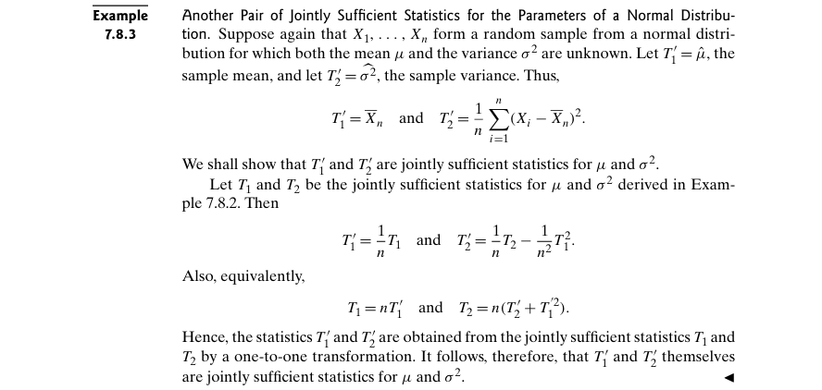

Example 7.8.4 – Non-Codable (Reason: Example with no scope of computation)

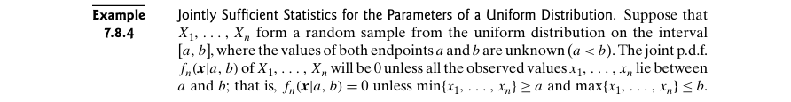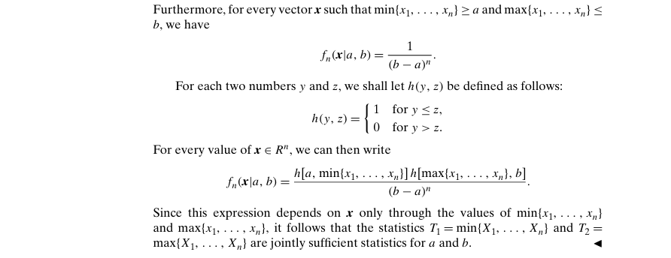

Example 7.8.5 – Non-Codable (Reason: Example with no computation)

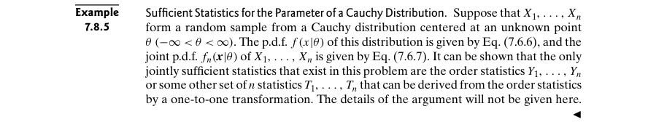

Example 7.8.6 – Non-Codable (Reason: Example with no computation)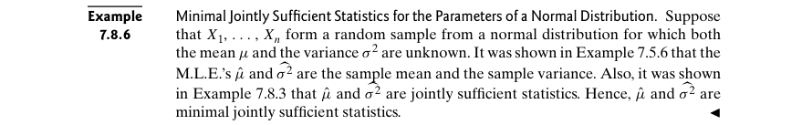

Example 7.9.1 – Non-Codable (Reason: Results are in variable format)

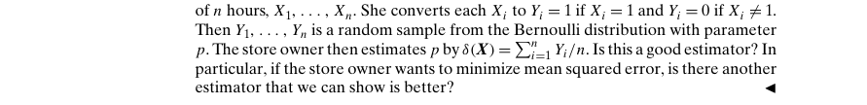

Example 7.9.2 – Non-Codable (Reason: Results are in variable format)

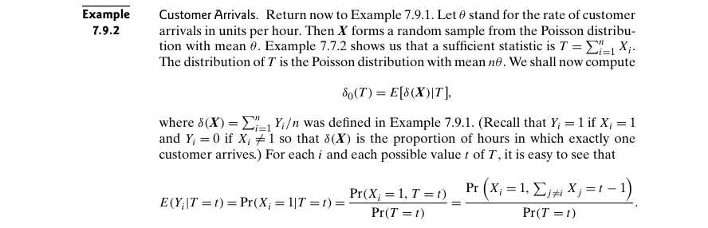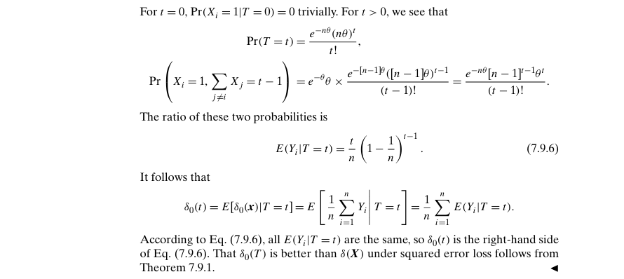

Example 7.9.3 – Non-Codable (Reason: Theoretical example to introduce a concept)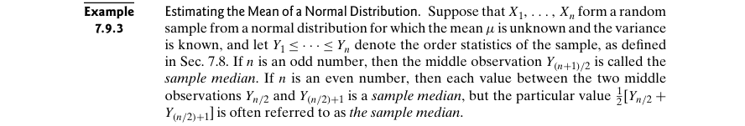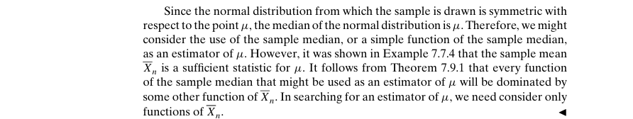

Example 7.9.4 – Non-Codable (Reason: Example with no scope of computation)

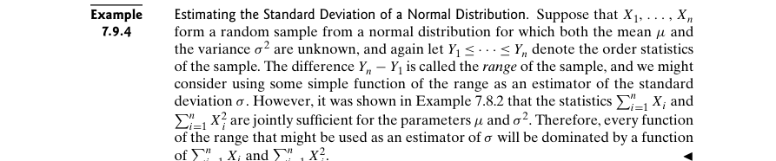

Example 7.9.5 – Non-Codable (Reason: Example with no scope of computation)

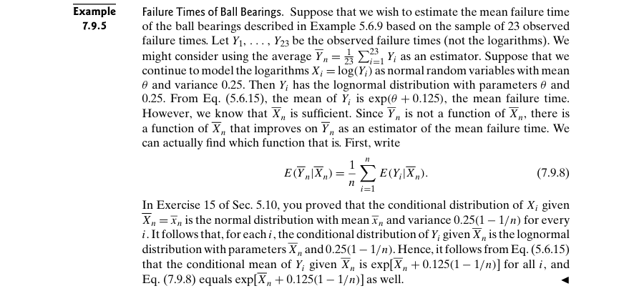

**Chapter 8: Sampling Distributions of Estimators**

Example 8.1.1 – Non-Codable (Reason: Example with no scope of computation)

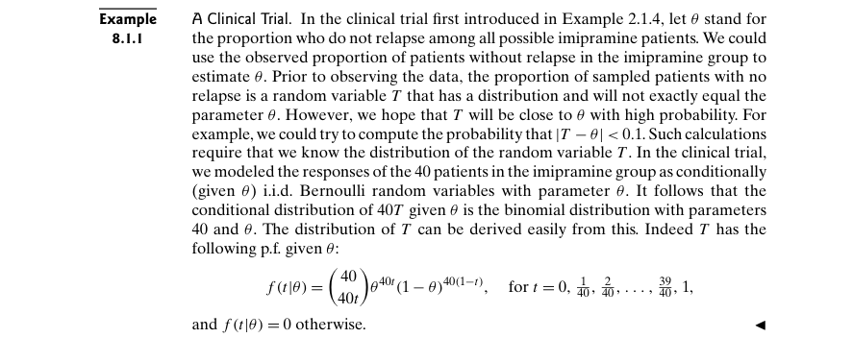

Example 8.1.2 – Non-Codable (Reason: Results are in variable format)

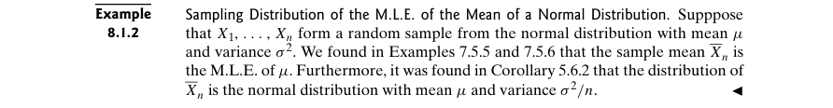

Example 8.1.3 – Non-Codable (Reason: Results are in variable format)

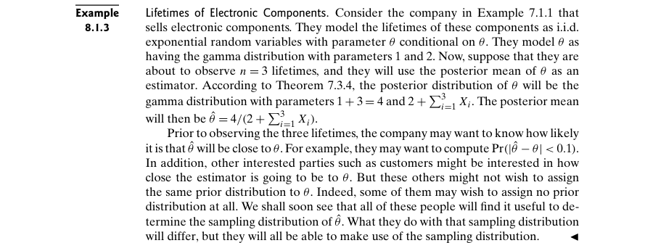

Example 8.1.4 – Non-Codable (Reason: Example with no scope of computation)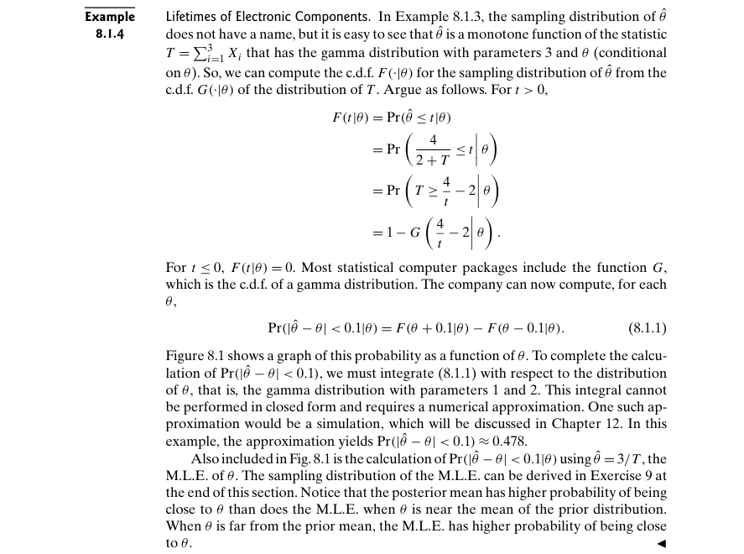

Example 8.1.5 – Codable

Example 8.1.6 – Codable

Example 8.2.1 – Non-Codable (Reason: Theoretical example to introduce a concept)

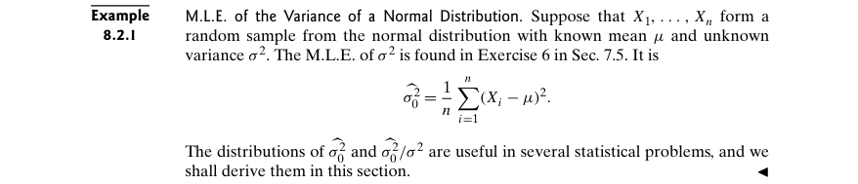

Example 8.2.2 – Non-Codable (Reason: Results are in variable format)

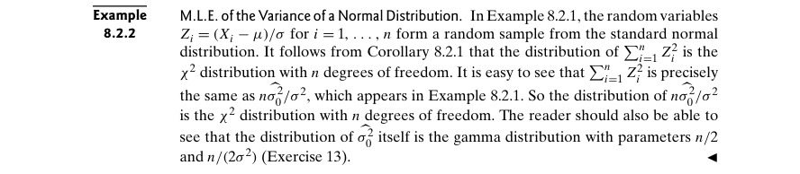

Example 8.2.3 – Codable

Example 8.3.1 – Non-Codable (Reason: Example with no computation)

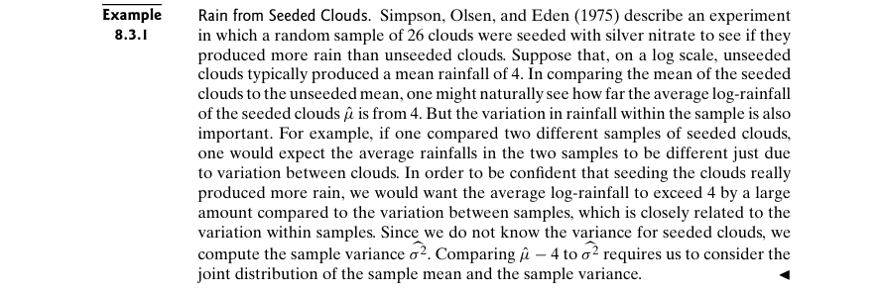

Example 8.3.2 – Codable

Example 8.4.1 – Non-Codable (Reason: Example with no scope of computation)

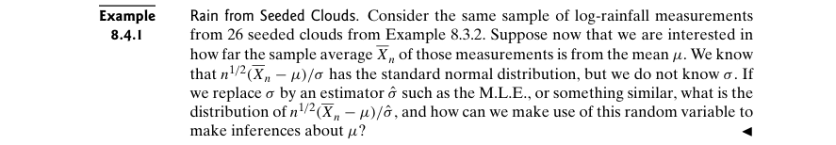

Example 8.4.2 – Non-Codable (Reason: Results are in variable format)

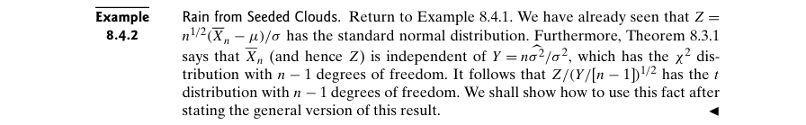

Example 8.4.3 – Codable

Example 8.5.1 – Non-Codable (Reason: Results are in variable format)

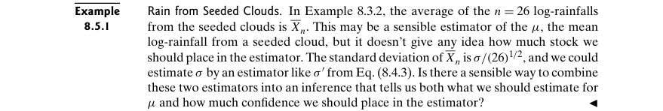

Example 8.5.2 – Codable

Example 8.5.3 – Codable

Example 8.5.4 – Codable

Example 8.5.5 – Non-Codable (Reason: Results are in variable format)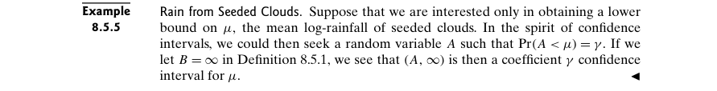

Example 8.5.6 – Codable

Example 8.5.7 – Codable

Example 8.5.8 – Non-Codable (Reason: Results are in variable format)

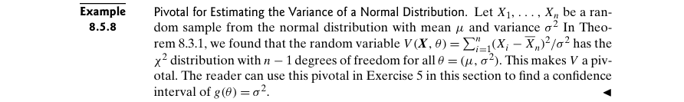

Example 8.5.9 – Non-Codable (Reason: Results are in variable format)

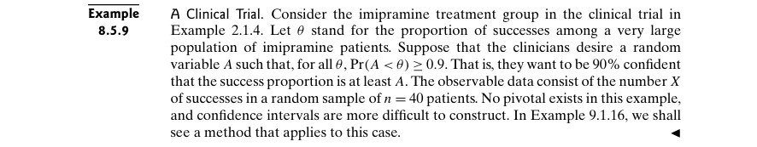

Example 8.5.10 – Codable

Example 8.5.11 – Codable

Example 8.6.1 – Non-Codable (Reason: Example with no computation)

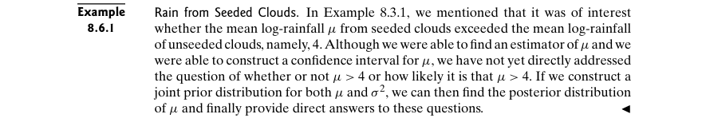

Example 8.6.2 – Codable

Example 8.6.3 – Codable

Example 8.6.4 – Codable

Example 8.7.1 – Non-Codable (Reason: Results are in variable format)

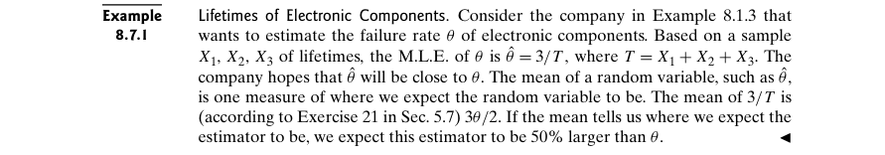

Example 8.7.2 – Non-Codable (Reason: Results are in variable format)



Example 8.7.3 – Codable

Example 8.7.4 – Non-Codable (Reason: Results are in variable format)

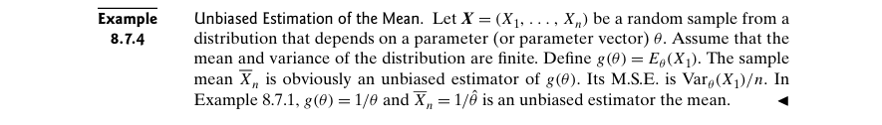

Example 8.7.5 – Non-Codable (Reason: Results are in variable format)

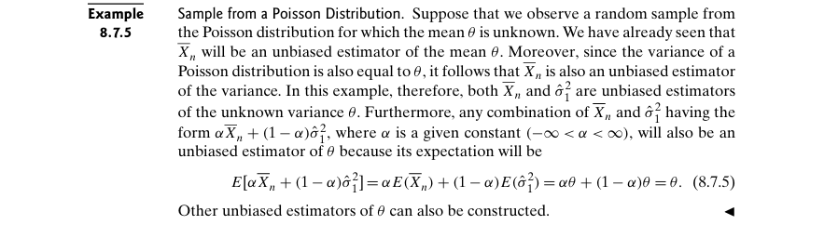

Example 8.7.6 – Non-Codable (Reason: Results are in variable format)

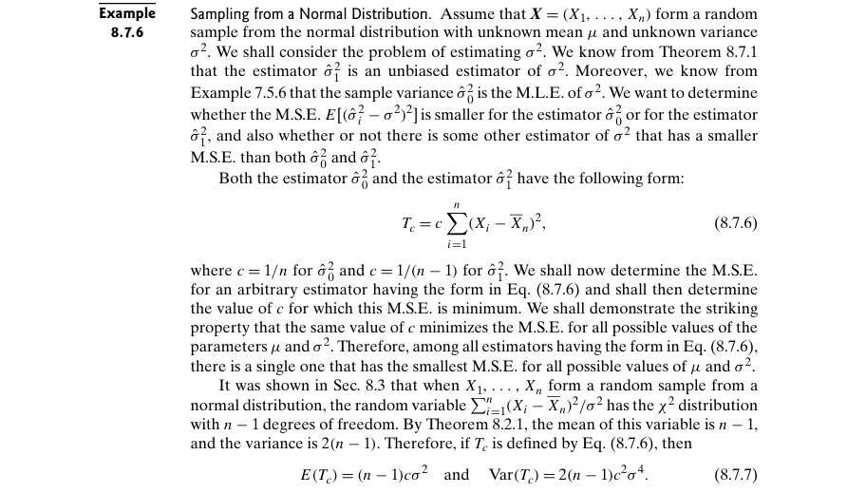

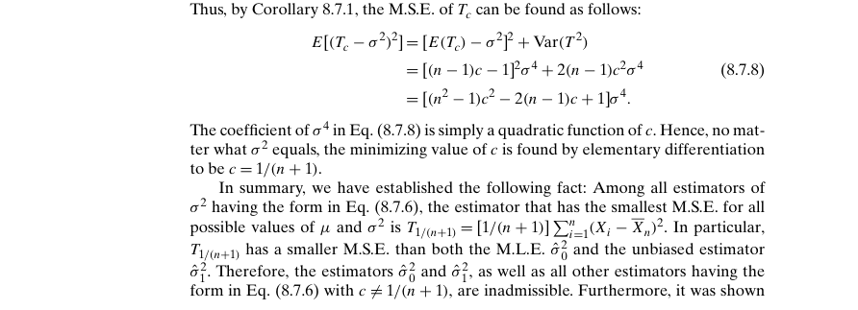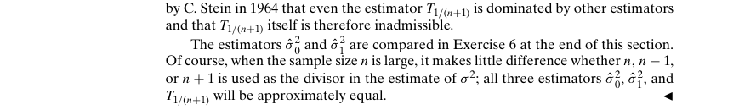

Example 8.8.1 – Non-Codable (Reason: Example with no computation)

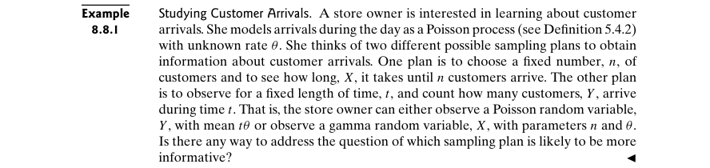

Example 8.8.2 – Non-Codable (Reason: Results are in variable format)

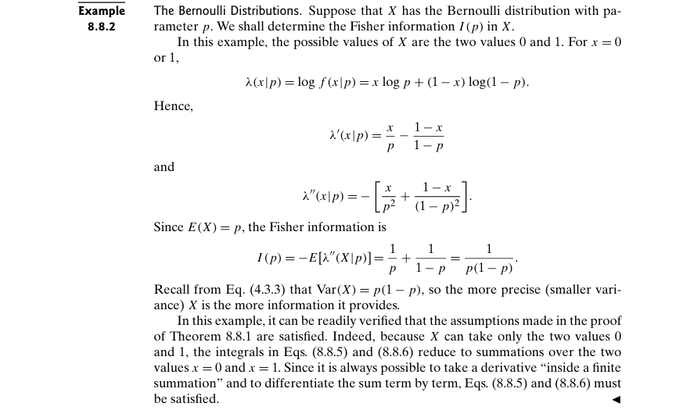

Example 8.8.3 – Non-Codable (Reason: Results are in variable format)

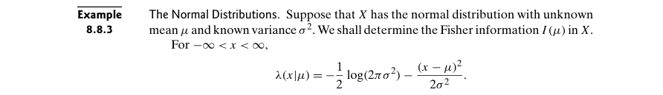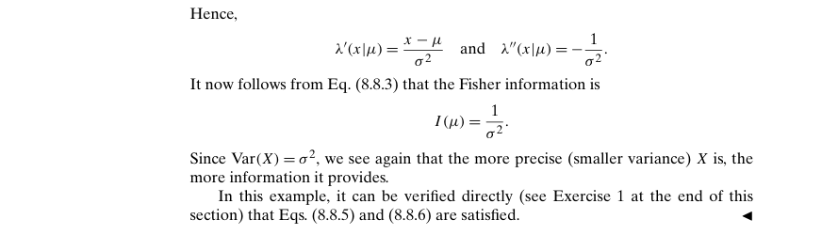

Example 8.8.4 – Non-Codable (Reason: Results are in variable format)

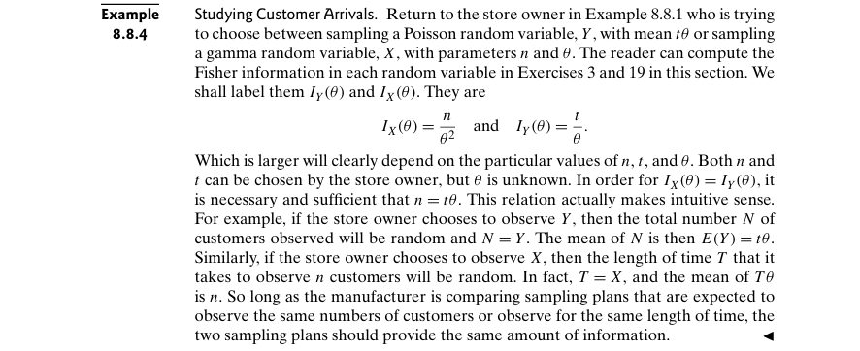

Example 8.8.5 – Non-Codable (Reason: Example with no computation)

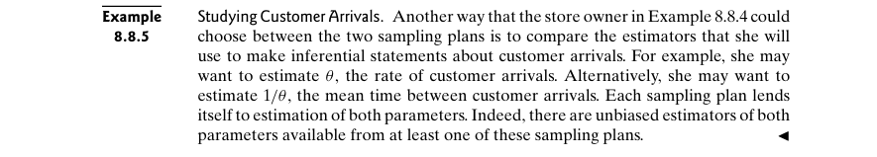

Example 8.8.6 – Non-Codable (Reason: Results are in variable format)

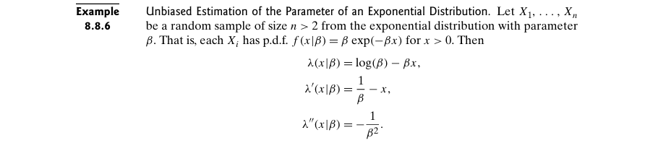

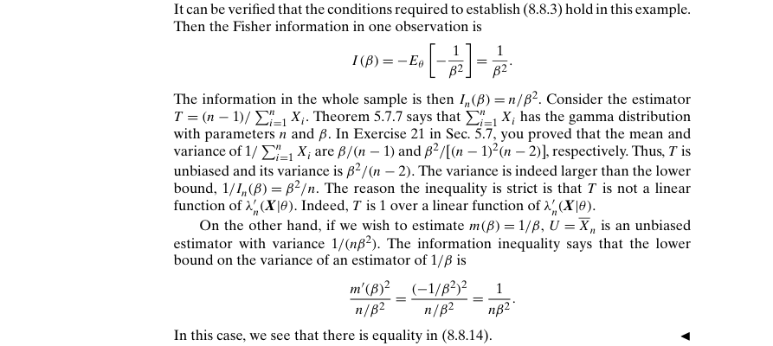

Example 8.8.7 – Non-Codable (Reason: Results are in variable format)

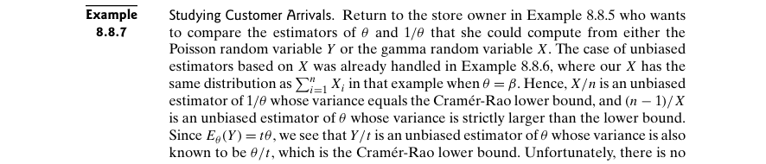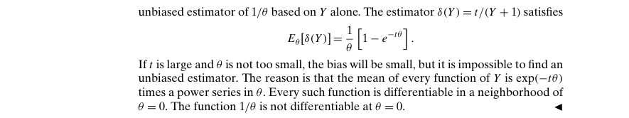

Example 8.8.8 – Non-Codable (Reason: Example with no computation)

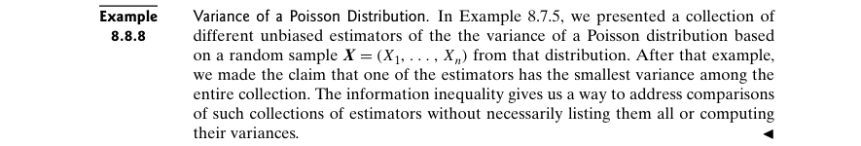

Example 8.8.9 – Non-Codable (Reason: Results are in variable format)

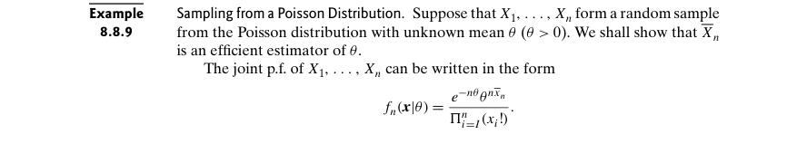

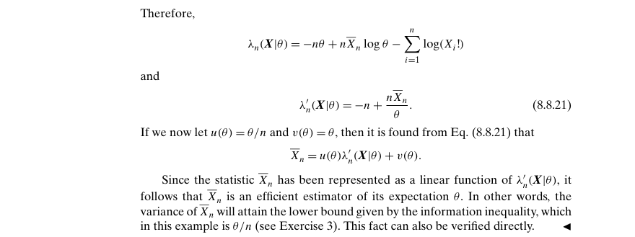

Example 8.8.10 – Non-Codable (Reason: Example with no scope of computation)

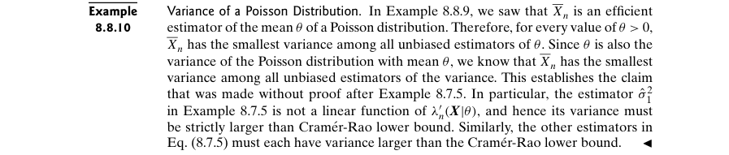

Example 8.8.11 – Non-Codable (Reason: Results are in variable format)

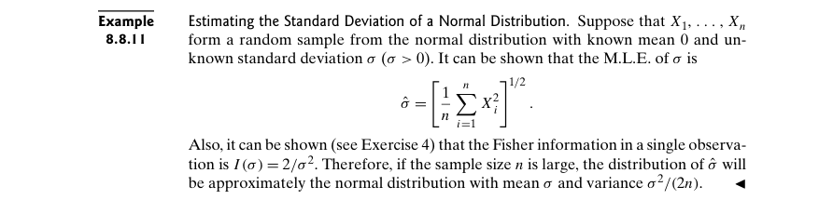

Example 8.8.12 – Codable

Example 8.8.13 – Non-Codable (Reason: Example with no computation)



Example 8.8.14 – Non-Codable (Reason: Results are in variable format)

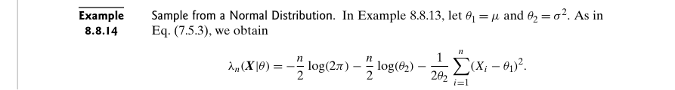

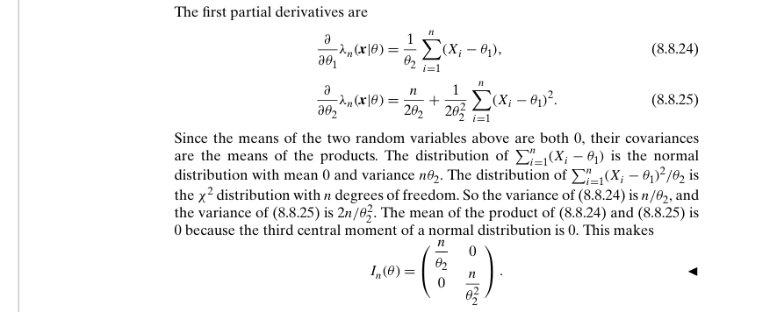

Example 8.8.15 – Non-Codable (Reason: Results are in variable format)

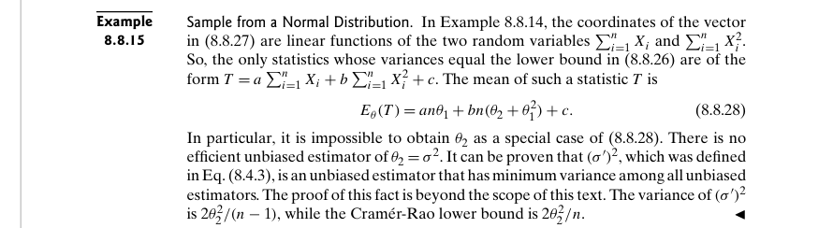

Example 8.8.16 – Non-Codable (Reason: Theoretical example with no scope of computation)

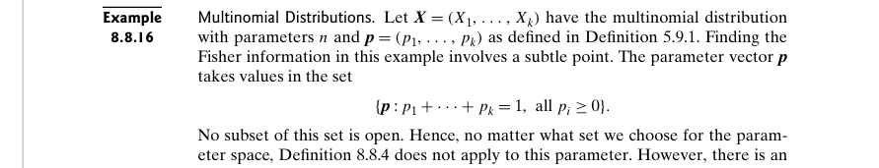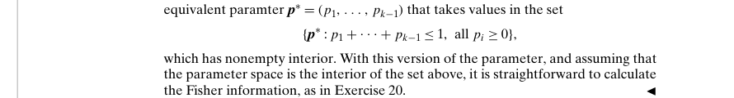

**Chapter 9: Testing Hypotheses**

Example 9.1.1 – Non-Codable (Reason: Example with no computation)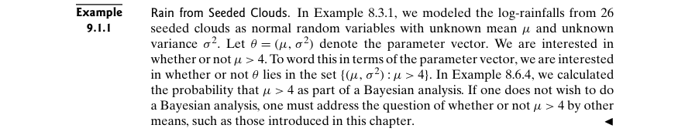

Example 9.1.2 – Non-Codable (Reason: Example with no scope of computation)

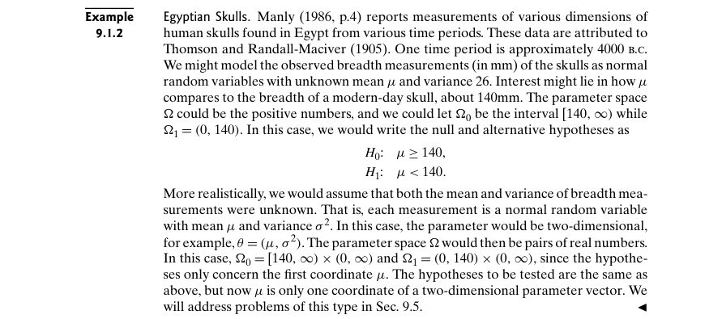

Example 9.1.3 – Non-Codable (Reason: Theoretical example with no scope of computation)

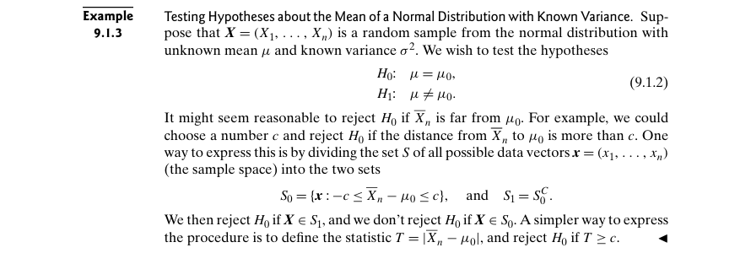

Example 9.1.4 – Non-Codable (Reason: Results are in terms of variables)

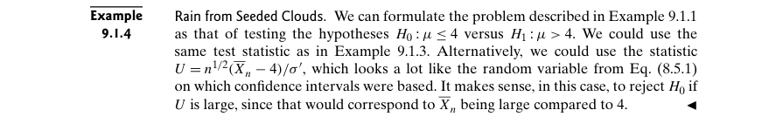

Example 9.1.5 – Codable

Example 9.1.6 – Non-Codable (Reason: Example with no scope of computation)

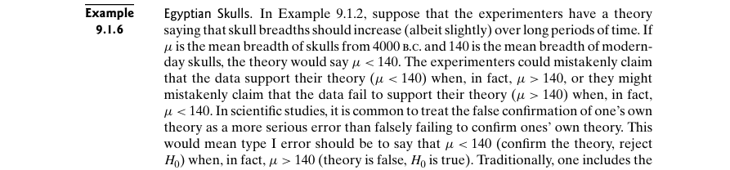

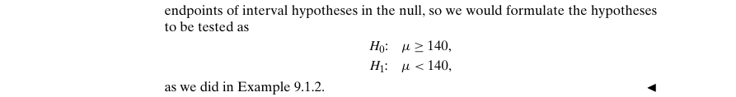

Example 9.1.7 – Codable

Example 9.1.8 – Non-Codable (Reason: Results are in variable expressions)

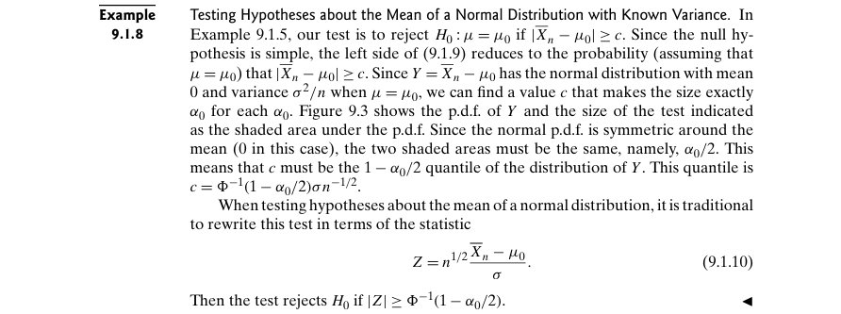

Example 9.1.9 – Codable

Example 9.1.10 – Codable

Example 9.1.11 – Codable

Example 9.1.12 – Codable

Example 9.1.13 – Non-Codable (Reason: Example with no scope of computation)

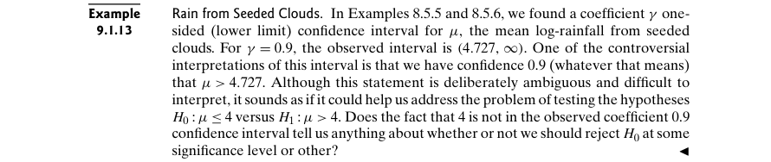

Example 9.1.14 – Non-Codable (Reason: Results are in terms of variable expressions)

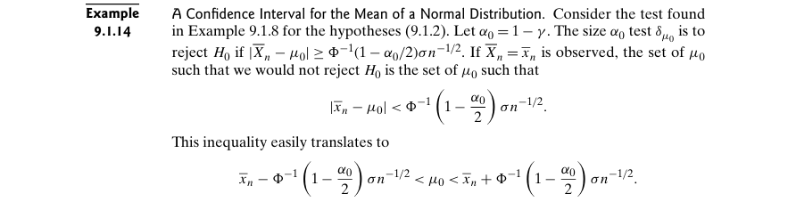

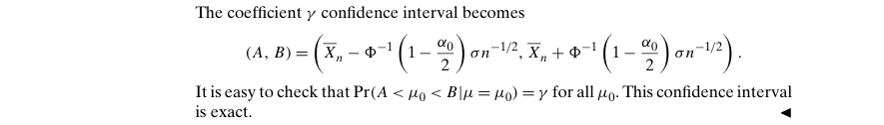

Example 9.1.15 – Non-Codable (Reason: Results are in terms of variable expressions)

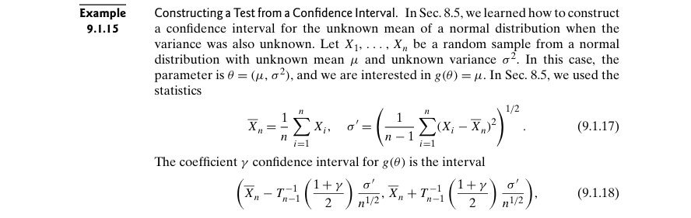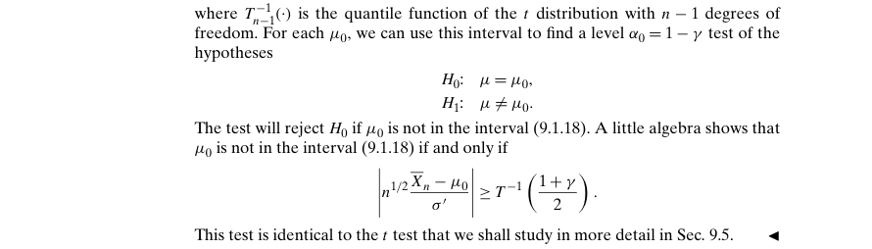

Example 9.1.16 – Codable

Example 9.1.17 – Non-Codable (Reason: Theoretical example with no scope of computation)

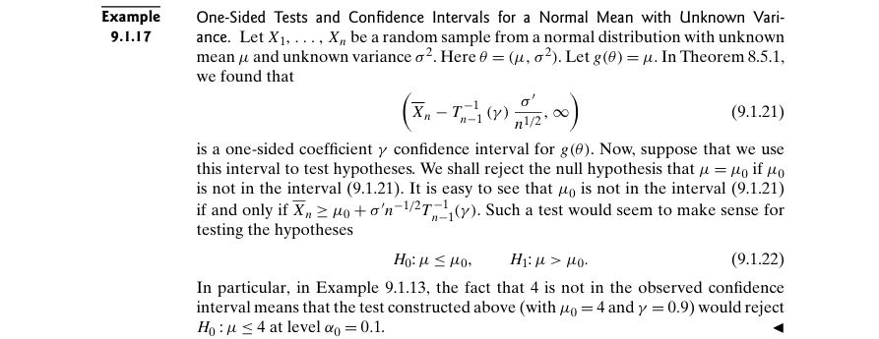

Example 9.1.18 – Codable

Example 9.1.19 – Codable

Example 9.2.1 – Codable

Example 9.2.2 – Codable

Example 9.2.3 – Codable

Example 9.2.4 – Codable

Example 9.2.5 – Codable

Example 9.2.6 – Codable

Example 9.3.1 – Non-Codable (Reason: Example with no scope of computation)

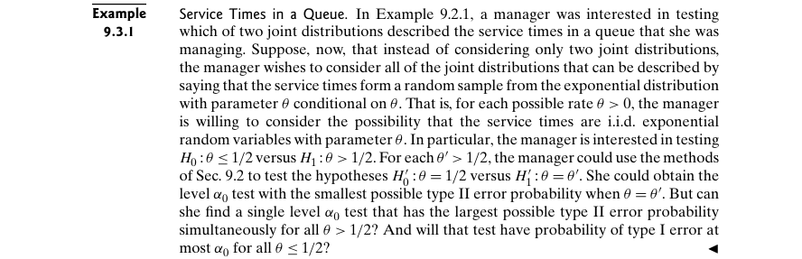

Example 9.3.2 – Non-Codable (Reason: Example with no scope of computation)

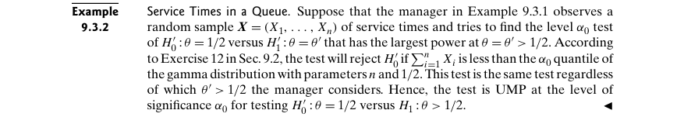

Example 9.3.3 – Non-Codable (Reason: Theoretical example with no scope of computation)

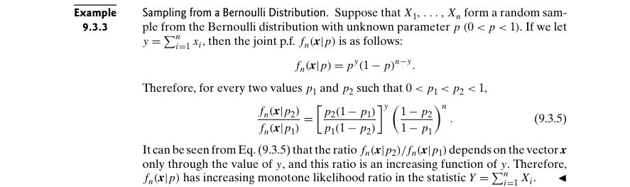

Example 9.3.4 – Non-Codable (Reason: Theoretical example with no scope of computation)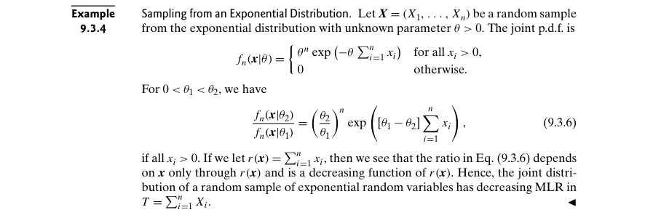

Example 9.3.5 – Non-Codable (Reason: Results are in terms of variable expressions)

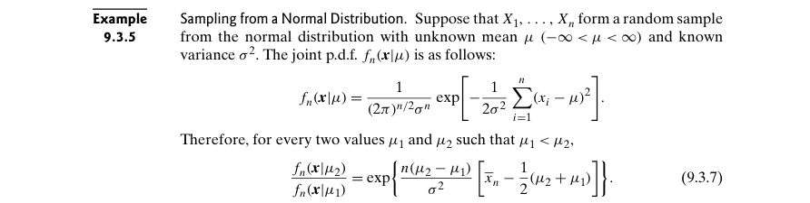

Example 9.3.6 – Codable

Example 9.3.7 – Codable

Example 9.3.8 – Non-Codable (Reason: Theoretical example with no scope of computation)

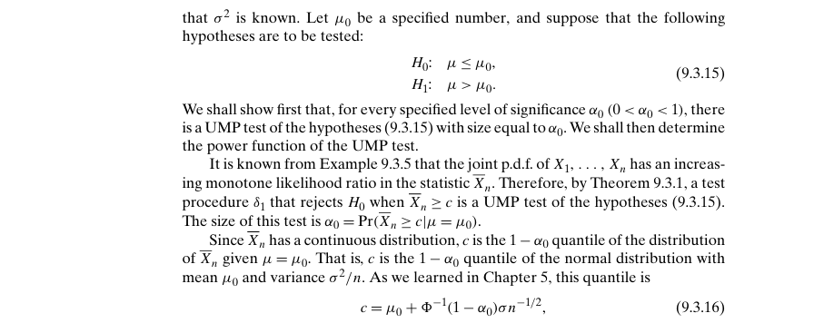

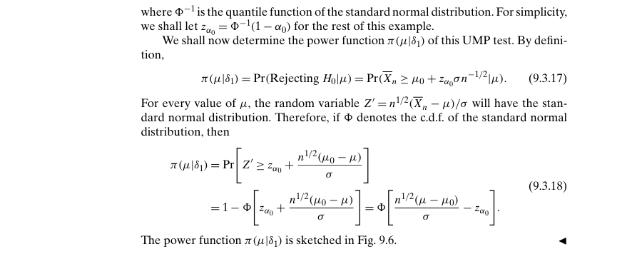

Example 9.3.9 – Non-Codable (Reason: Theoretical example with no scope of computation)

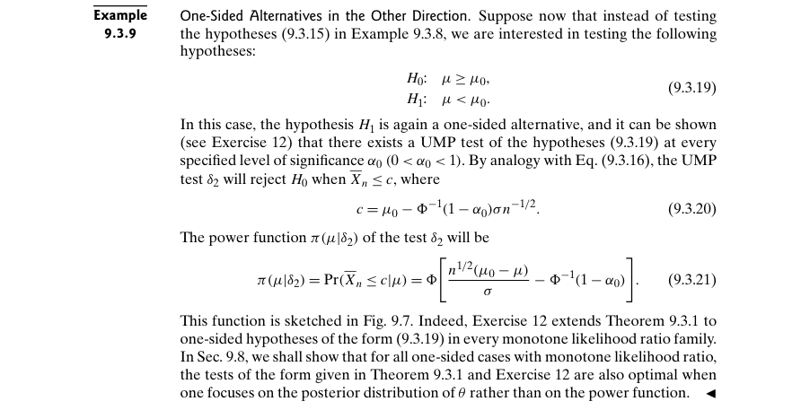

Example 9.4.1 – Non-Codable (Reason: Example with no scope of computation)

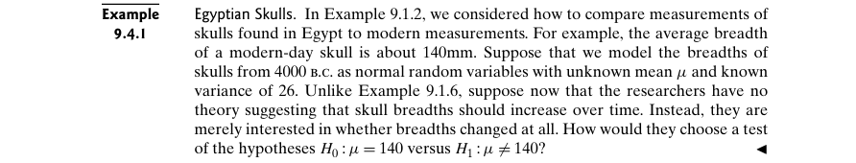

Example 9.4.2 – Codable

Example 9.4.3 – Non-Codable (Reason: Results are in terms of variable expressions)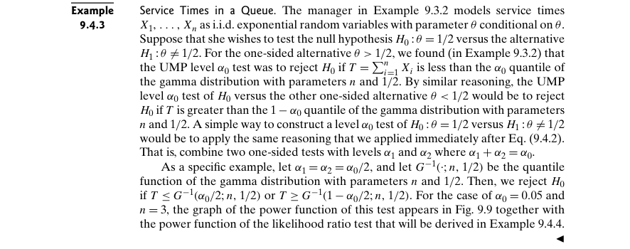

Example 9.4.4 – Codable

Example 9.4.5 – Codable

Example 9.4.6 – Non-Codable (Reason: Final solution is not provided)

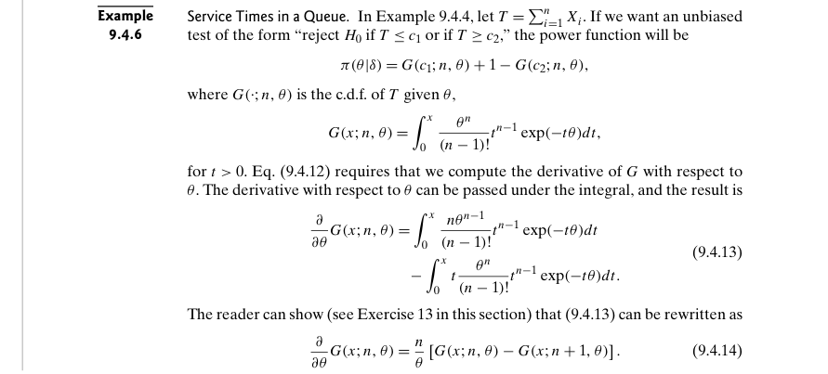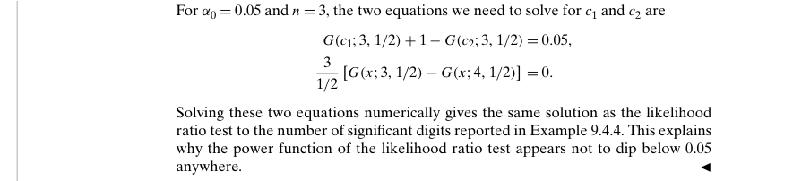

Example 9.5.1 – Non-Codable (Reason: Example with no scope of computation)

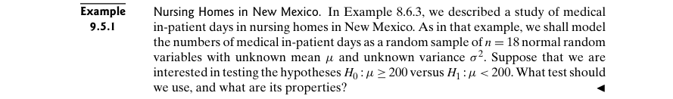

Example 9.5.2 – Non-Codable (Reason: Example with no computation)



Example 9.5.3 – Codable

Example 9.5.4 – Codable

Example 9.5.5 – Codable

Example 9.5.6 – Codable

Example 9.5.7 – Codable

Example 9.5.8 – Non-Codable (Reason: Theoretical example with no scope of computation)

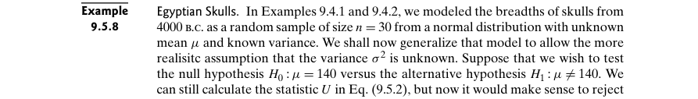

Example 9.5.9 – Codable

Example 9.5.10 – Codable

Example 9.5.11 – Codable

Example 9.5.12 – Non-Codable (Reason: Theoretical example with variable expressions)

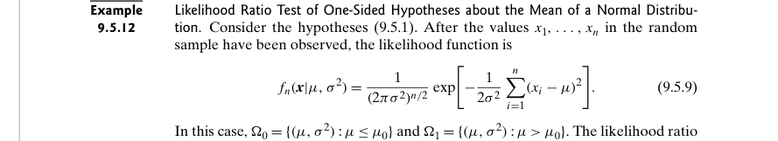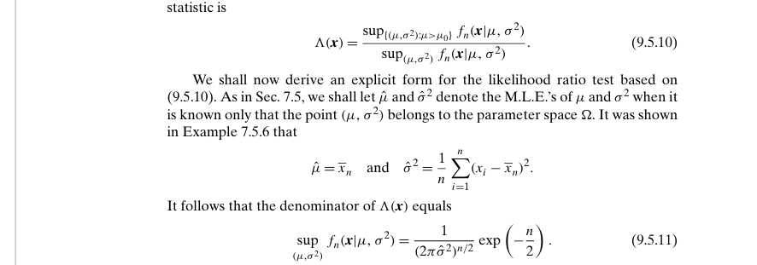

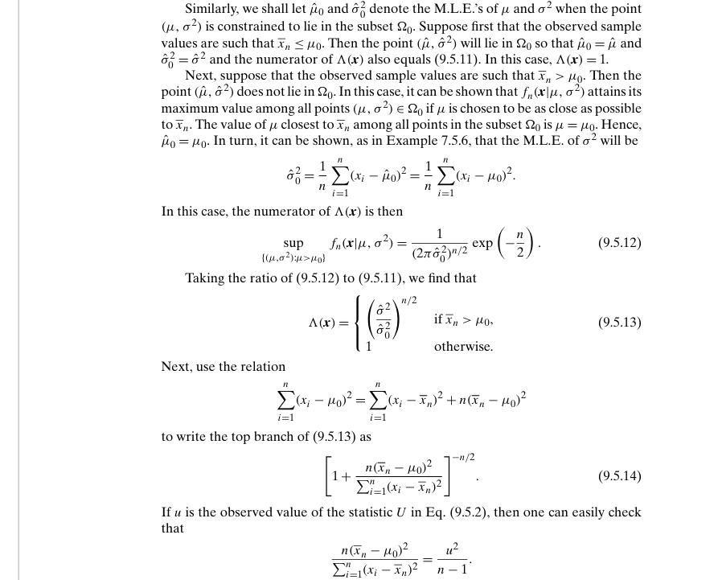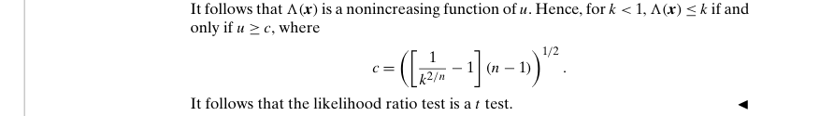

Example 9.6.1 – Non-Codable (Reason: Example with no computation)

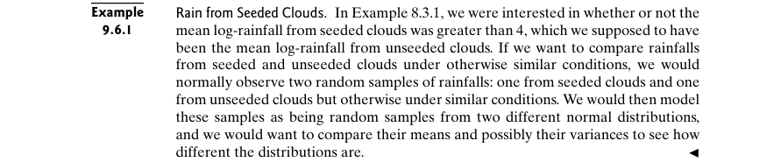

Example 9.6.2 – Codable

Example 9.6.3 – Codable

Example 9.6.4 – Codable

Example 9.6.5 – Codable

Example 9.6.6 – Codable

Example 9.6.7 – Codable

Example 9.7.1 – Non-Codable (Reason: Example with no computation)

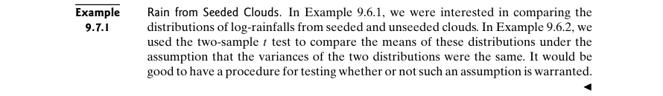

Example 9.7.2 – Codable

Example 9.7.3 – Codable

Example 9.7.4 – Codable

Example 9.8.1 – Non-Codable (Reason: Example with no computation)

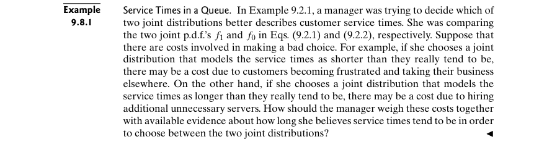

Example 9.8.2 – Non-Codable (Reason: Example with no scope of computation)

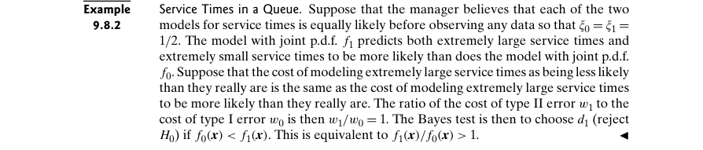

Example 9.8.3 – Non-Codable (Reason: Results are in terms of variables)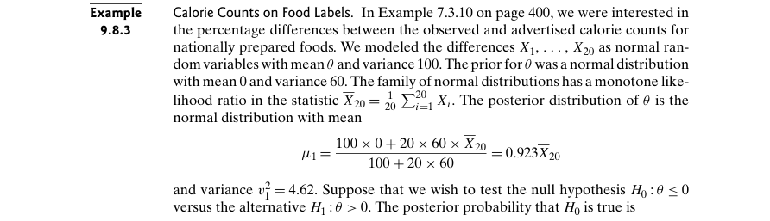

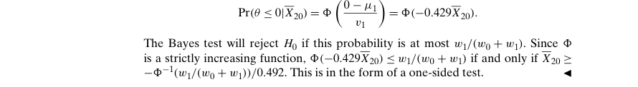

Example 9.8.4 – Codable

Example 9.8.5 – Codable

Example 9.8.6 – Codable

Example 9.8.7 – Codable

**Chapter 10: Categorical Data and Nonparametric Methods**

Example 10.1.1 – Non-Codable (Reason: Example with no scope of computation)

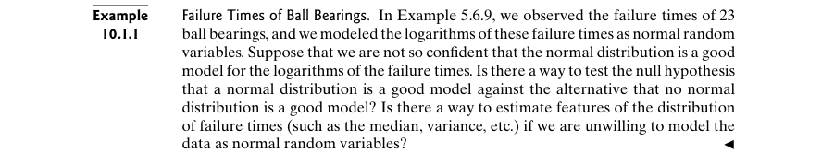

Example 10.1.2 – Non-Codable (Reason: Example with no scope of computation)

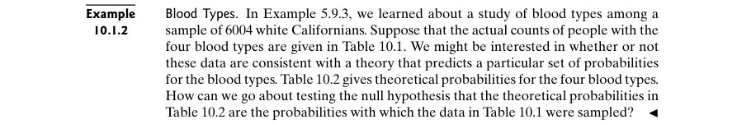

Example 10.1.3 – Codable

Example 10.1.4 – Codable

Example 10.1.5 – Codable

Example 10.1.6 – Codable

Example 10.1.7 – Codable

Example 10.2.1 – Non-Codable (Reason: Example with no scope of computation)

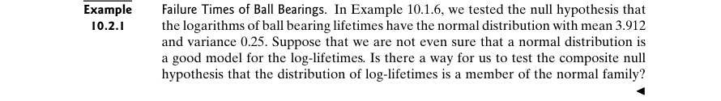

Example 10.2.2 – Non-Codable (Reason: Results are in terms of variables)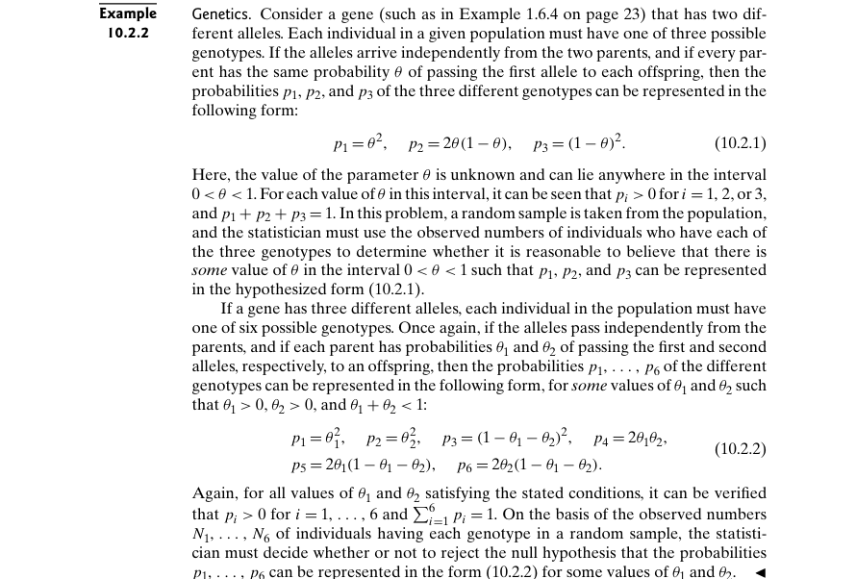

Example 10.2.3 – Non-Codable (Reason: Example with no scope of computation)

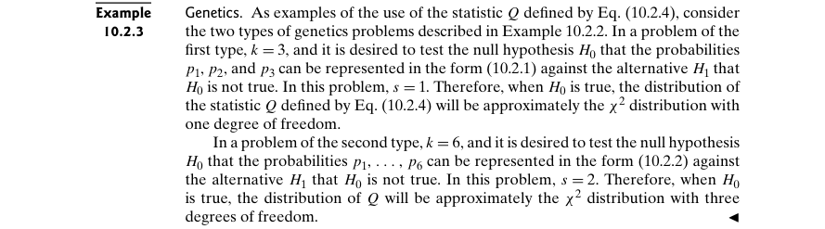

Example 10.2.4 – Non-Codable (Reason: Results are in terms of variables)

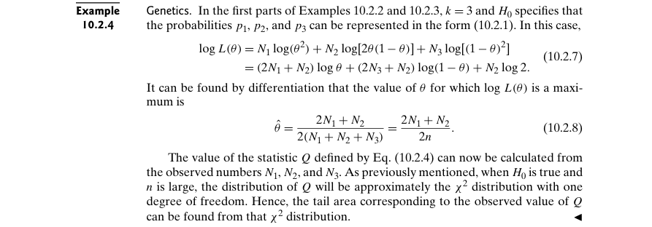

Example 10.2.5 – Codable

Example 10.2.6 – Codable

Example 10.3.1 – Non-Codable (Reason: Example with no scope of computation)

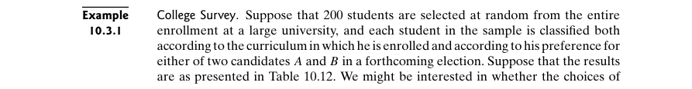

Example 10.3.2 – Codable

Example 10.3.3 – Codable

Example 10.4.1 – Non-Codable (Reason: Example with no computation)

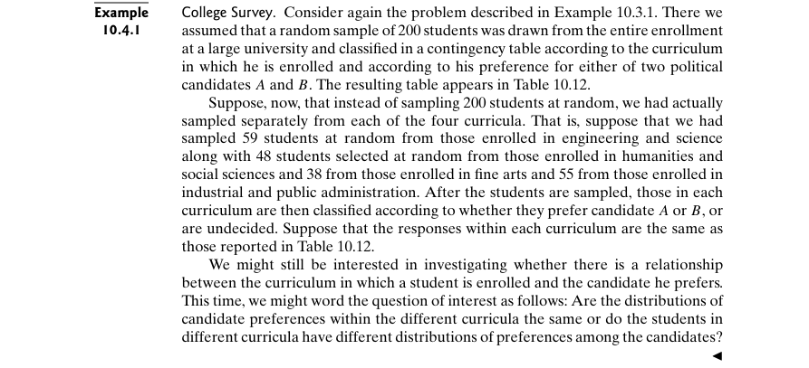

Example 10.4.2 – Non-Codable (Reason: Example with no scope of computation)

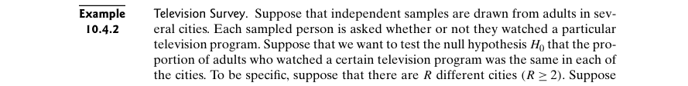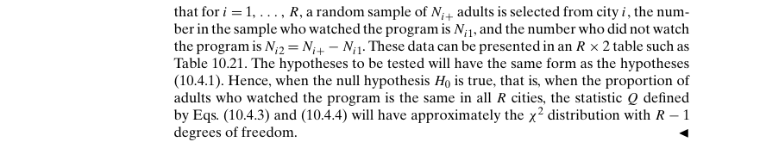

Example 10.4.3 – Codable

Example 10.5.1 – Non-Codable (Reason: Example with no scope of computation)

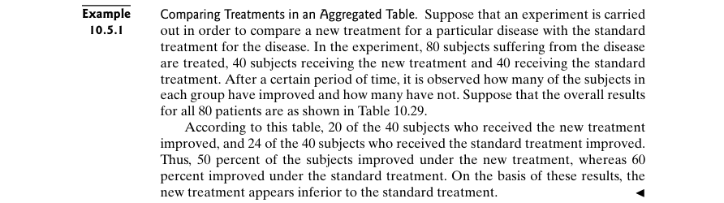

Example 10.5.2 – Non-Codable (Reason: Example with no scope of computation)

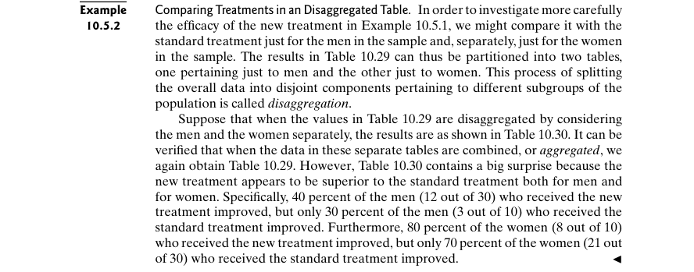

Example 10.5.3 – Non-Codable (Reason: Example with no scope of computation)

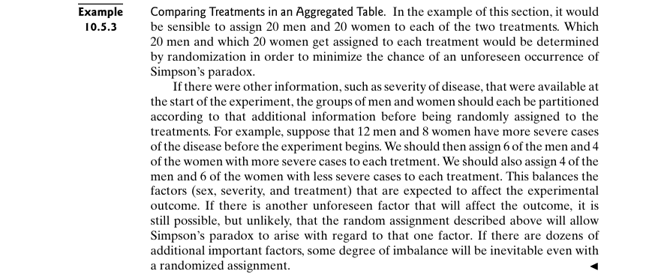

Example 10.6.1 – Non-Codable (Reason: Example with no scope of computation)

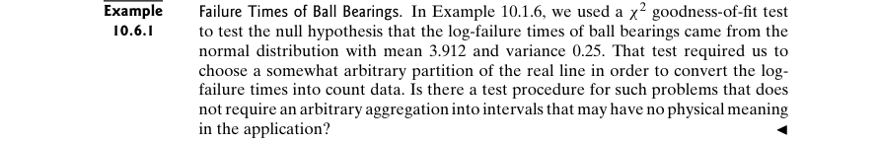

Example 10.6.2 – Codable

Example 10.6.3 – Non-Codable (Reason: Example with no scope of computation)

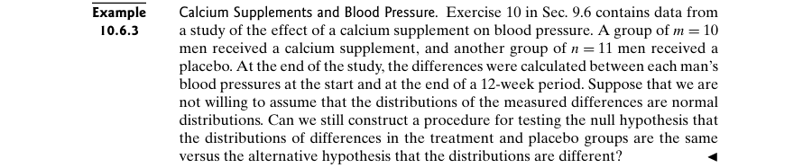

Example 10.6.4 – Codable

Example 10.7.1 – Non-Codable (Reason: Example with no scope of computation)

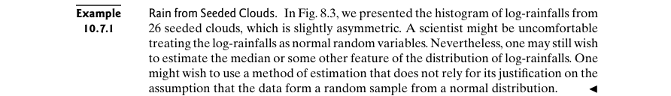

Example 10.7.2 – Non-Codable (Reason: Results are in terms of variables)

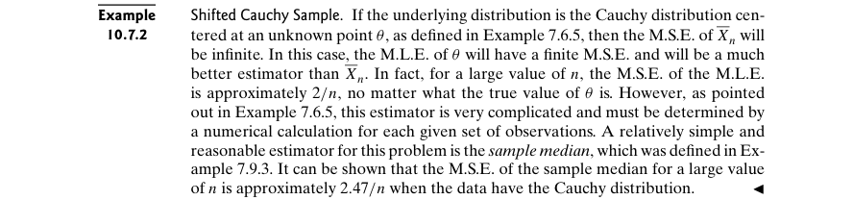

Example 10.7.3 – Codable

Example 10.8.1 – Non-Codable (Reason: Example with no scope of computation)



Example 10.8.2 – Codable

Example 10.8.3 – Non-Codable (Reason: Example with no computation)



Example 10.8.4 – Codable

Example 10.8.5 – Codable

**Chapter 11: Linear Statistical Models**

Example 11.1.1 – Codable

Example 11.1.2 – Codable

Example 11.1.3 – Codable

Example 11.1.4 – Non-Codable (Reason: Data is not available)

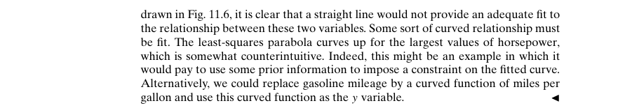

Example 11.1.5 – Codable

Example 11.2.1 – Codable

Example 11.2.2 – Non-Codable (Reason: Results are in terms of a variable)

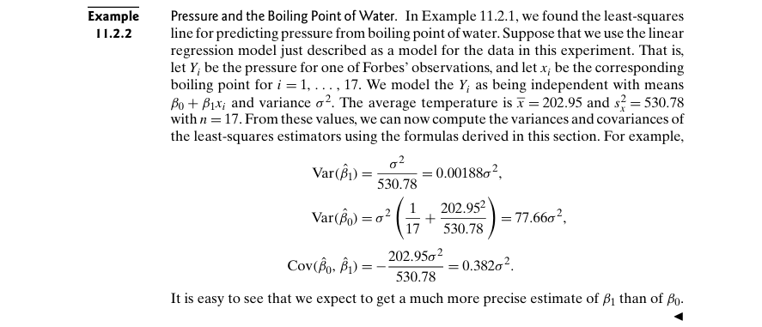

Example 11.2.3 – Non-Codable (Reason: Theoretical example with variable expressions)

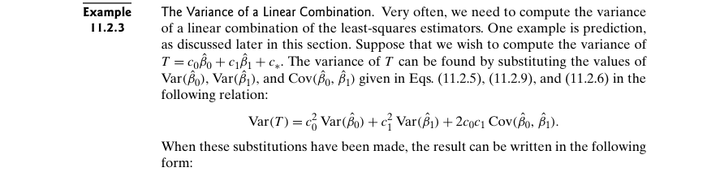

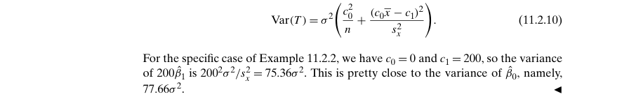

Example 11.2.4 – Non-Codable (Reason: Example with no computation)

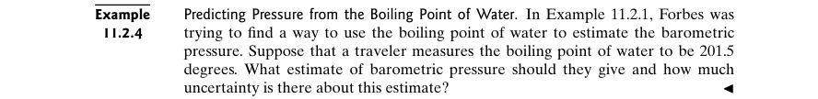

Example 11.2.5 – Codable

Example 11.3.1 – Non-Codable (Reason: Example with no scope of computation)

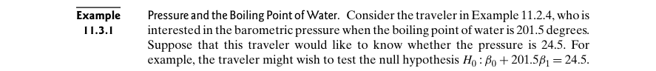

Example 11.3.2 – Codable

Example 11.3.3 – Codable

Example 11.3.4 – Codable

Example 11.3.5 – Codable

Example 11.3.6 – Codable

Example 11.3.7 – Codable

Example 11.3.8 – Non-Codable (Reason: Example with no computation)

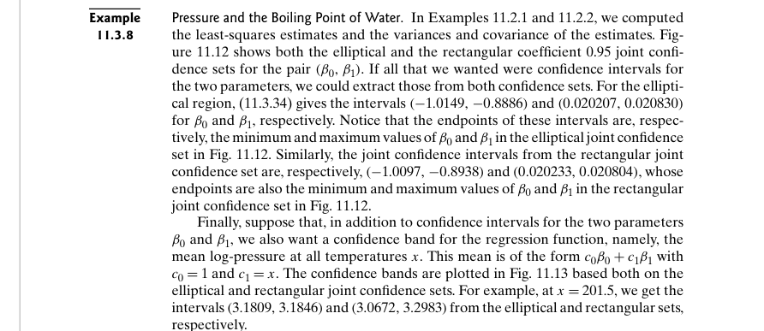



Example 11.3.9 – Codable

Example 11.4.1 – Non-Codable (Reason: Example with no computation)

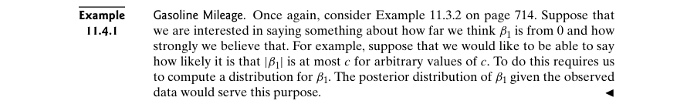

Example 11.4.2 – Codable

Example 11.4.3 – Codable

Example 11.4.4 – Codable

Example 11.5.1 – Codable

Example 11.5.2 – Non-Codable (Reason: Example with no computation)



Example 11.5.3 – Codable

Example 11.5.4 – Codable

Example 11.5.5 – Codable

Example 11.5.6 – Codable

Example 11.5.7 – Codable

Example 11.5.8 – Codable

Example 11.5.9 – Codable

Example 11.5.10 – Codable

Example 11.6.1 – Non-Codable (Reason: Example as an introduction to be used in further examples)

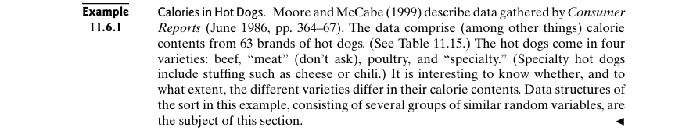

Example 11.6.2 – Non-Codable (Reason: Example as an introduction for a topic)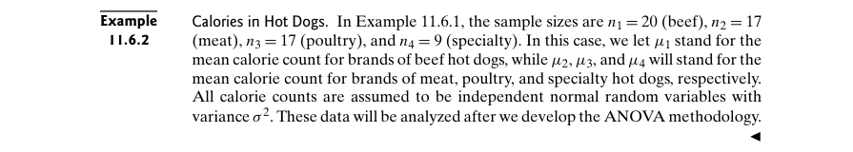

Example 11.6.3 – Non-Codable (Reason: Example with no computation)

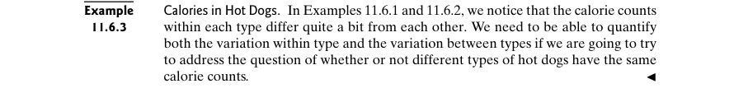

Example 11.6.4 – Codable

Example 11.6.5 – Codable

Example 11.6.6 – Codable

Example 11.7.1 – Non-Codable (Reason: Example as an introduction to be used in further examples)

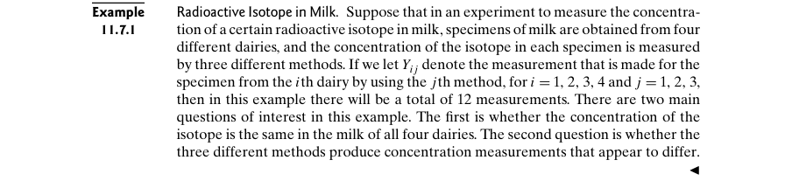

Example 11.7.2 – Codable

Example 11.7.3 – Codable

Example 11.7.4 – Non-Codable (Reason: Example with no computation)

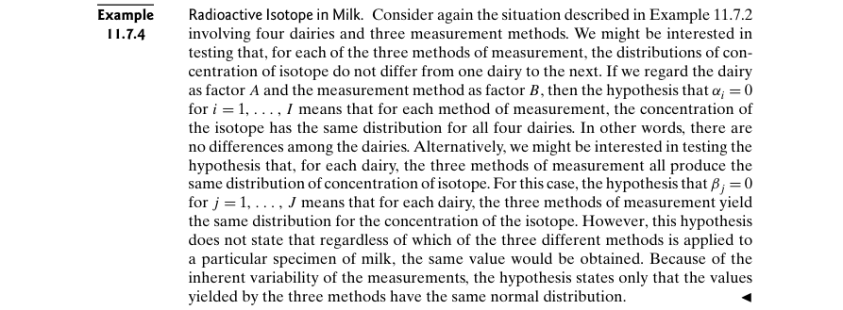

Example 11.7.5 – Codable

Example 11.7.6 – Codable

Example 11.8.1 – Non-Codable (Reason: Example as an introduction to be used in further examples)

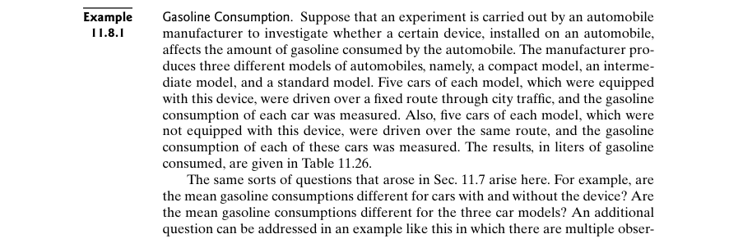

Example 11.8.2 – Codable

Example 11.8.3 – Codable

Example 11.8.4 – Codable

Example 11.8.5 – Codable

**Chapter 12: Simulation**

Example 12.1.1 – Codable

Example 12.1.2 – Codable

Example 12.1.3 – Codable

Example 12.1.4 – Codable

Example 12.2.1 – Non-Codable (Reason: Theoretical example with no computation)

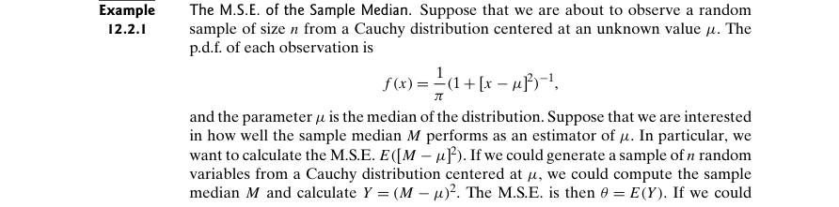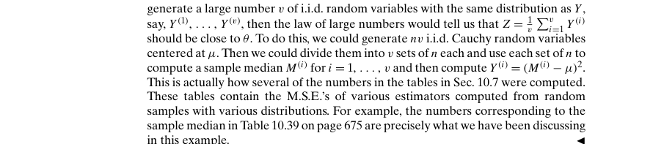

Example 12.2.2 – Non-Codable (Reason: Theoretical example with no computation)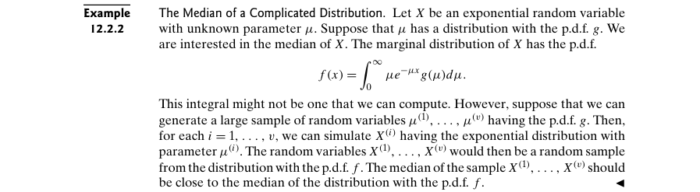

Example 12.2.3 – Non-Codable (Reason: Example with no computation)

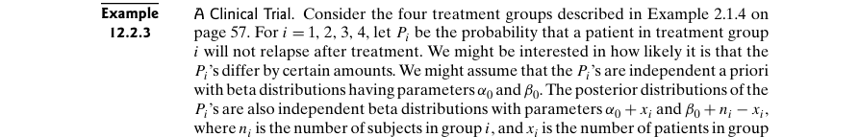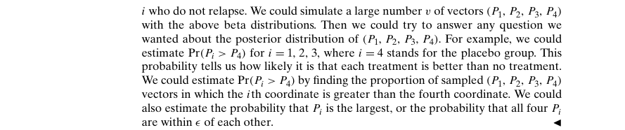

Example 12.2.4 – Non-Codable (Reason: Theoretical example)

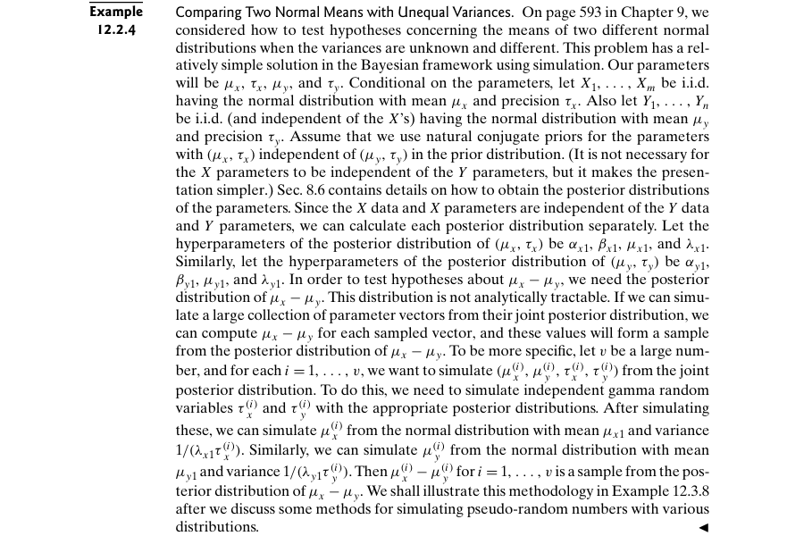

Example 12.2.5 – Non-Codable (Reason:Theoretical example with no computation)

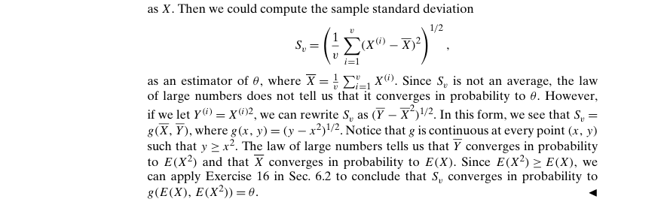

Example 12.2.6 – Non-Codable (Reason: Example with no computation)

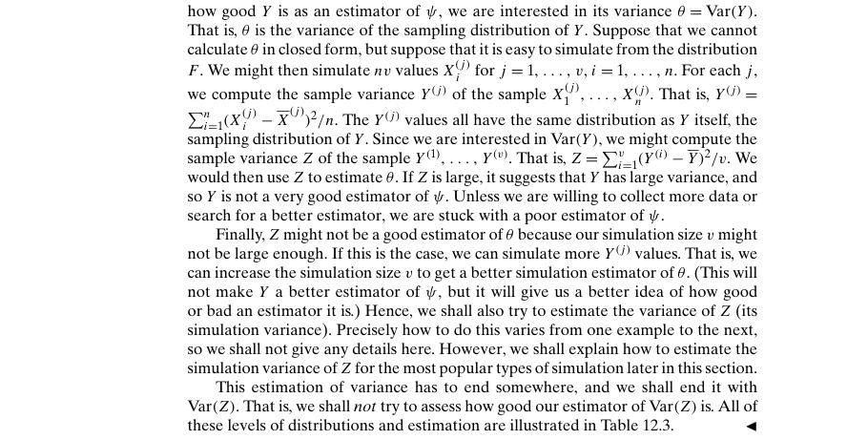

Example 12.2.7 – Non-Codable (Reason: Theoretical example with no computation)

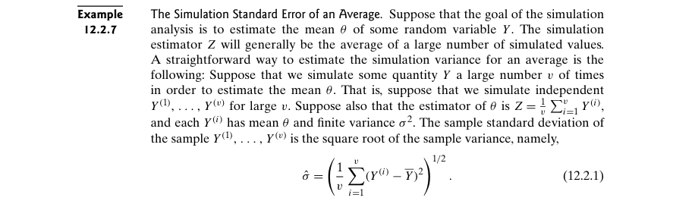

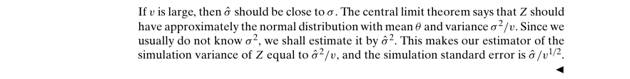

Example 12.2.8 – Non-Codable (Reason: Results are in variable expressions)

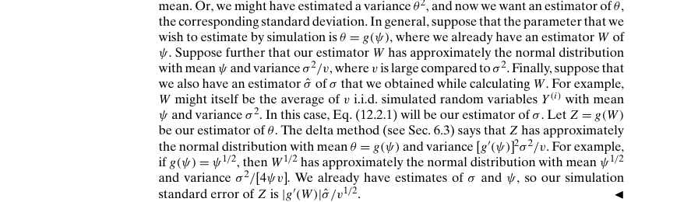

Example 12.2.9 – Non-Codable (Reason: Theoretical example with variable terms)

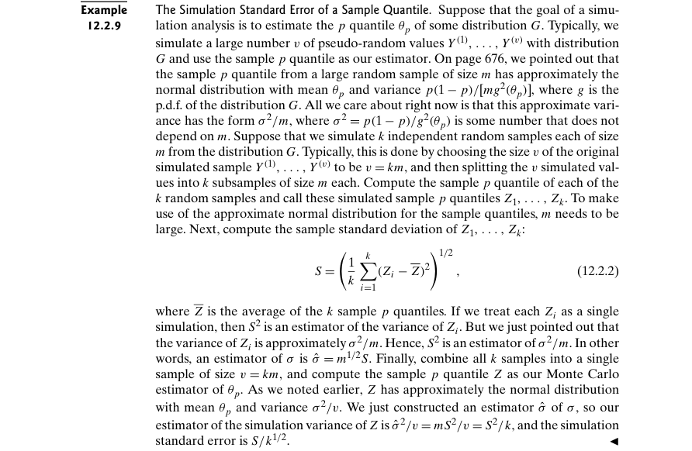

Example 12.2.10 – Non-Codable (Reason: Theoretical example with variable expressions)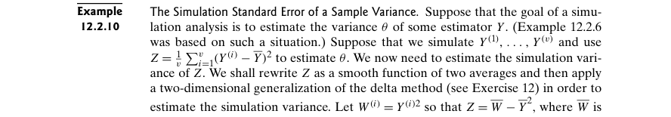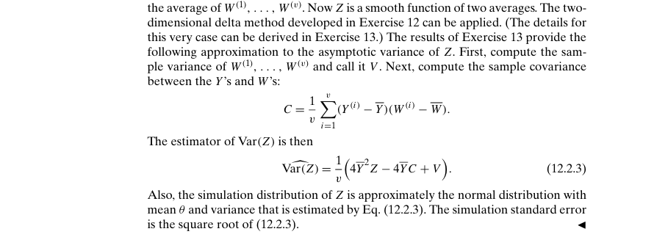

Example 12.2.11 – Codable

Example 12.2.12 – Codable

Example 12.2.13 – Non-Codable (Reason: Results are in variable terms)

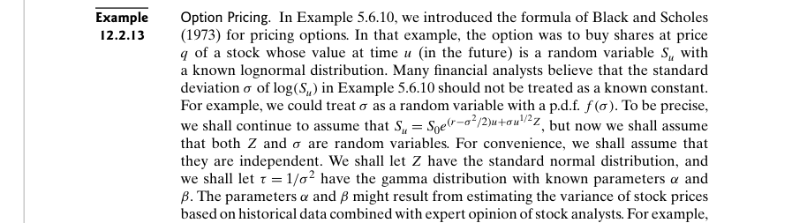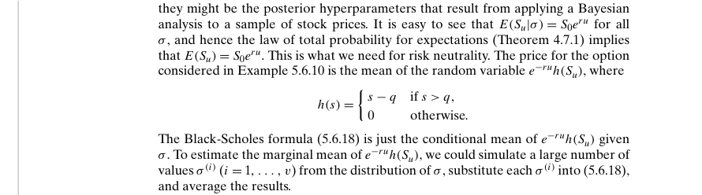

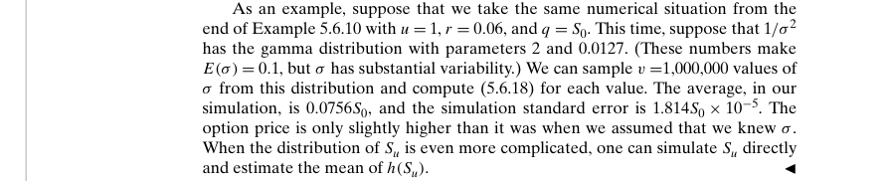

Example 12.2.14 – Codable

Example 12.3.1 – Non-Codable (Reason: Theoretical example with no computation)

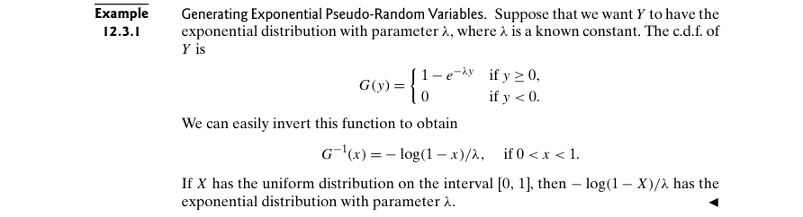

Example 12.3.2 – Non-Codable (Reason: Results are in variable expression)

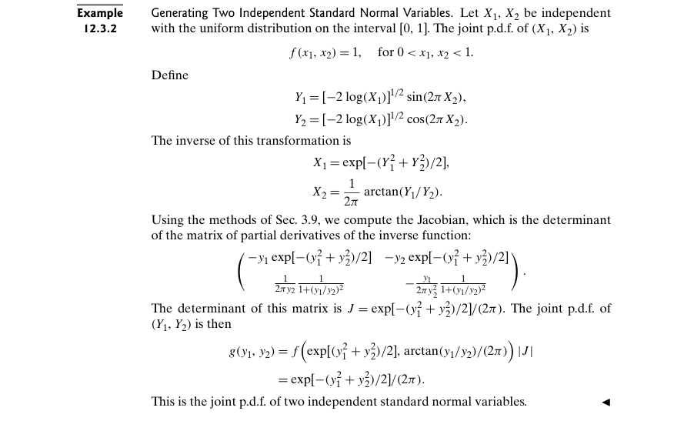

Example 12.3.3 – Non-Codable (Reason: Theoretical example with no computation)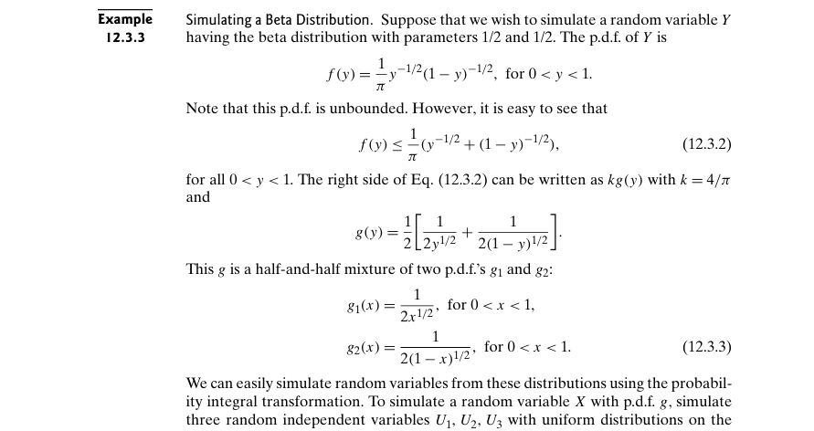

Example 12.3.4 – Non-Codable (Reason: Example with no computation)

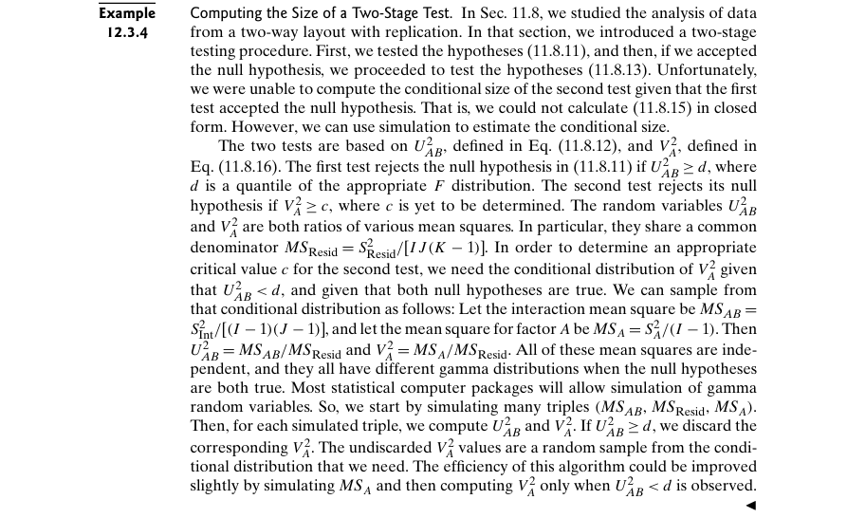

Example 12.3.5 – Non-Codable (Reason: Example with no computation)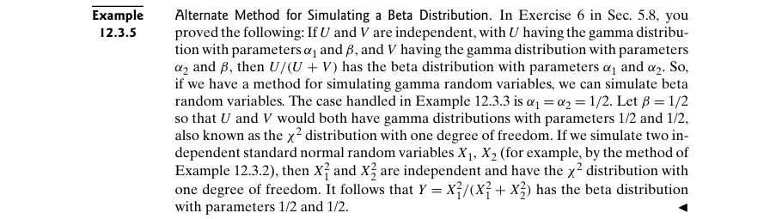

Example 12.3.6 – Non-Codable (Reason: Theoretical example)

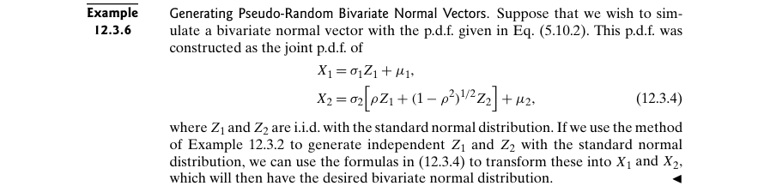

Example 12.3.7 – Codable

Example 12.3.8 – Codable

Example 12.3.9 – Non-Codable (Reason: Theoretical example)

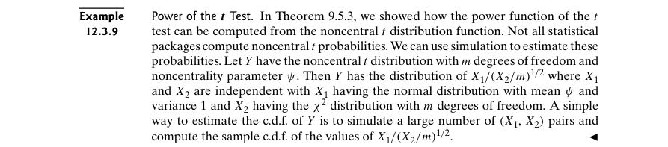

Example 12.3.10 – Non-Codable (Reason: Theoretical example with no computation)

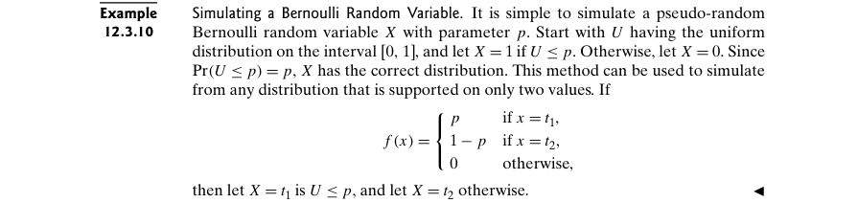

Example 12.3.11 – Non-Codable (Reason: Theoretical example with no computation)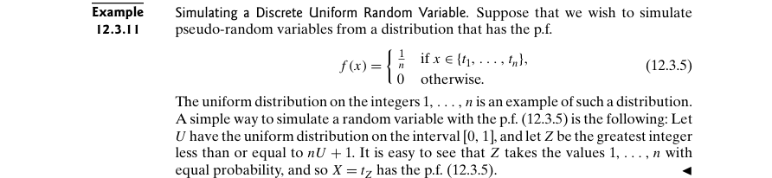

Example 12.3.12 – Non-Codable (Reason: Theoretical example with no computation)

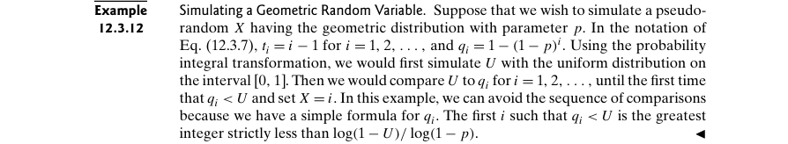

Example 12.3.13 – Codable

Example 12.4.1 – Codable

Example 12.4.2 – Codable

Example 12.4.3 – Non-Codable (Reason: Results are in variable expressions)

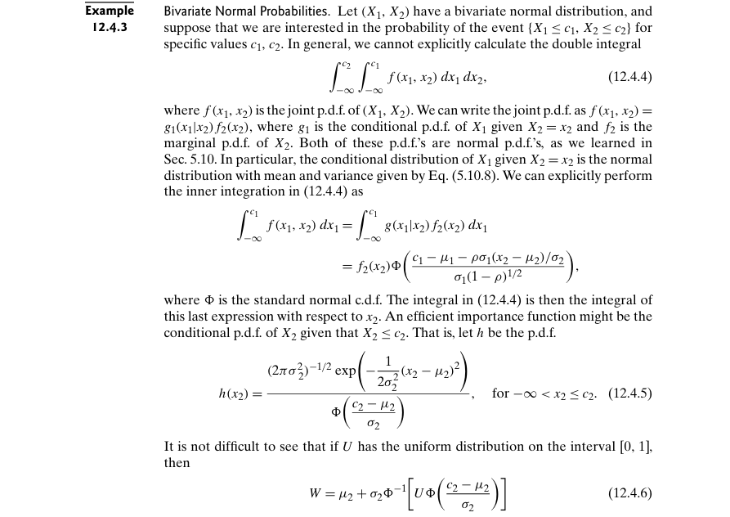

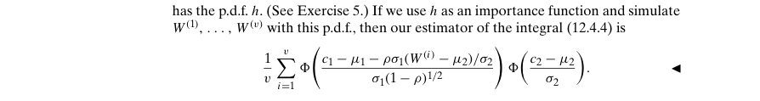

Example 12.4.4 – Codable

Example 12.5.1 – Non-Codable (Reason: Theoretical example with no computation)

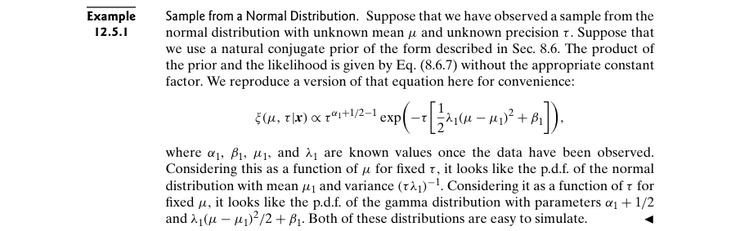

Example 12.5.2 – Codable

Example 12.5.3 – Codable

Example 12.5.4 – Non-Codable (Reason: Theoretical example with variable terms)

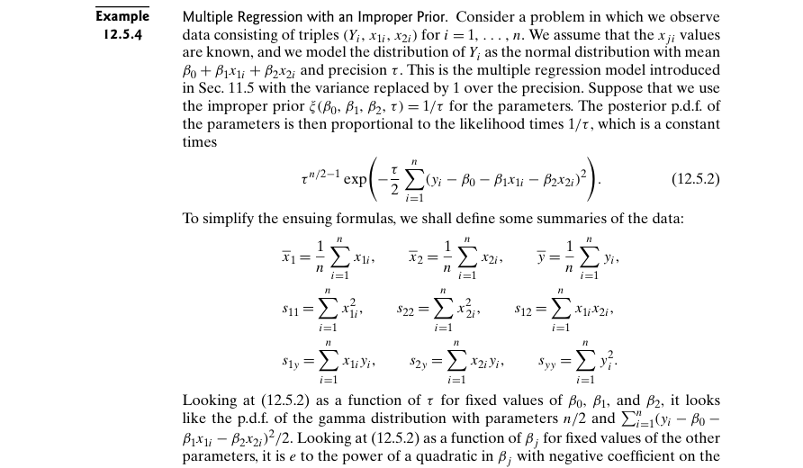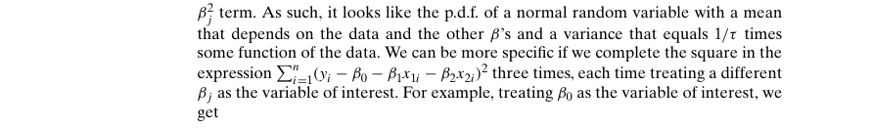

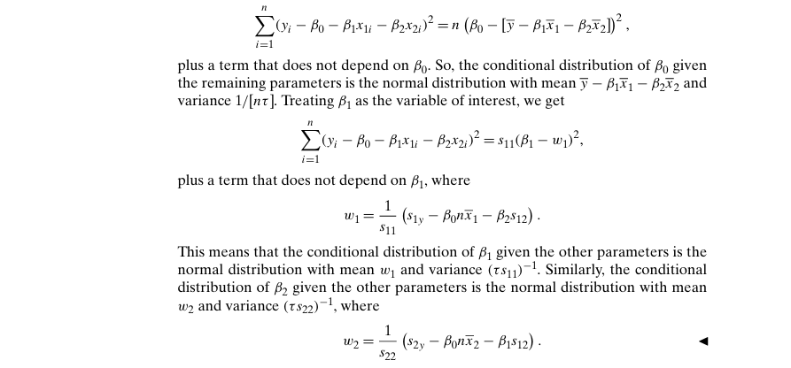Example 12.5.5 – Codable

Example 12.5.6 – Codable

Example 12.5.7 – Codable

Example 12.5.8 – Codable

Example 12.6.1 – Non-Codable (Reason: Theoretical example with variable results)

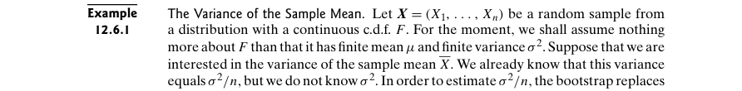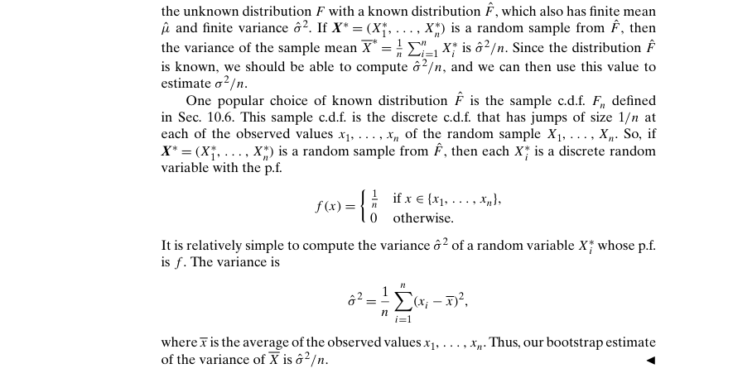

Example 12.6.2 – Non-Codable (Reason: Theoretical example with no computation)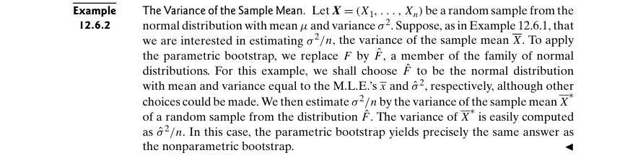

Example 12.6.3 – Codable

Example 12.6.4 – Codable

Example 12.6.5 – Non-Codable (Reason: Example with no computation)

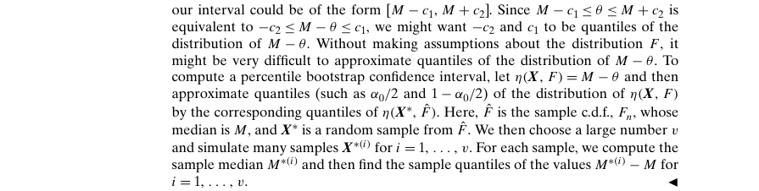

Example 12.6.6 – Codable

Example 12.6.7 – Codable

Example 12.6.8 – Codable

Example 12.6.9 – Codable

Example 12.6.10 – Codable

Example 12.6.11 – Non-Codable (Reason: Example already computed in a previous example)

